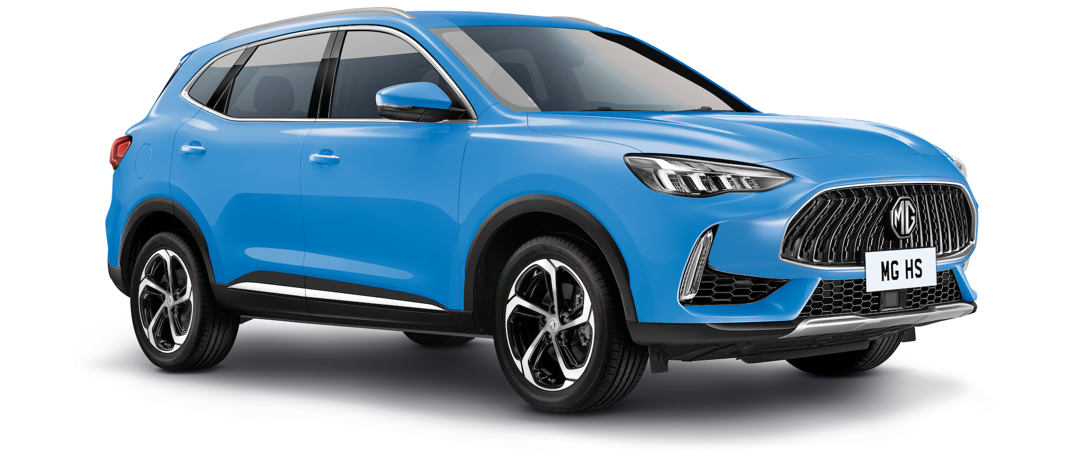
Technical Specifications
The New MG HS

 | MG HS SE  manual | MG HS SE  DCT | MG HS Trophy  manual | MG HS Trophy DCT
Price (on the road) | £23,495 | £24,995 | £25,995 | £27,495
Servicing intervals | 12 months / 15,000 miles
Warranty | 7 years / 80,000 miles
ENGINE & DRIVETRAIN
Engine | 1490cc turbocharged GDI 4-cyl 16v petrol
Configuration | Front-wheel drive
Gearbox | 6-spd manual | 7-spd dual clutch transmission | 6-spd manual | 7-spd dual clutch transmission
Maximum power | 162 PS / 119 kW at 5500rpm
Maximum torque | 184 lb/ft / 250 Nm at 1500-4400rpm
PERFORMANCE
0-60mph | 9.6 seconds
0-62mph | 9.9 seconds
Maximum speed | 118 mph
EFFICIENCY
Fuel consumption (combined WLTP) | 37.9 mpg | 36.6 mpg | 37.9 mpg | 36.6 mpg
CO2 emissions (WLTP) | 168 g/km | 174 g/km | 168 g/km | 174 g/km
WEIGHTS
Kerb weight | 1495 kg | 1516 kg | 1539 kg | 1563 kg
Gross vehicle weight | 2001 kg | 2023 kg | 2001 kg | 2023 kg
Maximum towing weight (unbraked) | 745 kg | 750 kg | 750 kg | 750 kg
Maximum towing weight (braked) | 1750 kg
Gross train weight | 3751 kg | 3773 kg | 3751 kg | 3773 kg
Maximum tow ball weight | 75 kg
Maximum roof rail load | 50 kg
Turning circle | 11.1
DIMENSIONS
Overall length | 4610 mm
Overall height (incl. roof rails) | 1685 mm
Overall width (incl. mirrors) | 2078 mm
Overall width (excl. mirrors) | 1876 mm
Wheelbase | 2720 mm
Front track | 1573 mm
Rear track | 1584 mm
Boot capacity (seats up) | 463 litres
Boot capacity (seats folded) | 1454 litres

Press Information – Equipment (1 of 2)
The New MG HS
EXTERIOR | MG HS SE  manual | MG HS SE  DCT | MG HS Trophy  manual | MG HS Trophy DCT
18" diamond cut alloy wheels | l | l | l | l
Auto bi-function LED headlights | l | l | l | l
LED daytime running lights | l | l | l | l
Front and rear LED sequential indicators | l | l | l | l
LED centre brake light | l | l | l | l
Follow me home headlights | l | l | l | l
Silver roof rails | l | l | l | l
Rear parking sensors | l | l | l | l
Electrically adjustable/folding, heated & body coloured door mirrors | l | l | l | l
Front and rear aero wipers | l | l | l | l
SEATING
Black leather-style upholstery | l | l | l | l
Red/black leather-style upholstery with black headlining |  |  | +£500 | +£500
Sports style front seats with one-piece rear |  |  | l | l
6-way manually adjustable driver’s seat with lumbar adjustment | l | l
6-way electrically adjustable driver’s seat with lumbar adjustment |  |  | l | l
4-way manually adjustable passenger seat | l | l
4-way electrically adjustable passenger seat |  |  | l | l
Heated front seats |  |  | l | l
Front centre sliding armrest with storage | l | l | l | l
Rear 60:40 split folding seats | l | l | l | l
Rear seats with 2-stage incline adjustment | l | l | l | l
COMFORT & CONVENIENCE
Air conditioning | l | l
Dual-zone auto air conditioning |  |  | l | l
Remote central locking | l | l | l | l
Keyless entry with push button start | l | l | l | l
Speed-sensing door lock function | l | l | l | l
Full digital driver information display | l | l | l | l
Adjustable ambient lighting |  |  | l | l
Rain-sensing wipers | l | l | l | l
12v power socket | l | l | l | l
Cruise control | l |  | l
Adaptive cruise control |  | l |  | l
Leather steering wheel | l | l | l | l
Steering wheel paddle shifters |  |  |  | l
Metal sports pedals |  |  |  | l
Height and reach adjustable steering wheel | l | l | l | l
Electric parking brake with autohold | l | l | l | l
Switchable driving modes (incl. Super Sport) |  |  |  | l
Front & rear one-touch electric windows | l | l | l | l
Auto-dimming rear view mirror | l | l | l | l
Power assisted tailgate |  |  |  | l
Rear privacy glass |  |  | l | l

Press Information – Equipment (2 of 2)

The New MG HS

IN-CAR ENTERTAINMENT | MG HS SE  manual | MG HS SE  DCT | MG HS Trophy  manual | MG HS Trophy DCT
4-speaker audio system | l | l
6-speaker audio system |  |  | l | l
10.1" colour touchscreen | l | l | l | l
DAB radio | l | l | l | l
Satellite navigation | l | l | l | l
Apple CarPlay™ | l | l | l | l
Android Auto™ | l | l | l | l
Rear parking camera | l | l | l | l
USB mobile phone charging | l | l | l | l
4 USB ports (2 front, 2 rear) | l | l | l | l
Bluetooth connectivity | l | l | l | l
SAFETY & SECURITY

MG Pilot (Active Emergency Braking with Pedestrian and Bicycle Detection, Lane Keep Assist (LKA) with Lane Departure Warning System (LDWS), Intelligent Speed Limit Assist, Blind Spot Detection (BSD), Rear Cross Traffic Alert (RCTA), Intelligent High Beam Assist) | l | l | l | l
MG Pilot (As above, plus Traffic Jam Assist) |  | l |  | l
ABS and EBD | l | l | l | l
Cornering Brake Control | l | l | l | l
Rear ISOFIX (x2) | l | l | l | l
Front side airbags | l | l | l | l
Front dual airbags | l | l | l | l
Front passenger airbag deactivation | l | l | l | l
Side curtain airbag | l | l | l | l
Anti rolling protection | l | l | l | l
Tyre pressure monitoring system | l | l | l | l
ESP | l | l | l | l
Hill launch assist | l | l | l | l
Hill descent control | l | l | l | l
Driver's seatbelt reminder | l | l | l | l
Front and rear passenger seatbelt reminder | l | l | l | l
Front seatbelts (with pretensioner and load limiter) | l | l | l | l
Rear seatbelts (outer with pretensioner and load limiter) | l | l | l | l
Front seatbelt height adjustment | l | l | l | l
Rear headrests | l | l | l | l
Alarm & engine immobiliser | l | l | l | l
Tyre repair kit | l | l | l | l

