MG4 EV
UK media data

August 2022

Contents

Introduction 3
MG4 EV: At a glance 4
Powertrain 5
Modular Scalable Platform (MSP) 6
Design 7
MG Pilot 8
Interior & technology 9
Model range specifications 10
Market comparison 11
Technical data 12
Trim levels 13
Future models 14
About MG 15

The MG4 EV: Introduction
The new MG4 EV is an all-electric hatchback designed to offer customers affordable, zero-emissions motoring without compromise.
With an extremely competitive £25,995 starting price, MG’s first fully-electric hatchback optimises space, technology, affordability and driving quality.
The MG4 EV is the first to use the innovative new Modular Scalable Platform (MSP) that will underpin a new generation of MGs, featuring rear-wheel drive, 50:50 weight distribution and thin battery technology.
Three specifications will be offered at launch - the MG4 EV SE Standard Range, the SE Long Range and the Trophy Long Range.
With battery capacities from 51kWh to 64kWh, the MG4 EV Standard Range is capable of 218 miles on the WLTP cycle, with Long Range SE and Trophy models capable of 281 miles and 270 miles respectively.
This remarkably affordable range of battery options gives customers the opportunity to find their most suitable driving specification and price point.
The 64kWh battery is also capable of recharging at up to 135kW, meaning a charge time of only 35 minutes from 10% - 80% using a 150kW DC rapid charger.
The MG4 EV is expected to bring zero-emissions motoring within reach for far more UK customers, representing an affordable, credible alternative to conventional petrol, diesel and hybrid hatchbacks.
The MG4 EV also carries MG’s trademark 7-year/80,000-mile warranty as standard, which remains one of the longest fully-transferable warranties in its class.

MG4 EV: At a glance

- Prices from £25,995 OTR (SE Standard Range model)
- Centred around four key qualities: space, technology, affordability and driver engagement
- The first fully-electric MG hatchback and the first MG to utilise the all-new Modular Scalable Platform
- New MSP offers superb roadholding and engagement, thanks to 50:50 weight distribution and a rear-wheel drive configuration
- Long Range SE and Trophy models with Active Grille Shutter system (AGS), regulating air flow according to vehicle requirements and increasing EV efficiency, especially at motorway speeds
- A choice of 5 driving modes to optimise the MG4 EV for different driving conditions
- MSP design also creates exceptional storage, cabin and boot space
- A choice of two battery options – 51kWh (Standard Range) and 64kWh (Long Range)
- Available in three trim levels: SE Standard Range, SE Long Range and Trophy Long Range
- MG Pilot advanced driver assistance as standard on all models, with Blind Spot Detection, Lane Change Assist, Rear Cross Traffic Alert and Door Opening Warning on Trophy models
- iSMART system integrates car, internet, and user communication, now with voice activation and remote control features
- 7-year/80,000-mile fully-transferable warranty as standard

Powertrain
The MG4 EV has a remarkably affordable range of battery options to offer different customers their most suitable driving specification and price point, with three highly competitive specifications available at launch.
- Initially available with battery capacities from 51kWh to 64kWh
- MG4 EV Standard Range capable of 218 miles range on the WLTP cycle
- Long Range SE and Trophy Models capable of 281 miles and 270 miles respectively
- 64kWh Long Range battery is also capable of charging at up to 135kW, with a charge time of only 35 minutes from 10% - 80% (150kW DC rapid charger)

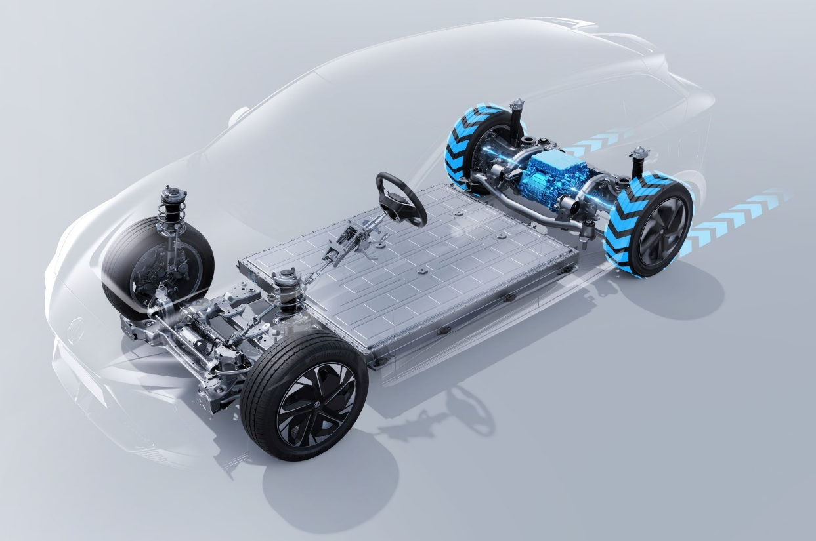

Modular Scalable Platform
As the first model to use the innovative new MSP, the MG4 EV will pave the way for the next generation of all-electric MGs across a range of body styles.
- Advanced platform offers drivers superb roadholding and engagement
- Battery design and placement delivers 50:50 weight distribution and a low centre of gravity, alongside rear-wheel drive configuration
- Designed to maximise battery efficiency and interior/storage space
- MSP allows scalable range and performance for a wide variety of customer requirements, initially available with battery capacities from 51kWh to 64kWh
- Allows integration with future technologies, including battery swap systems
- Capable of supporting all-wheel drive powertrains

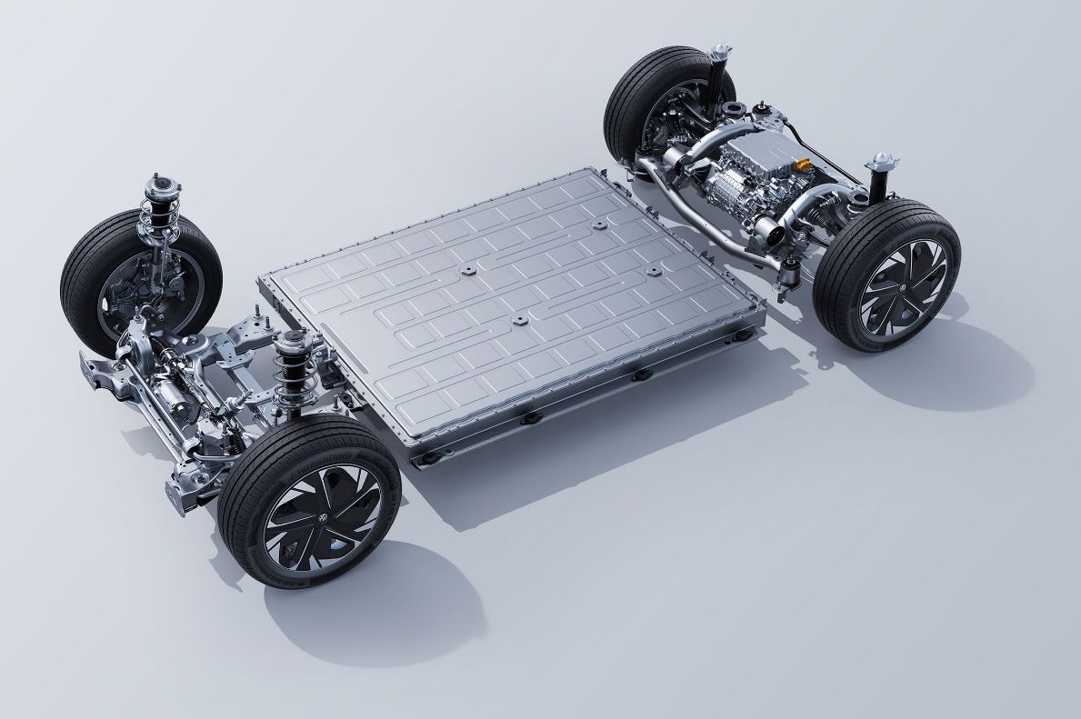

Design
Manufactured using highly advanced laser welding technology and with a new, modern, striking design language, the MG4 EV boasts sophisticated aerodynamics and distinctive style.
- A brand-new design from MG’s Advanced Design team
- Twin aero rear spoiler
- 17’’ aerodynamic alloy wheels
- All-new LED rear light design
- Trophy models with black roof and distinctive rear centre light bar cross hatch design
- Six exterior colour options: Arctic White, Holborn Blue, Black Pearl (Metallic), Camden Grey (Metallic), Dynamic Red (Tri-Coat) and Volcano Orange (Tri-Coat)

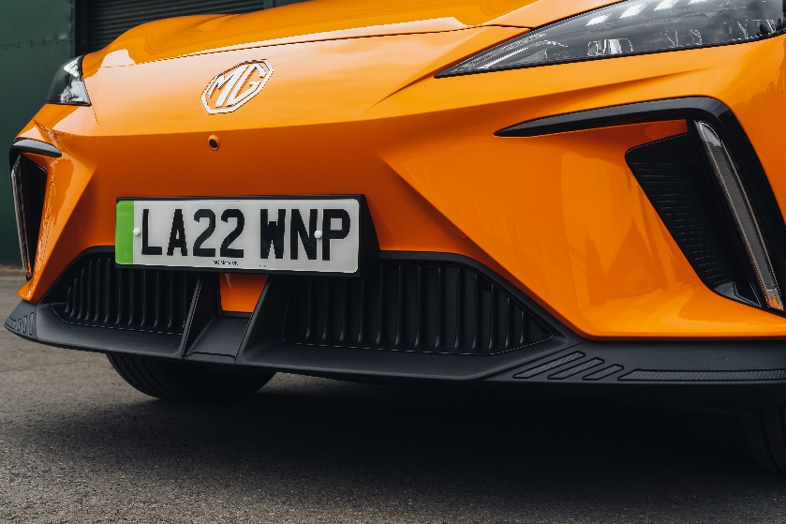
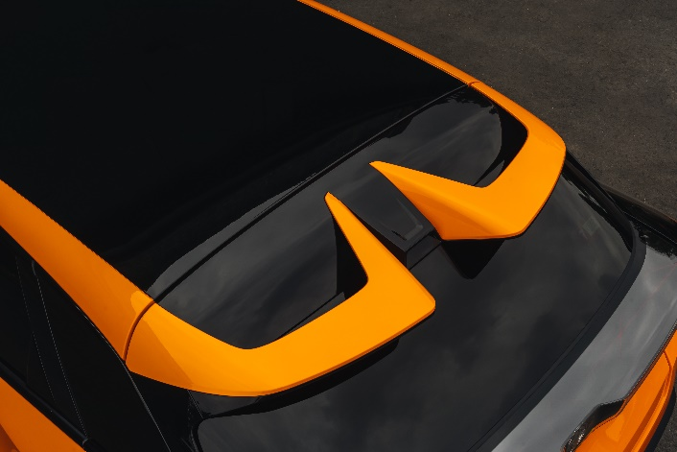

MG Pilot
MG Pilot is included as standard on all MG4 EV models, a comprehensive package of safety equipment that features:
- Active Emergency Braking with Pedestrian and Bicycle Detection
- Adaptive Cruise Control with Traffic Jam Assist
- Intelligent Speed Limit Assist with Traffic Sign Recognition
- Lane Keep Assist with Lane Departure Warning System
- Driver Attention Alert
- Intelligent High Beam Assist
Trophy Long Range models are also equipped with Door Open Warning, Rear Cross Traffic Alert, Blind Spot Detection and Lane Change Assist.

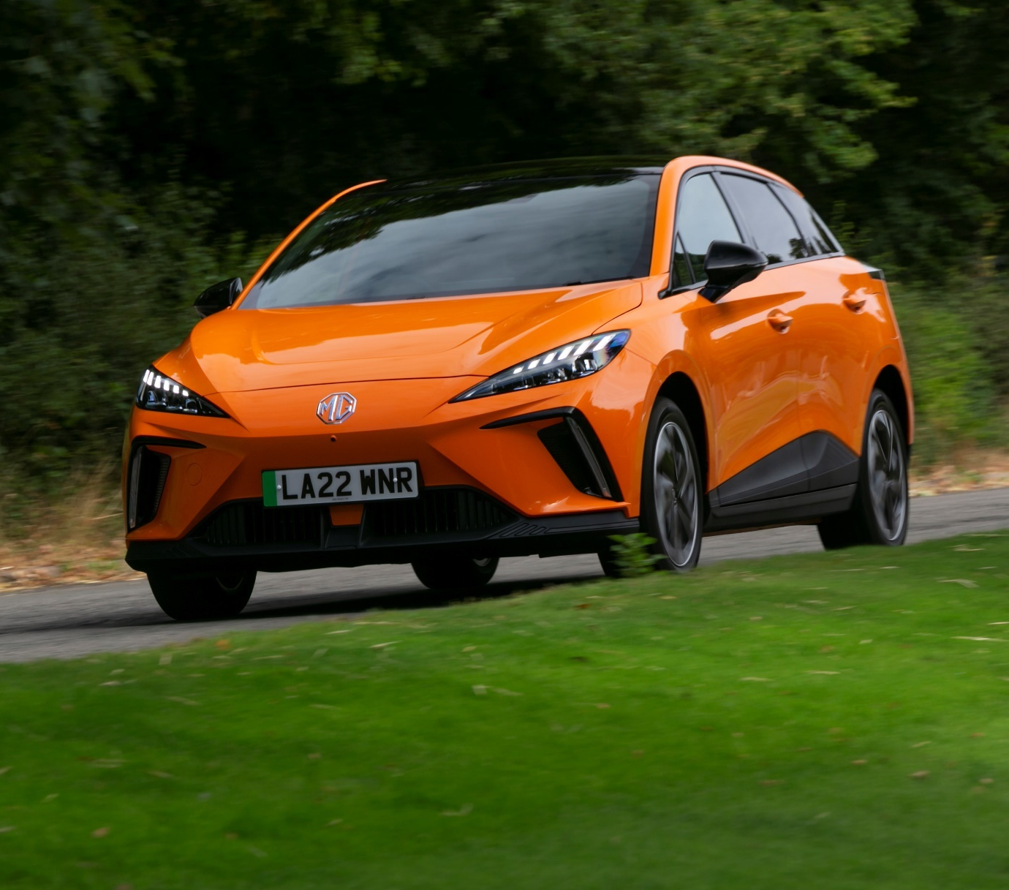

Interior & technology
The MG4 EV’s simple, elegant interior combines minimalist design with hi-tech integration and functionality.
- A choice of black fabric upholstery (SE) or leather style with cloth inserts (Trophy)
- MG iSMART connected car features as standard, with live services on Trophy models
- Integrated, interacting dual screen technology with configurable 7’’ driver display and 10.25” floating infotainment screen
- 4-speaker audio system with Apple CarPlay® and Android Auto® as standard, with upgraded 6-speaker 3D system on Trophy models
- Rotary Gear Selector
- Trophy models gain satellite navigation, 360° parking camera, heated front seats and steering wheel, height-adjustable loading floor, wireless phone charging, Bluetooth key and auto-dimming rear view mirror

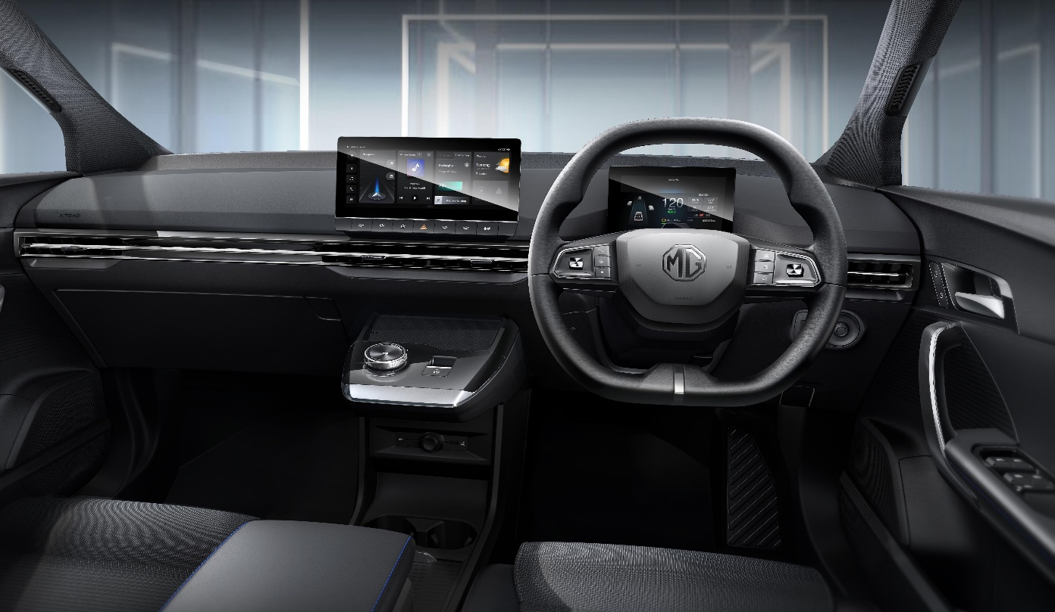

MG4 EV model range specifications
 | MG4 EV SE  Standard Range | MG4 EV SE  Long Range | MG4 EV Trophy  Long Range
Prices from (OTR) | £25,995 | £28,495 | £31,495
Power (kW) | 125 | 150
Top speed (mph) | 100
0-62 mph (secs) | 7.7 | 7.9
Transmission / Drivetrain | 1 speed auto / RWD
Combined WLTP range (miles) | 218 | 281 | 270
Nominal battery capacity (kWh) | 51 | 64
Rapid charging from 10-80% on 150kW rapid charger (mins) | 39 | 35 | 35
Gross weight (kg) | 2,103 | 2,133

Market comparison
 | 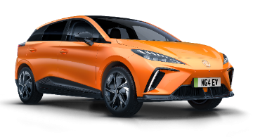 | 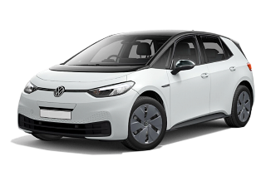 | 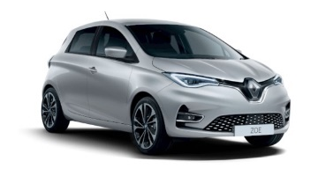
 | MG4 EV SE Long Range | Volkswagen ID.3 Life Pro Performance | Renault Zoe R135 Rapid Charge
Price from (OTR) | £28,495 | £36,195 | £31,195
Power (kW) | 150 | 150 | 100
Top Speed (mph) | 100 | 99 | 87
0-62 mph (secs) | 7.9 | 7.3 | 9.7
Transmission / Drivetrain | 1 speed auto / RWD | 1 speed auto / RWD | 1 speed auto / FWD
Combined WLTP Range (miles) | 281 | 265 | 239
Nominal Battery Capacity (kWh) | 64 | 58 | 52
Rapid charging from 10-80% on 150kW DC rapid charger (mins) | 35 | 31 | N/A
Miles per kWh | 3.8 | 4.1 | 4.6
Gross weight (kg) | 2,113 | 2,270 | 1,976

Technical data | MG4 SE  Standard Range | MG4 SE  Long Range | MG4 Trophy  Long Range
Electric motor | Synchronous, rear-mounted, rear wheel drive
Maximum power | 170 PS (125 kW) | 203 PS (150 kW) | 203 PS (150 kW)
Maximum torque | 184 lb/ft (250 Nm) | 184 lb/ft (250 Nm) | 184 lb/ft (250 Nm)
BATTERY
Battery type | LFP (Lithium Iron Phosphate) | NCM (Nickel Cobalt Manganese) | NCM (Nickel Cobalt Manganese)
Battery capacity (nominal) | 51 kWh | 64 kWh | 64 kWh
Battery capacity (usable) | 50.8 kWh | 61.7 kWh | 61.7 kWh
PERFORMANCE
0-30mph | 3.1 secs | 3.5 secs | 3.5 secs
0-60mph | 7.5 secs | 7.7 secs | 7.7 secs
0-62mph | 7.7 secs | 7.9 secs | 7.9 secs
Maximum speed | 100 mph | 100 mph | 100 mph
EFFICIENCY
Driving efficiency – Combined | 3.6 miles/kWh (17.0 kWh/100km) | 3.8 miles/kWh (16.0 kWh/100km) | 3.7 miles/kWh (16.6 kWh/100km)
Driving efficiency – City | 5.2 miles/kWh (11.9 kWh/100km) | 5.0 miles/kWh (12.3 kWh/100km) | 4.9 miles/kWh (12.4 kWh/100km)
Max. driving range – Combined | 218 miles (350 km) | 281 miles (450 km) | 270 miles (435 km)
Max. driving range – City | 305 miles (492 km) | 360 miles (579 km) | 358 miles (577 km)
CO₂ emissions | 0 g/km | 0 g/km | 0 g/km
CHARGING
Connection type | Combined Type 2 and CCS
On-board charger (AC) | 7 kW | 7 kW | 7 kW
Rapid charging (DC) | 117 kW | 135 kW | 135 kW
Est. charging time (2.2 kW AC) 10-100% | 20.5 hours @ 25°C | 26.0 hours @ 25°C | 26.0 hours @ 25°C
Est. charging time (7 kW AC) 10-100% | 7.5 hours @ 25°C | 9.0 hours @ 25°C | 9.0 hours @ 25°C
Est. charging time (50 kW DC) 10-80% | 52 minutes | 60 minutes | 60 minutes
Est. charging time (150 kW DC) 10-80% | 39 minutes | 35 minutes | 35 minutes
WEIGHTS (kg)
Kerb weight | 1655 | 1685 | 1685
Gross vehicle weight | 2103 | 2133 | 2133
Max. towing weight (unbraked) | 500 | 500 | 500
Max. towing weight (braked) | 500 | 500 | 500
Gross train weight | 2603 | 2633 | 2633
Max. tow ball weight | 50 | 50 | 50
Max. roof load | 0 | 0 | 0
DIMENSIONS (mm)
Overall length | 4287
Overall height | 1504
Overall width (inc. mirrors) | 2060
Overall width (exc. mirrors) | 1836
Wheelbase | 2705
Front track | 1550
Rear track | 1551
Boot capacity (seats up) | 363 litres wet volume
Boot capacity (seats folded) | 1177 litres wet volume
Turning circle | 10.6 m

Trim levels | MG4 SE  Standard Range | MG4 SE  Long Range | MG4 Trophy  Long Range
Projector LED Headlights | l | l
Projector LED Headlights with reflective technology |  |  | l
Integrated LED Daytime Running Lights | l | l
LED Daytime Running Lights (integrated into front bumper indicator lights) |  |  | l
LED Rear Lights | l | l | l
Rear Centre Light Bar with cross hatch design effect |  |  | l
Auto Headlights | l | l | l
LED Centre Brake Light | l | l | l
Two-Tone / Black Roof |  |  | l
Tinted Glass | l | l | l
Rear Privacy Glass |  |  | l
Rear Spoiler | l | l
Twin Aero Rear Spoiler |  |  | l
Rear Parking Sensors | l | l | l
Active Grille System (AGS) |  | l | l
Electrically Adjustable, Heated, Black Door Mirrors | l | l
Electrically Adjustable, Power Folding, Heated, Black Door Mirrors |  |  | l
17" Alloy Wheels with low wind resistance aero design | l | l | l
SEATING
Black Fabric Upholstery | l | l
Black Leather Style with Cloth Inserts Upholstery |  |  | l
Driver's 6-way Adjustable Seat | l | l
Electric Driver's 6-way Adjustable Seat |  |  | l
Passenger's 4-way Adjustable Seat | l | l | l
2nd Row 60:40 Split Fold Seat | l | l | l
Heated Front Seats |  |  | l
COMFORT & CONVENIENCE
Climate Control | l | l | l
Mobile Phone Bluetooth Key |  |  | l
7" Full Digital Driver Information Display | l | l | l
Auto Dimming Rear View Mirror |  |  | l
Vehicle to Load charging (max load 2200W) | l | l | l
Leather Steering Wheel | l | l | l
Heated Steering Wheel |  |  | l
Reach & Height Adjust Steering Wheel | l | l | l
5 Driving Modes (Eco, sport, snow, custom, standard) | l | l | l
4 Regenerative Braking Modes (Auto, 1, 2, 3) | l | l | l
Height Adjustable Loading Floor |  |  | l
Front & Rear Electric Windows with Driver's one-touch up/down | l | l
Front & Rear Electric Windows All one-touch up/down |  |  | l
IN-CAR ENTERTAINMENT
4-Speaker Audio System | l | l
6-Speaker Audio System with 3D Sound |  |  | l
DAB+ Radio | l | l | l
10.25" Floating Colour Touchscreen | l | l | l
iSmart | l | l
Live services (additional services include Weather, Live Traffic, Amazon Music) |  |  | l
USB Ports (2 front, 1 rear) | l | l | l
Satellite Navigation |  |  | l
Apple CarPlay™ | l | l | l
Android Auto™ | l | l | l
360° Parking Camera |  |  | l
Wireless Mobile Phone Charger |  |  | l
SAFETY & SECURITY
MG Pilot – Adaptive Cruise Control, Active Emergency Braking with Pedestrian and Bicycle Detection, Lane Keep Assist (LKA) with Lane Departure Warning System (LDWS), Traffic Jam Assist, Intelligent Speed Limit Assist with traffic sign recognition, Intelligent High Beam Assist, Driver Attention Alert | l | l | l
MG Pilot – As above plus Blind Spot Detection (BSD), Lane Change Assist (LCA), Rear Cross Traffic Alert (RCTA), Door Opening Warning (DOW) |  |  | l
ABS and EBD | l | l | l
Rear ISOFIX (x2) | l | l | l
Airbags: Front Dual, Front Side, Side Curtain | l | l | l
Front Passenger Airbag Deactivation Switch | l | l | l
Tyre Pressure Monitoring System (TPMS) | l | l | l
ESP | l | l | l
Hill Start Assist | l | l | l
EBA | l | l | l
Driver's and Front and Rear Passenger’s Seat Belt Reminder | l | l | l
Front Seat Belt (3 point with Pretensioner and Load Limiter) | l | l | l
Alarm & Immobiliser | l | l | l
Future models
Following the launch of the new MG4 EV, MG Motor UK plans to expand on the existing range of model specifications to suit an even wider range of customers.
More information will be released in 2023, with the following features currently in development for future models:
- New powertrain options
- A further increase in electric range capabilities
- A higher performance MG4 EV model, with dual motor powertrain and launch control

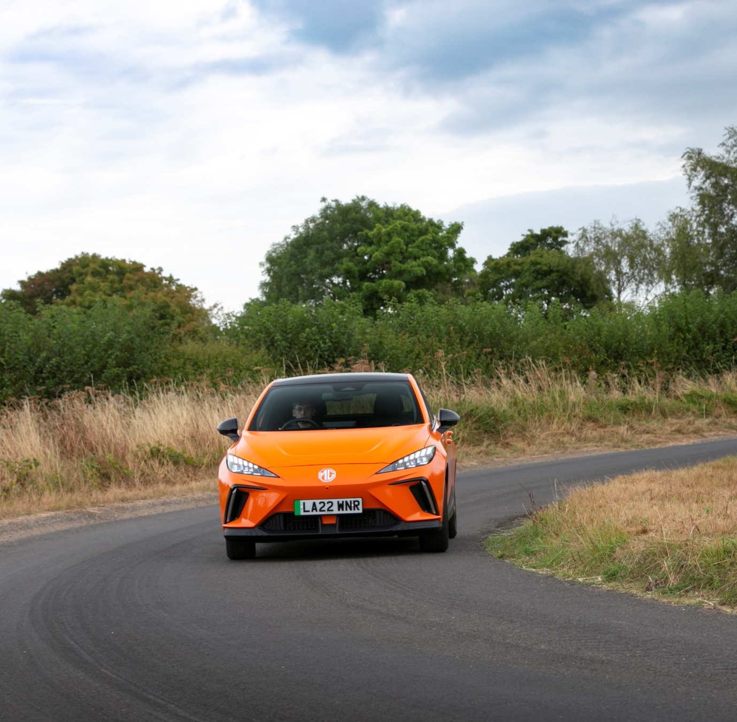

About MG
MG is the fastest growing car brand in the UK, with a market-leading range of electric vehicles that are encouraging more drivers than ever to switch to zero-emission motoring.
Tracing its history back to 1924, MG is famous for building sporty, exciting and affordable cars. Today, the company is establishing itself as a driving force in the rapidly expanding UK electric car market, with a reputation for outstanding design, market-leading technology and excellent value for money.
Designed in Marylebone, London, and manufactured in state-of-the-art factories in several countries, today’s MGs are practical, spacious and packed with technology. From its innovative new Modular Scalable Platform (MSP) to the intelligent iSmart vehicle data app, MG continues to demonstrate a forward-thinking and progressive approach to the needs of today’s discerning motorists.
With a national network of over 150 dealerships, MG is accessible to customers everywhere with professional sales and aftersales provision across the UK. All new MGs are built with world-class components and are backed by a comprehensive manufacturer’s 7-year warranty.

