MG ZS EV
UK media data

May 2022

Contents

The MG ZS EV: UK media data 3
MG ZS EV: At a glance 4
Introduction 5
Powertrain 6
Design 7
MG Pilot 8
Interior & technology 9
Trim levels 10
Model specifications 11
Rival comparison 12
About MG 13

The MG ZS EV: UK media data

The dynamic, forward-looking MG ZS EV range has established itself as one of the best value electric SUVs on the market, offering a thrilling new perspective on affordable electric driving.
With new design features, upgraded technology and new, powerful batteries that go further than ever on a single charge, the ZS EV is the most technologically-advanced MG ever.
Packed with new safety systems within MG Pilot, alongside 2% benefit-in-kind values, the MG ZS EV makes perfect sense for families and company car users alike.

The story so far…

“Affordable, practical and now boasting increased range, the all-electric MG ZS EV makes a strong case for itself.” – Auto Express

“The problem with electric cars, particularly of the SUV variety, is that, while they're cheap to run, they can be rather expensive to buy. There is one notable exception – the MG ZS EV.” – WhatCar?

"The MG ZS EV is a surprise hit thanks to a powerful electric motor, excellent practicality and bargain price." – Carbuyer

“The MG ZS EV is an affordable all-electric SUV that ticks almost every box. It's stylish, spacious and has plenty of features as standard and as a result, it gets TotallyEV's Value award.” – TotallyEV

MG ZS EV: At a glance

- The most technologically-advanced MG ever, now with upgraded styling, infotainment, and extended range capabilities
- Prices from £27,745 OTR (incl. PiCG)
- Powerful new water-cooled lithium-ion battery
- MG Pilot advanced driver assistance as standard on all models
- Available in three new trim levels: SE, Trophy and Trophy Connect
- iSMART system integrates car, internet, and user communication
- KERS system provides three levels of regenerative braking to enhance efficiency and extend range
- The first fully-electric vehicle in the MG range with towing capability, allowing small trailers or cycle carriers up to 500kg
- 7-year/80,000-mile warranty as standard
- 2% benefit-in-kind values for company car users in the 2022/23 tax year

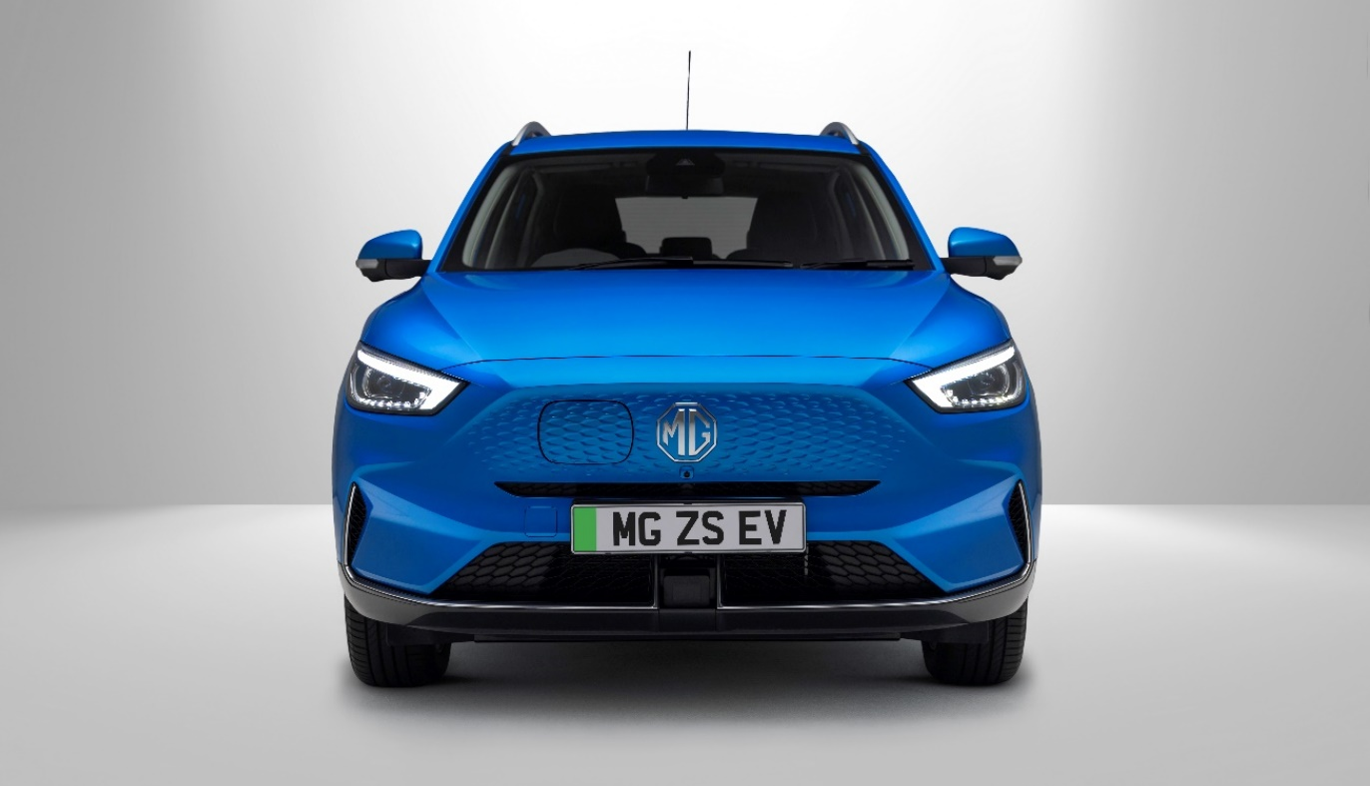

Introduction

The new, updated MG ZS EV is a spacious, family-friendly pure-electric model that offers market-leading value for money.
As MG’s current best-selling vehicle, and the tenth most popular electric vehicle of 2021, the revised ZS EV now offers an extended range of 273 miles on a single charge thanks to advanced battery technology.
Updated styling features a new, more aerodynamic front-end design with a revised side-opening electric charging port, while the distinctive LED taillights and redesigned rear bumper give the MG ZS EV a unique, dynamic look.
Designed in Marylebone, London, and engineered by MG’s Longbridge team, the ZS EV’s chassis has been tuned for British roads, offering users a fantastic blend of comfort and ease of use.
Three new trim levels are available, with customers choosing between SE, Trophy and Trophy Connect. The MG ZS EV notably offers an especially generous range of equipment as standard, the entry level SE model including Automatic Air Conditioning, Bi-Function LED Headlights, Adaptive Cruise Control, Keyless Entry, 360° Parking Camera, a 10.1-inch Touchscreen, Satellite Navigation, and MG iSMART vehicle control application.
The ZS EV is also equipped with the 7-year/80,000-mile warranty now offered on the complete MG range - one of the longest fully-transferable warranties in its class.

Powertrain

With a choice of greater performance (Standard Range) or increased economy (Long Range) depending on customer requirements, the MG ZS EV range can offer the best of both worlds – along with the reduced running costs of an all-electric vehicle.

- Efficient, water-cooled lithium-ion batteries optimise performance and battery life in all weathers
- Standard Range with 176PS motor and 51.1kWh battery, offering 198 miles combined electric range
- Long Range with 156PS motor and 72.6kWh battery, offering 273 miles combined electric range
- Smooth, effortless automatic transmission
- A choice of three driving modes for each driving situation: Eco, Normal and Sport
- Charging from 10% to 80% in 42 minutes using 100kW rapid charger

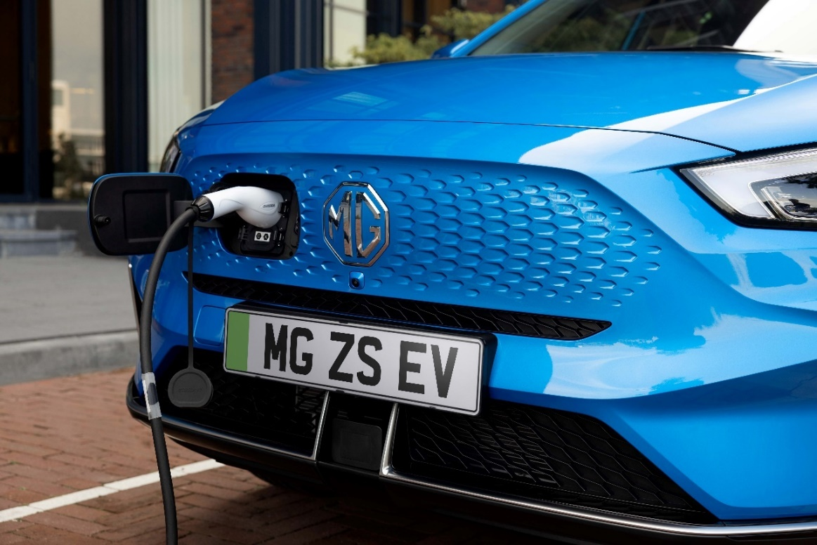

Design

With a new, electric-only front end, the MG ZS EV stands out from the crowd, with distinctive LED headlights and modernised design.
- Integrated, Colour-Coded Front Grille with discrete hidden charging port
- Bi-Function Automatic LED Headlights with 21 LED units
- Electrically Adjustable Folding Door Mirrors
- 17’’ Aerodynamic Alloy Wheels
- Five exterior colour options: Arctic White, Monument Silver (Metallic), Black Pearl (Metallic), Battersea Blue (Metallic), and Dynamic Red (Tri-Coat)
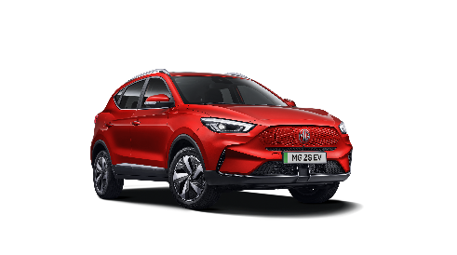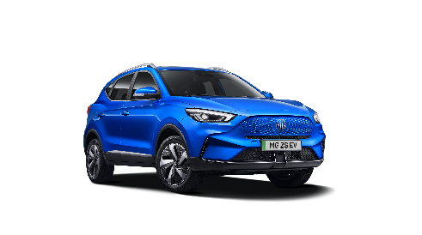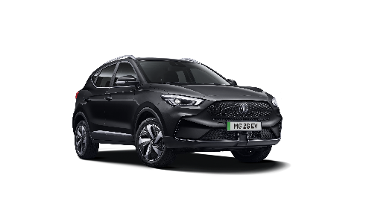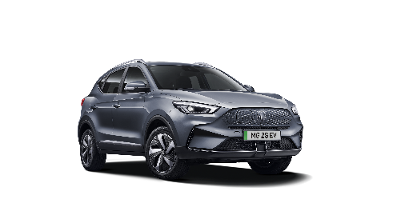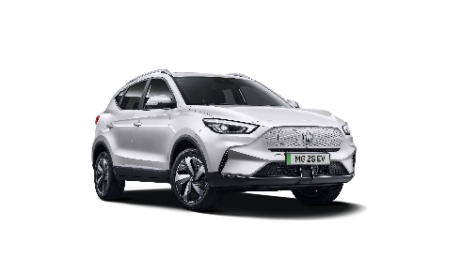

MG Pilot

As a market-leading electric family car, the MG ZS EV puts safety at the forefront of its offering. MG’s suite of driver assistance technology, MG Pilot, offers an advanced level of protection for ZS EV occupants and other road users.
MG Pilot is available as standard on all ZS EV models, featuring:
- Intelligent Speed Limit Assist
- Intelligent High Beam Assist
- Active Emergency Braking with Pedestrian and Bicycle Detection
- Lane Keep Assist with Lane Departure Warning System
- Traffic Jam Assist
- Adaptive Cruise Control
Trophy and Trophy Connect models are also equipped with Rear Cross Traffic Alert, Blind Spot Detection with Lane Change Assist.

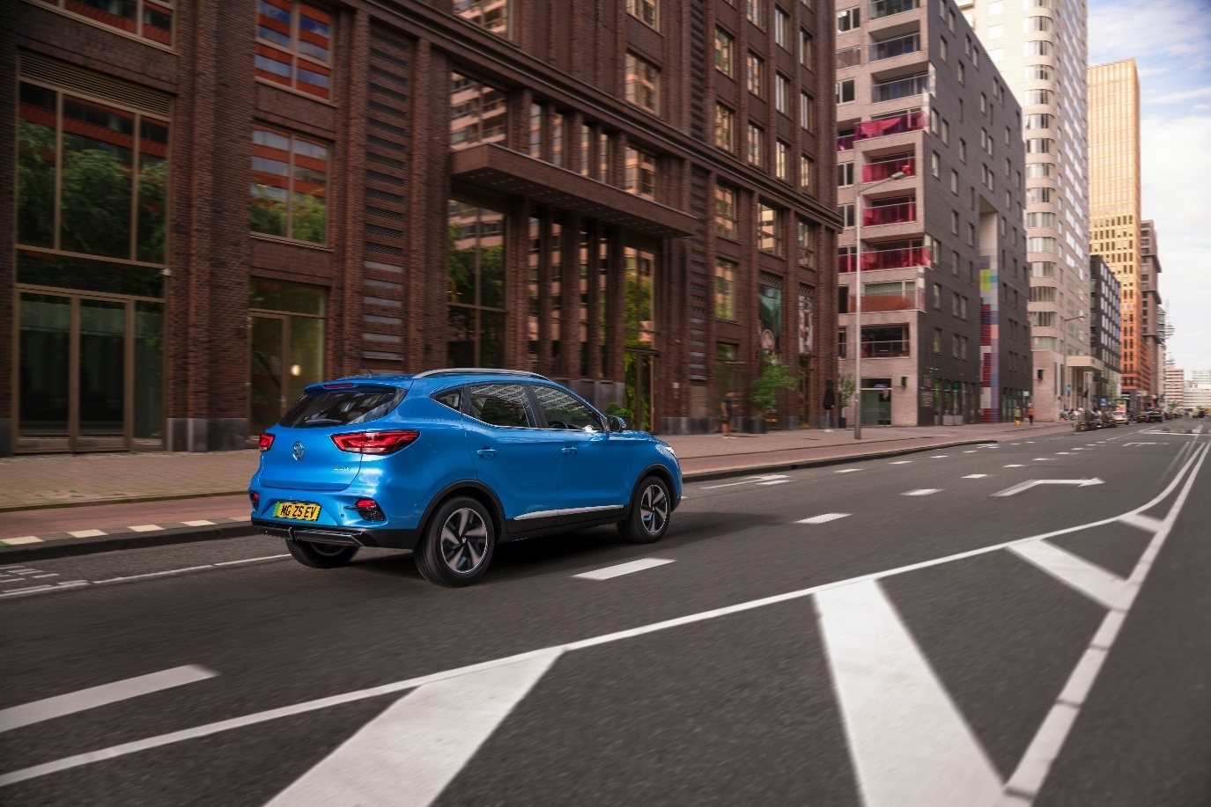

Interior & Technology

The MG ZS EV is packed with a range of features that make the cabin feel comfortable, convenient, and relaxing.
- 10.1” Colour Touchscreen with Apple CarPlay® and Android Auto® as standard
- 360° Parking Camera
- MG iSMART app allows remote charge scheduling and climate control system prestart to cool or heat the car
- Trophy and Trophy Connect models with opening Panoramic Sky Roof, Leather Style Upholstery with Contrast Stitching, 3D 6-Speaker Sound System and high-class air purification system
- Rotary Gear Selector
- Trophy and Trophy Connect models with Wireless Phone Charging

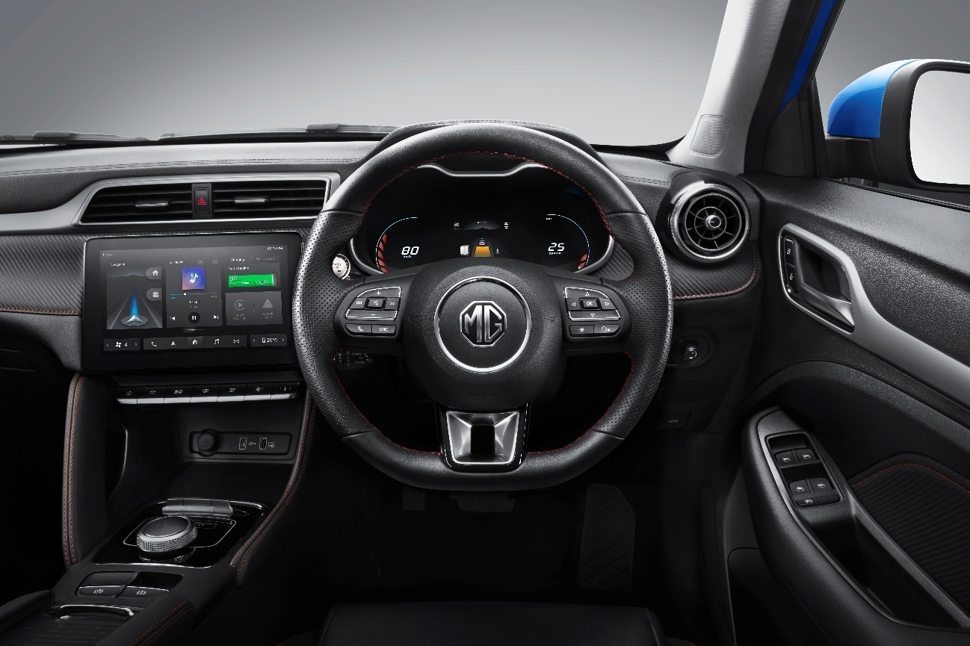

Trim levels
SE – From £27,745 after PiCG
- MG Pilot Advanced Driver Assistance Systems
- Keyless Entry with Push Button Engine Start
- 10.1" Colour Touchscreen with Apple CarPlay® and Android Auto®
- iSMART user app
- DAB+ radio with AUX/USB, MP3
- 4-Speaker Audio System
- Satellite Navigation
- Electric Parking Brake with Auto-Hold
- Automatic Air Conditioning
- Leather Steering Wheel
- Bluetooth Telephone and Audio Streaming
- Automatic Headlights
- Rear Parking Sensors
- 360° Parking Camera
- Electrically Adjustable, Folding Body Colour Door Mirrors
- 17" Propeller Alloy Wheels
- 3x USB Ports and 2x USB-C Ports
Trophy – From £29,995 after PiCG
In addition to SE
- 6-speaker Audio System with 3D sound
- Blind Spot Detection with Lane Change Assist
- Silver Roof Rails
- Electrically Adjustable, Folding, Heated Body Colour Door Mirrors
- Leather Style Upholstery with Contrast Stitching
- Electric Driver’s 6-way Adjustable Seat
- Heated Front Seats
- Rain Sensing Wipers
- Panoramic Sky Roof
- Wireless Mobile Phone Charger
Trophy Connect – From £30,495 after PiCG
In addition to Trophy
- Live Traffic Information
- Live Weather Information
- Amazon Music

Model Specifications

MG ZS EV | Standard Range | Long Range
Prices from (incl. PiCG) | £27,745 | £29,995
Power (PS) | 176 | 156
Top Speed (mph) | 108
0-60 mph (secs) | 8.0 | 8.2
Transmission / Drivetrain | 1 speed auto / FWD
Combined WLTP range (miles) | 198 | 273
Nominal Battery Capacity | 51.1 | 72.6
Estimated Charge Time to 100% on 7kW Fast Charger | 8 hrs | 10.5 hrs
Rapid Charging to 80% (50kW / 100kW) | 54 mins / 36 mins | 63 mins / 42 mins
Gross weight (kg) | 2060 | 2070

Rival Comparison

*Including PiCG.  **Using a 100kWh rapid charger. | MG ZS EV SE Long Range | 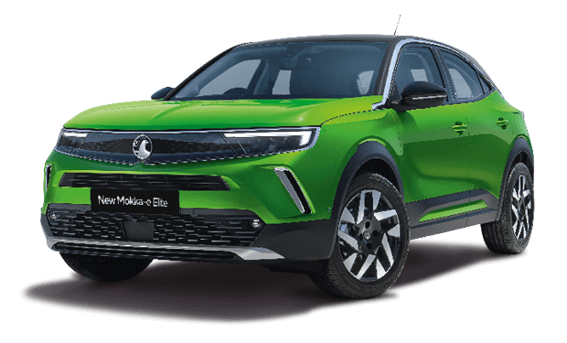  Vauxhall Mokka-e | 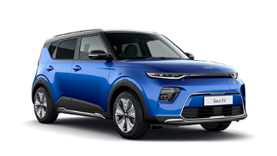  Kia Soul EV
Price from (OTR) | £29,995* | £30,840* | £34,995*
Power (PS) | 156 | 136 | 203
Top Speed (mph) | 108 | 93 | 104
0-60 mph (secs) | 8.2 | 8.7 | TBC
Transmission / Drivetrain | 1 speed auto / FWD | 1 speed auto / FWD | 1 speed auto / FWD
Combined WLTP Range (miles) | 273 | 209 | 280 (estimated)
Nominal Battery Capacity (kWh) | 72.6 | 45.0 | 64.0
Rapid Charging to 80% | 42 mins** | 35 mins** | 54 mins**
Gross weight (kg) | 2,070 | 2,015 | TBC
CO₂ Emissions (g/km) | 0 | 0 | 0

About MG

Tracing its history back to 1924, MG is the iconic British motoring brand, famous for building sporty, exciting and value-for-money cars which are always fun to drive. From the original MG 14/28 Super Sports car designed by the legendary Cecil Kimber to the all-electric MG5 EV of today, MG has always been innovative, radical and fun!
Today, MG is the fastest growing car brand in the UK, fielding a six-car range of practical and affordable hatchbacks, SWs and SUVs. Designed in Marylebone, London, and manufactured in state-of-the-art factories in several countries, today’s MGs are practical, spacious, packed with technology and perfect for modern life. With a national network of over 150 dealerships, MG is accessible to customers everywhere with professional sales and aftersales provision across the UK.
All new MGs are built with world-class components and are backed by a comprehensive manufacturer’s 7-year warranty. Well-established in the UK, MGs are now sold worldwide with western Europe being the latest region for expansion.

