PRESS INFORMATION – 13 May 2022

MG DIRECTOR NAMED UK AUTOMOTIVE OUTSTANDING LEADER
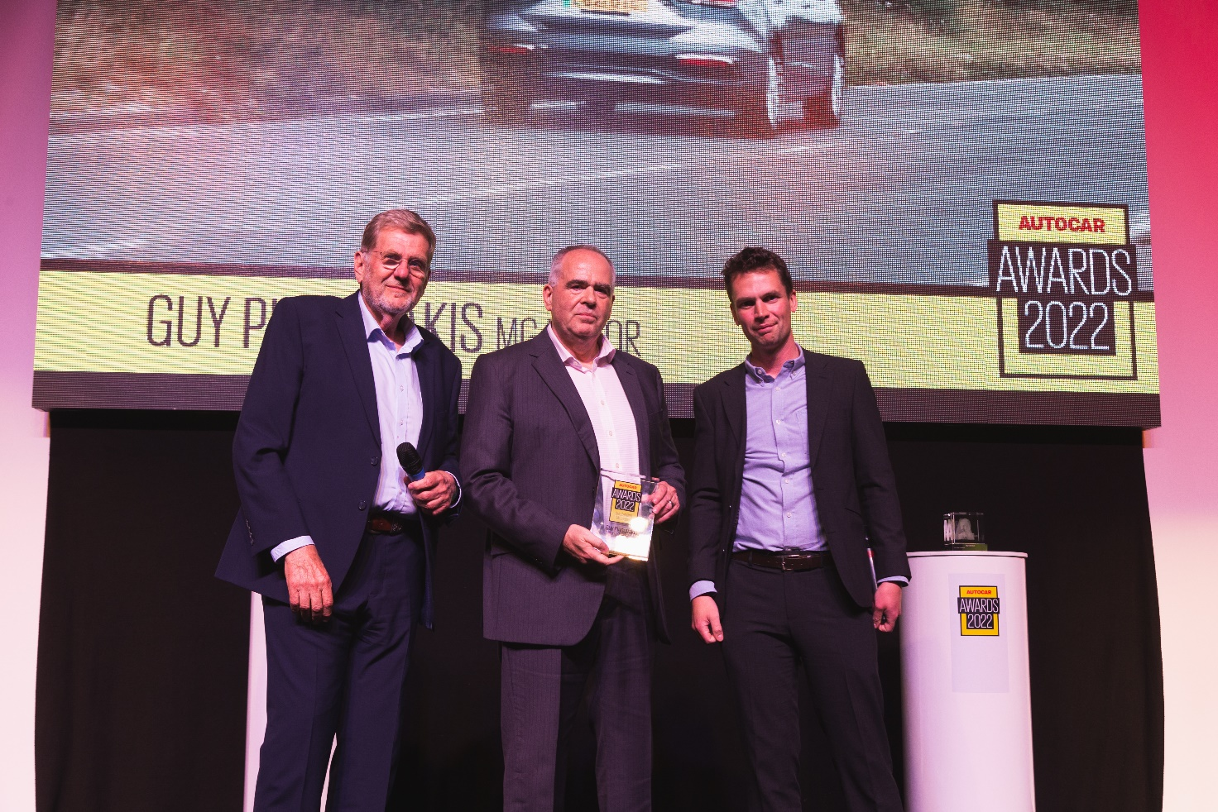

- GUY PIGOUNAKIS NAMED OUTSTANDING UK AUTOMOTIVE LEADER
- MG MOTOR UK COMMERCIAL DIRECTOR HONOURED BY AUTOCAR
- JUDGES PRAISE BRAND’S ‘METEORIC GROWTH’ UNDER GUY’S LEADERSHIP

Guy Pigounakis, Commercial Director at MG Motor UK, has been named one of the UK’s outstanding automotive leaders by the influential title Autocar.
He collected the honour at this week’s Autocar Awards at Silverstone after judges praised the exceptional skills he has shown to sustain and build the brand.
During Guy’s time with the brand, MG Motor UK has gone from strength-to-strength and is now the UK’s fastest growing mainstream car manufacturer.
Accepting his award from Autocar Editor in Chief, Steve Cropley, and Editor, Mark Tisshaw, Guy said: “I am thrilled but at the same time very humbled to have been recognised in this way.
“The success we have enjoyed as a brand and the growth we are experiencing is not down to one individual but rather a combination of factors – a fantastic product range that offers outstanding quality and exceptional value for money, and the brilliant team of people working directly for the brand and our fast-expanding network of dealer partners.”
Building on a record-breaking 2021, the marque’s success continued into the new year with registrations in January and February (4,471 units) totalling more than those for the whole of 2017.
March registrations of 9,367 were greater than the whole of 2018 and the total volume of cars registered by the brand in Q1 2022 (13,838 units) is up 124.6 percent on the first quarter of 2021.
This gives the brand a market share of 3.31 percent year-to-date, up from 1.45 percent in 2021.
But Guy told the hundreds gathered at this year’s awards that 2022 looks set to be even better still, as MG Motor UK continues its meteoric rise.
He said: “This year’s sales plan was exceeded in orders six weeks into the year. The biggest challenge is to make sure we get the production to satisfy those orders. And we’re taking between 200 and 300 orders every day, so the bank is only getting bigger. But it’s a fantastic problem to have.”
To find your local dealer, or to discover the high-tech, value-for-money range of cars on offer, please visit MG.CO.UK.
– ENDS –
Notes to editors:
About MG

Tracing its history back to 1924, MG is the iconic British motoring brand, famous for building sporty, exciting and value-for-money cars which are always fun to drive. From the original MG 14/28 Super Sports car, designed by the legendary Cecil Kimber, to the all-electric MG5 EV of today, MG has always been innovative, always been radical and always been fun!

Today, MG is the fastest growing car brand in the UK, fielding a six-car range of practical and affordable hatchbacks, SWs and SUVs. Designed in Marylebone, London, and manufactured in state-of-the-art factories in several countries, today’s MGs are practical, spacious, packed with technology and perfect for modern life. With a national network of over 150 dealerships, MG is accessible to customers everywhere with professional sales and aftersales provision across the UK.

All new MGs are built with world-class components and are backed by a comprehensive manufacturer’s 7-year warranty. Well-established in the UK, MGs are now sold worldwide with western Europe being the latest region for expansion.

For further information please contact:

HEATHER WEBB
MG Press Office
T: +44 (0)7513 121613
E: pr@mg.co.uk

