PRESS INFORMATION – 16 May 2022

EASTBOURNE SHOPPERS GET MORE AT THE MALL WITH MG
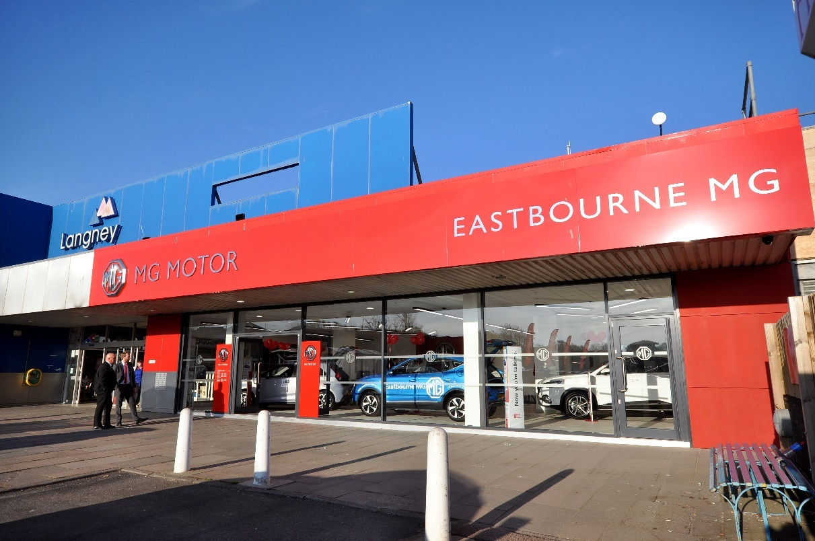

- Eastbourne MG relocates entire dealership to local shopping centre
- New outlet now provides a full service, with sales showroom, workshop and used car forecourt, following official grand opening on Saturday 14th May
Eastbourne MG Motor UK retailer has taken customer convenience to the next level by relocating its entire dealership to a nearby shopping centre.
Eastbourne MG (formerly Seaford MG) has left its traditional roadside operation to relocate to the nearby Langley Shopping Centre on Kingfisher Drive, allowing shoppers to choose their next vehicle while picking up their groceries.
The dealership’s new showroom officially opened on Saturday, located in the shopping centre itself between Tesco’s supermarket and a Domino’s pizza outlet.
Meanwhile a car park at the rear of the mall has been transformed into the dealer’s car forecourt, stocked with more than 35 quality approved used MGs.
A fully equipped workshop has also been installed in a vacant unit beneath the new showroom, offering aftersales customers the highest quality of care and attention.
The relocation is already proving a big hit with customers, with the sales team selling four new cars during its opening day.
Eastbourne MG Sales Director, Ben Smith, said: “We opened our MG franchise at our old Seaford site in 2015 and outgrew it virtually straight away.
“From day one, the franchise took off in such a way that we knew we would have to find somewhere bigger to keep up.”
He added: “It may seem like an unusual step for us to relocate to a shopping mall in this way, but the new space is absolutely perfect for us.
“It’s showcasing the brand to people who might otherwise not come into contact with it and the range of shops, restaurants and facilities on site means it’s much more convenient for customers.”
MG Motor UK Operations Director, Guy Pigounakis, said: “We’re thrilled to have a new site opening in Eastbourne, strengthening our growing network on the South Coast, but we’re especially delighted to see one of our dealers innovating in this way with its location.
“MG is a people’s brand boasting an exciting range of models that combine exceptional quality, state-of-the-art technology and the reassurance of a seven-year warranty across the board, with outstanding value for money.
“Anything a dealer can do to bring our brand to the people, such as opening a showroom where people work, play and shop, has to be welcome.”
MG Motor UK is officially the UK’s fastest-growing mainstream car brand, with registrations in the first three months of 2022 up 124.6 percent year-on-year.
This success has seen a raft of new dealer partners join the brand, with more than 40 new outlets added to the MG Motor network nationwide in the past 12 months.
To find your local dealer, or to discover the high-tech, incredibly competitive range of cars on offer, please visit MG.CO.UK.
- ENDS –
Notes to editors:

About MG

Tracing its history back to 1924, MG is the iconic British motoring brand, famous for building sporty, exciting and value-for-money cars which are always fun to drive. From the original MG 14/28 Super Sports car, designed by the legendary Cecil Kimber, to the all-electric MG5 EV of today, MG has always been innovative, always been radical and always been fun!

Today, MG is the fastest growing car brand in the UK, fielding a six-car range of practical and affordable hatchbacks, SWs and SUVs. Designed in Marylebone, London, and manufactured in state-of-the-art factories in several countries, today’s MGs are practical, spacious, packed with technology and perfect for modern life. With a national network of over 150 dealerships, MG is accessible to customers everywhere with professional sales and aftersales provision across the UK.

All new MGs are built with world-class components and are backed by a comprehensive manufacturer’s 7-year warranty. Well-established in the UK, MGs are now sold worldwide with western Europe being the latest region for expansion.

For further information please contact:

HEATHER WEBB
MG Press Office
T: +44 (0)3301 756940
E: pr@mg.co.uk

www.mg.co.uk

