PRESS INFORMATION – 31 MARCH 2022

MG MOTOR UK CROWNED FLEET WORLD’S RISING STAR

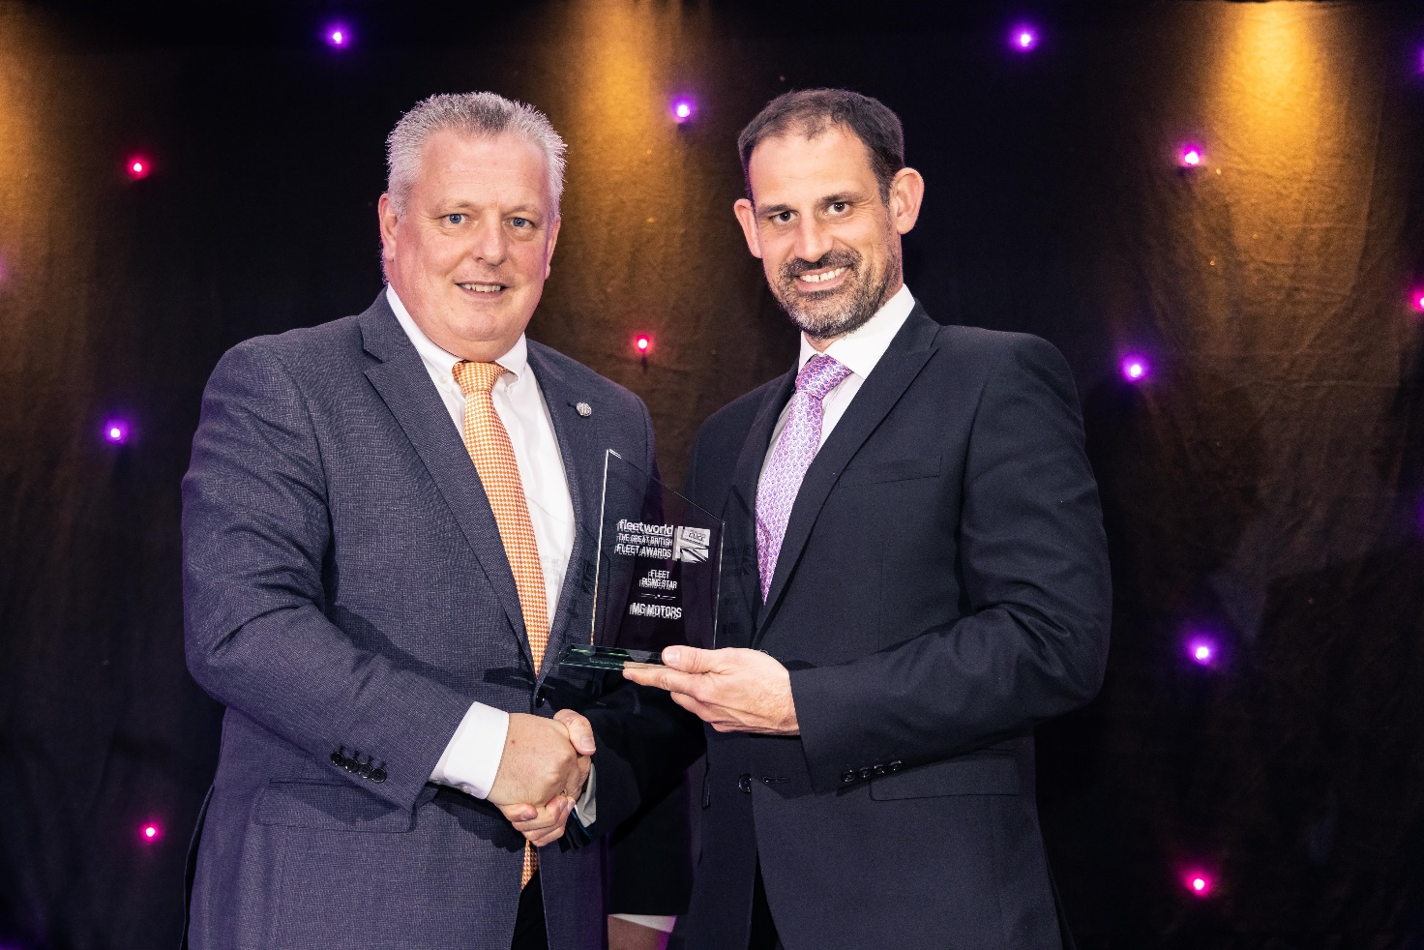

- MG Motor UK wins coveted Fleet World Rising Star Award
- Award recognises the brand’s growth as well as improvements to its fleet operation
- MG ZS EV and MG5 also highly commended by Fleet World judges

MG Motor UK’s growing reputation as a fleet manufacturer of choice was further strengthened this week when the brand was named Fleet Rising Star of the Year in the Fleet World Great British Fleet Awards 2022.
The coveted honour recognises MG’s fast-growing fleet presence and the huge improvements made across the board to its fleet operation.
Two models from the brand’s fleet-friendly line-up – the MG ZS EV and MG5 – were also highly commended by Fleet World judges.
Presenting the Rising Star award, John Challen, Editor of Fleet World, praised MG’s performance and said the brand was the only name in the frame for the Rising Star title.
He added: "MG has gained a reputation for bringing cost-effective, reliable and impressive vehicles to market. With a growing number of EVs set to launch, the company’s fortunes are only going in one direction in the years ahead."
Commenting on the award win, Geraint Isaac, MG’s Head of Fleet, said: “We are delighted to have won this award and it is further evidence that MG’s reputation as a fleet manufacturer is consistently growing.
“The MG brand is really resonating with fleet customers with the right line-up of models available, at the right price, at the right time and now with the right level of specialist fleet support and aftersales back-up.
“Because of this you will see MG continue to grow as a fleet manufacturer over the coming years and there are very exciting times ahead.”
He added: “This award is real recognition of the hard work and dedication put in by our small but super professional and experienced team. Their passion for the brand is really reflected in the quality of service our fleet customers have come to expect.”
Judged by an expert panel of Fleet World Group editors, the awards cover 39 categories and recognise latest developments and innovations amid a year awash with ingenuity.
For more information about the latest MG fleet offerings, click here.
– ENDS –
Notes to editors:
Caption: MG Motor UK Head of Fleet, Geraint Isaac (left), receives the Rising Star Award from Fleet World Editor, John Challen.
About MG

Tracing its history back to 1924, MG is the iconic British motoring brand, famous for building sporty, exciting and value-for-money cars which are always fun to drive. From the original MG 14/28 Super Sports car, designed by the legendary Cecil Kimber, to the all-electric MG5 EV of today, MG has always been innovative, always been radical and always been fun!

Today, MG is the fastest growing car brand in the UK, fielding a six-car range of practical and affordable hatchbacks, SWs and SUVs. Designed in Marylebone, London, and manufactured in state-of-the-art factories in several countries, today’s MGs are practical, spacious, packed with technology and perfect for modern life. With a national network of over 150 dealerships, MG is accessible to customers everywhere with professional sales and aftersales provision across the UK.

Backed by SAIC Motor, one of the world’s largest automotive companies, all new MGs are built with world-class components and are backed by a comprehensive manufacturer’s 7-year warranty. Well-established in the UK, MGs are now sold worldwide with western Europe being the latest region for expansion.

For further information please contact:

JASMINE JIANG
Event Marketing Manager, MG Motor
T: +44 (0)7443 071138
E: lin.jiang@mg.co.uk

MAL HAY
MG Press Office
T: +44 (0)7899 992871
E: pr@mg.co.uk

HEATHER WEBB
MG Press Office
T: +44 (0)7513 121613
E: pr@mg.co.uk

