PRESS INFORMATION – 6 APRIL 2022

MG MOTOR UK BREAKS MORE SALES RECORDS IN Q1
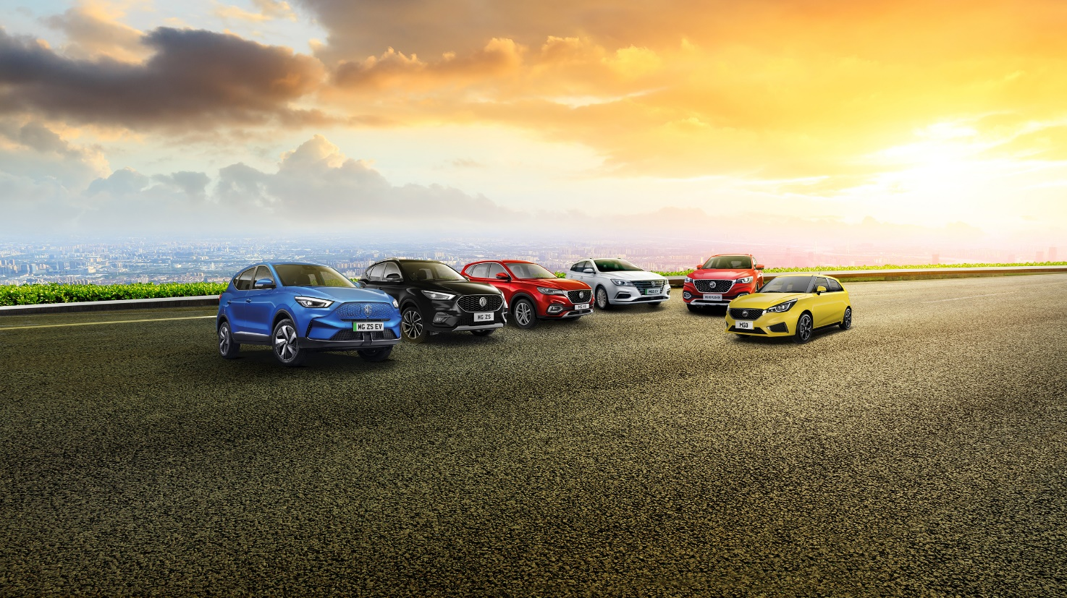

- MG Motor UK builds on record-breaking 2021 with stellar Q1 sales results
- Brand’s sales for first three months of the year exceed those for the whole of 2019
- Figure represents growth of 124.6 percent year-on-year
- MG Motor UK remains the nation’s fastest-growing mainstream car brand

MG Motor UK has underlined its position has the nation’s fastest-growing car brand after posting another set of stellar sales figures.
Building on a record-breaking 2021, the marque’s success continued into the new year with registrations in January and February (4,471 units) totalling more than those for the whole of 2017 (4,471 units).
March registrations of 9,367 were greater than the whole of 2018 and the total volume of cars registered by the brand in Q1 2022 (13,838 units) is up 124.6 percent on the first quarter of 2021.
According to the latest figures published by SMMT (Society of Motor Manufacturers and Traders) yesterday, this gives the brand a market share of 3.31 percent year-to-date, up from 1.45 percent in 2021.
Growth was seen across all drivetrains offered by the brand, with petrol sales up 155 percent, PHEV up 441 percent and pure electric up 40 percent. The MG ZS was the brand’s biggest seller, accounting for 29 percent of sales or 4,042 units.
This performance ensures MG remains one of the UK’s most compelling investment opportunities for automotive franchises, with more than 39 new dealer partners joining its network in the past 12 months. This includes some of the nation’s biggest dealer groups like Vertu Motors, RRG and Arnold Clark.
Guy Pigounakis, Commercial Director at MG Motor UK, said: “We are absolutely thrilled with the results we have achieved in the first quarter and that the incredible momentum we built in over the course of a record-breaking 2021 has carried into the new year.
“We are particularly pleased because it means that our core message of cutting edge technology, great quality and exciting cars all at an affordable price is clearly resonating with our target demographic.”
He added: “With two important new models set to launch in the UK later this year we fully expect 2022 to be another year of spectacular growth.”
MG currently offers six models in the UK including three plug-in cars – the New MG ZS EV, the New MG5 EV and MG HS Plug-in Hybrid - all backed up by MG’s comprehensive manufacturer’s 7-year warranty and rapidly developing dealer network.
To find your local dealer, or to discover the high-tech, value-for-money range of cars on offer, please visit MG.CO.UK.
– ENDS –
Notes to editors:
About MG

Tracing its history back to 1924, MG is the iconic British motoring brand, famous for building sporty, exciting and value-for-money cars which are always fun to drive. From the original MG 14/28 Super Sports car, designed by the legendary Cecil Kimber, to the all-electric MG5 EV of today, MG has always been innovative, always been radical and always been fun!

Today, MG is the fastest growing car brand in the UK, fielding a six-car range of practical and affordable hatchbacks, SWs and SUVs. Designed in Marylebone, London, and manufactured in state-of-the-art factories in several countries, today’s MGs are practical, spacious, packed with technology and perfect for modern life. With a national network of over 150 dealerships, MG is accessible to customers everywhere with professional sales and aftersales provision across the UK.

Backed by SAIC Motor, one of the world’s largest automotive companies, all new MGs are built with world-class components and are backed by a comprehensive manufacturer’s 7-year warranty. Well-established in the UK, MGs are now sold worldwide with western Europe being the latest region for expansion.

For further information please contact:

MAL HAY
MG Press Office
T: +44 (0)7899 992871
E: pr@mg.co.uk

HEATHER WEBB
MG Press Office
T: +44 (0)7513 121613
E: pr@mg.co.uk

