PRESS INFORMATION – FOR IMMEDIATE RELEASE
4 MARCH 2022

THIAGO CHARGES AHEAD WITH NEW ELECTRIC MG

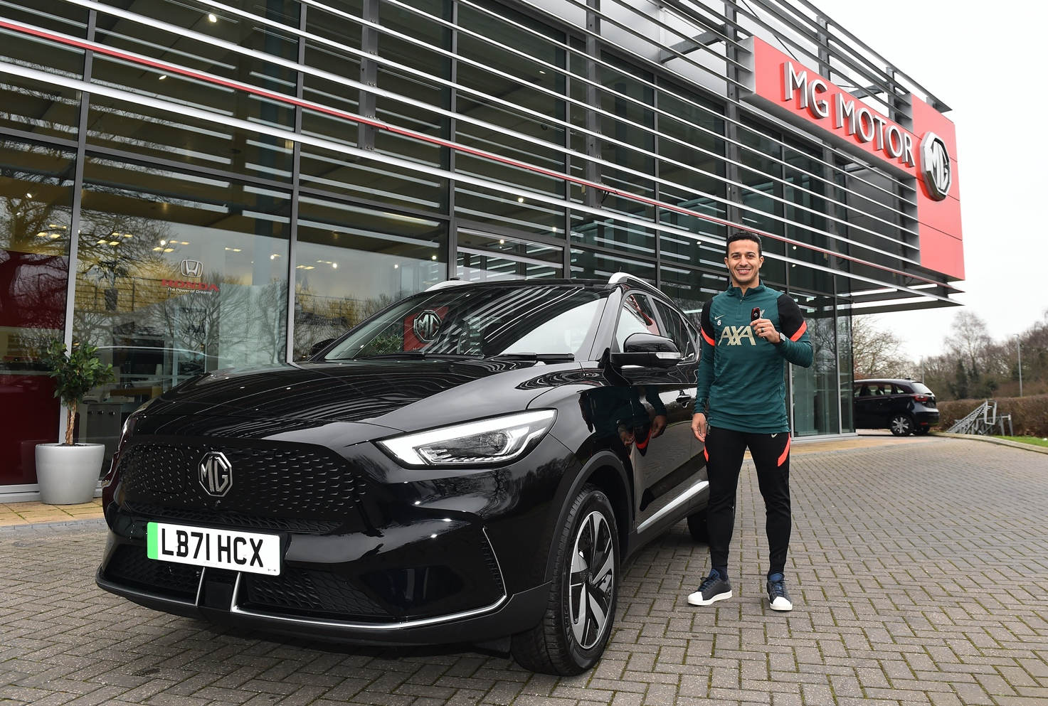

- Liverpool FC star midfielder Thiago Alcântara takes delivery of new MG ZS EV
- Anfield ace favours emissions-free motoring
- ZS EV in showrooms now, from just £27,495 (after PiCG)

Liverpool FC’s star midfielder, Thiago Alcântara, has taken delivery of a brand new MG ZS EV Trophy Long Range.
The Spanish international is more used to charging through the opposition defence than he is charging an electric car, but he is looking forward to emissions-free motoring.
He said: “I really wanted to try an EV and it was the perfect chance to do it alongside our partner MG. I think it is important to be aware as a society of sustainable driving to preserve our planet. With the ZS EV, I’ve found versatility and comfort for every day.””
The ZS EV is an ideal choice for Thiago, who is a father-of-two, as it offers the perfect combination of family-friendly motoring and zero exhaust emissions. It also reflects a relationship that has seen MG become a staunch supporter of Liverpool FC in recent years.
Thiago collected his new MG from one of the brand’s newest dealerships, the Holdcroft Cheshire Oaks MG site near Ellesmere Port, which opened in 2021.
Franchise Director Kevin Williams said: “It was an absolute delight to welcome Thiago to our dealership to collect his new MG. He was a lovely guy, and we wish him every enjoyment and happiness with his new car, as well as his football career.”
On-sale now, the ZS EV is available in both Standard and Long Range variants, offering a range of either 198 or 273 miles, and in three trim levels, priced from £27,495 (after PiCG).
MG currently offers six models in the UK including three plug-in cars – the New MG ZS EV, the New MG5 EV and MG HS Plug-in Hybrid - all backed up by MG’s comprehensive manufacturer’s 7-year warranty and rapidly developing dealer network.
To find your local dealer, or to discover the high-tech, value-for-money range of cars on offer, please visit MG.CO.UK.
- ENDS –
Notes to editors:

About MG

Tracing its history back to 1924, MG is the iconic British motoring brand, famous for building sporty, exciting and value-for-money cars which are always fun to drive. From the original MG 14/28 Super Sports car, designed by the legendary Cecil Kimber, to the all-electric MG5 EV of today, MG has always been innovative, always been radical and always been fun!

Today, MG is the fastest growing car brand in the UK, fielding a six-car range of practical and affordable hatchbacks, SWs and SUVs. Designed in Marylebone, London, and manufactured in state-of-the-art factories in several countries, today’s MGs are practical, spacious, packed with technology and perfect for modern life. With a national network of over 130 dealerships, MG is accessible to customers everywhere with professional sales and aftersales provision across the UK.

Backed by SAIC Motor, one of the world’s largest automotive companies, all new MGs are built with world-class components and are backed by a comprehensive manufacturer’s 7-year warranty. Well-established in the UK, MGs are now sold worldwide with western Europe being the latest region for expansion.

For further information please contact:

JASMINE JIANG
Event Marketing Manager, MG Motor
T: +44 (0)7443 071138
E: lin.jiang@mg.co.uk

CRAIG CHEETHAM
MG Press Office
T: +44 (0)7900 085571
E: craig@crccreative.co.uk

www.mg.co.uk

