PRESS INFORMATION – 24 FEB 2022

MG MOTOR UK EXPANDS IN EDINBURGH WITH NEW MACKLIN MOTORS SITE

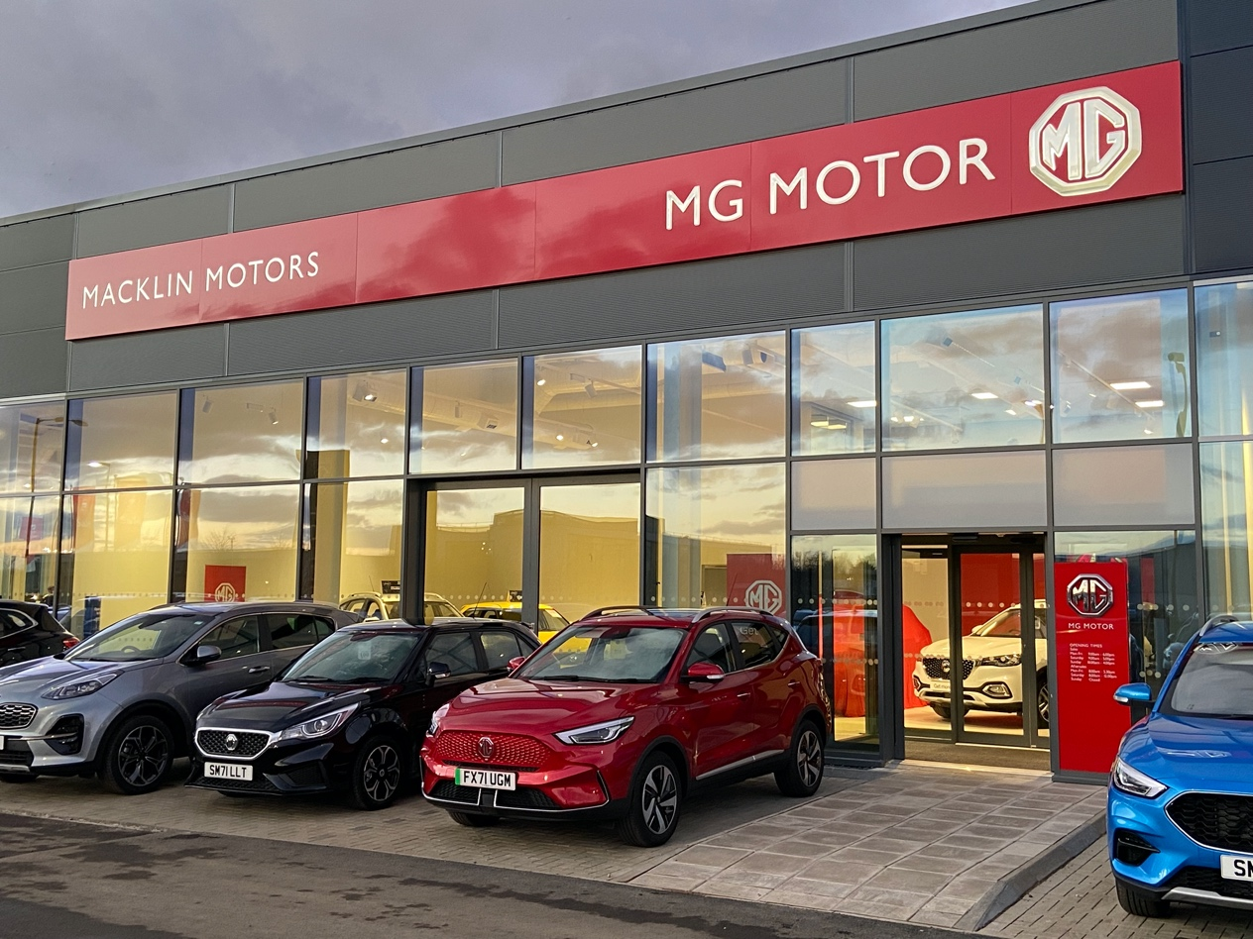

- MG Motor takes pride of place in new Macklin Motors sales site
- Move follows over 40 new dealers joining the brand in past 12 months
- Multi-million pound investment sees new dealership in high profile location
- MG achieved record 30,600 sales in 2021
- All MGs covered by 7 year warranty

A brand new MG Motor UK dealership has opened in Edinburgh following a £5m investment by Vertu Motors plc in a new multi-franchise Macklin Motors site.

Macklin MG Edinburgh Newbridge is situated just outside of the Scottish capital, alongside the M9 motorway, and will carry the full range of new and used MG cars as well as offering on-site EV charging, specialist advice to Motability customers, vehicle servicing and full aftersales support.
The site has a 16-bay service area and has created 14 new jobs, along with two apprenticeships. The dealership benefits from all the latest technology, including automatic number plate recognition, which notifies the service centre to a customer’s arrival and begins the check-in process the moment they reach the site.
MG Motor Commercial Director, Guy Pigounakis, added: “We are thrilled to once again partner with Vertu Motors plc as we develop our relationship and further our growth in Scotland, not least because EV registrations in Scotland grew by over 75% last year. We’re well-positioned to help Scottish motorists further their uptake of electric cars with a great value, high quality range of plug-in vehicles, alongside a line-up of excellent petrol models.”
Joe McCauley (left), General Manager at Macklin Motors Edinburgh Newbridge, said: “Prior to the seven-month long build programme, the location was an undeveloped plot overlooking the M9 motorway. Now it is a state-of-the-art workplace we can all be proud of and a welcoming modern space for customers.
“Moving into our new home is a fantastic way to begin 2022 and I’m looking forward to working with colleagues, old and new, to welcome customers and show them everything we have on offer.”
MG currently offers six models in the UK and Northern Ireland including three plug-in cars – the new MG ZS EV, the New MG5 EV and MG HS Plug-in Hybrid - all backed up by MG’s comprehensive 7 year warranty and fast-developing dealer network.
To find your local dealer, or to discover the high-tech, value-for-money range of cars on offer, please visit MG.CO.UK.
- ENDS –
Picture caption: (L-R) Joe McCauley (General Manager), Richie Anderson (Sales Manager), Macklin Motors MG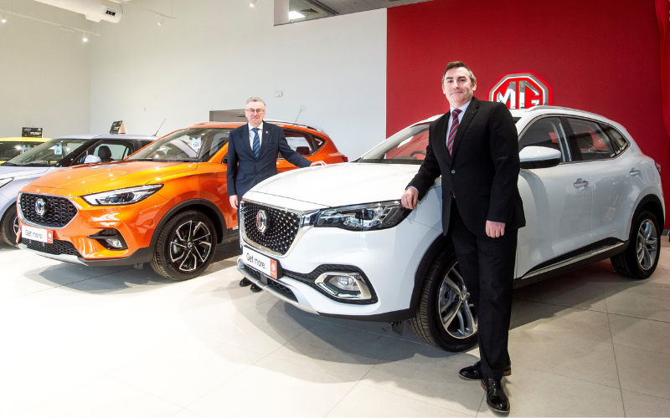
Notes to editors:

About MG

Tracing its history back to 1924, MG is the iconic British motoring brand, famous for building sporty, exciting and value-for-money cars which are always fun to drive. From the original MG 14/28 Super Sports car, designed by the legendary Cecil Kimber, to the all-electric MG5 EV of today, MG has always been innovative, always been radical and always been fun!

Today, MG is the fastest growing car brand in the UK, fielding a six-car range of practical and affordable hatchbacks, SWs and SUVs. Designed in Marylebone, London, and manufactured in state-of-the-art factories in several countries, today’s MGs are practical, spacious, packed with technology and perfect for modern life. With a national network of over 140 dealerships, MG is accessible to customers everywhere with professional sales and aftersales provision across the UK.

Backed by SAIC Motor, one of the world’s largest automotive companies, all new MGs are built with world-class components and are backed by a comprehensive manufacturer’s 7-year warranty. Well-established in the UK, MGs are now sold worldwide with western Europe being the latest region for expansion.

For further information please contact:

JASMINE JIANG
Event Marketing Manager, MG Motor
T: +44 (0)7443 071138
E: lin.jiang@mg.co.uk

CRAIG CHEETHAM
MG Press Office
T: +44 (0)7900 085571
E: craig@crccreative.co.uk

www.mg.co.uk

