PRESS INFORMATION – 11 FEB 2022

CHORLEY GROUP MG RELOCATES FOR MULTI-MILLION POUND MAKEOVER

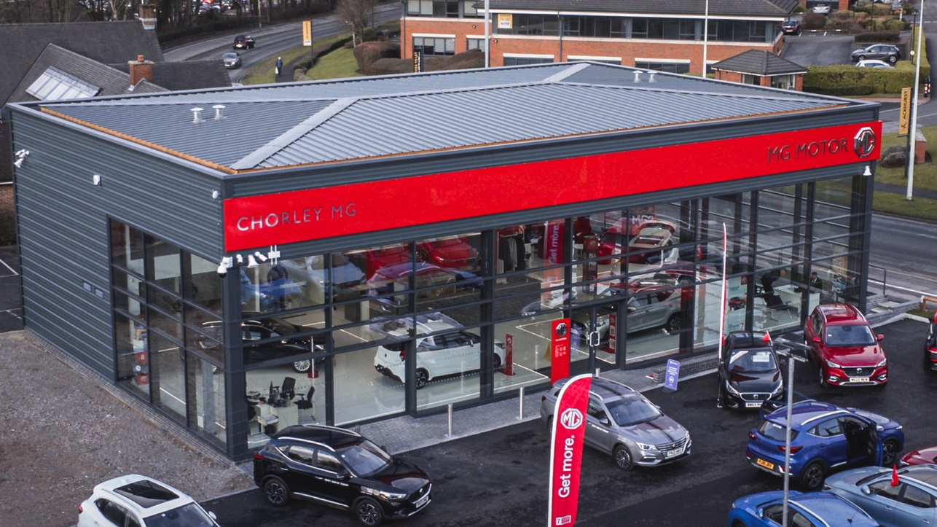

- Chorley MG relocates to substantial new site
- Dealership space more than triples following MG sales success
- Chorley sold over 360 MGs in 2021
- Move follows over 40 new dealers joining the brand in past 12 months

One of the best-loved dealer groups in the North West is expanding its relationship with MG following a year of successful growth.
Chorley MG in Lancashire delivered over 650 new cars for MG in 2021 and has subsequently expanded and invested in a much bigger and bolder site.
The new site, just 200 metres away from the old dealership on Foxhole Road, Chorley, can hold up to seven vehicles in its showroom display and has a dedicated servicing, aftersales and dual class seven MOT bay.
The state-of-the-art site carries a range of new and used cars and has on-site EV charging.
Adam Turner, Chorley Group Managing Director, said: “We are really proud to continue our investment in the local community and the MG brand. The exponential growth of the MG brand in the UK has been incredible and enabled us to make this statement investment in the flagship store. Our growth plans are matched by MG’s bold ambitions, and we look forward to continuing to grow with them.”
MG Motor Commercial Director, Guy Pigounakis, added: “We are delighted to witness the opening of the new Chorley MG site and, of course, the substantial investment this represents from Chorley Group’s shareholders. They are one of our consistently best-performing dealerships with a clear commitment to the brand and strong family-run values that offer the absolute best to MG customers and our ongoing partnership.”
MG currently offers six models in the UK including three plug-in cars – the new MG ZS EV, the New MG5 EV and MG HS Plug-in Hybrid - all backed up by MG’s comprehensive 7 year warranty and fast-developing dealer network.
- ENDS –
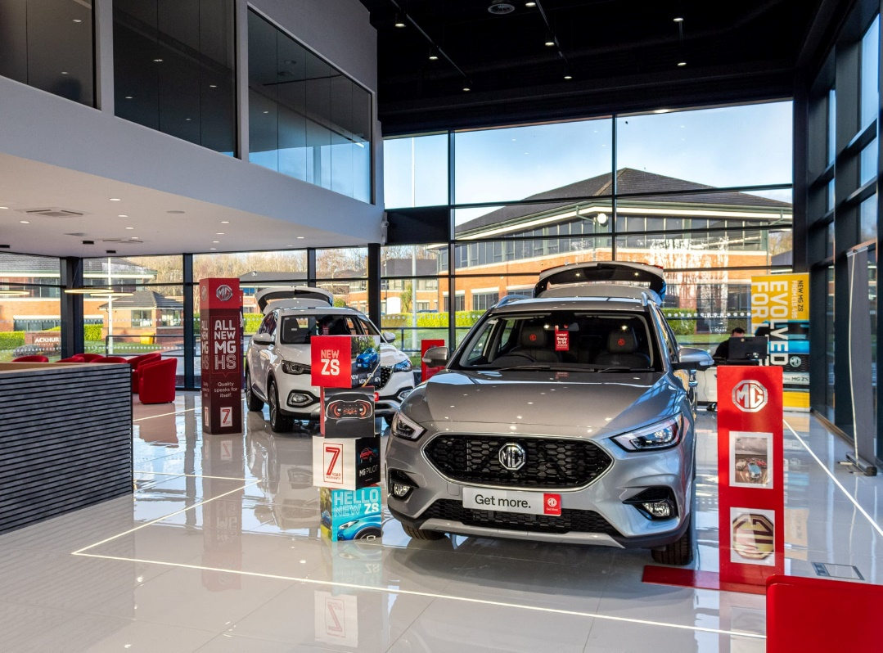
Notes to editors:

About MG

Tracing its history back to 1924, MG is the iconic British motoring brand, famous for building sporty, exciting and value-for-money cars which are always fun to drive. From the original MG 14/28 Super Sports car, designed by the legendary Cecil Kimber, to the all-electric MG5 EV of today, MG has always been innovative, always been radical and always been fun!

Today, MG is the fastest growing car brand in the UK, fielding a six-car range of practical and affordable hatchbacks, SWs and SUVs. Designed in Marylebone, London, and manufactured in state-of-the-art factories in several countries, today’s MGs are practical, spacious, packed with technology and perfect for modern life. With a national network of over 130 dealerships, MG is accessible to customers everywhere with professional sales and aftersales provision across the UK.

Backed by SAIC Motor, one of the world’s largest automotive companies, all new MGs are built with world-class components and are backed by a comprehensive manufacturer’s 7-year warranty. Well-established in the UK, MGs are now sold worldwide with western Europe being the latest region for expansion.

For further information please contact:

JASMINE JIANG
Event Marketing Manager, MG Motor
T: +44 (0)7443 071138
E: lin.jiang@mg.co.uk

CRAIG CHEETHAM
MG Press Office
T: +44 (0)7900 085571
E: craig@crccreative.co.uk

www.mg.co.uk

