PRESS INFORMATION – XX FEB 2022

MG MOTOR UK AND UNITY AUTOMOTIVE DRIVE GROWTH WITH NEW DEALERSHIP IN COVENTRY

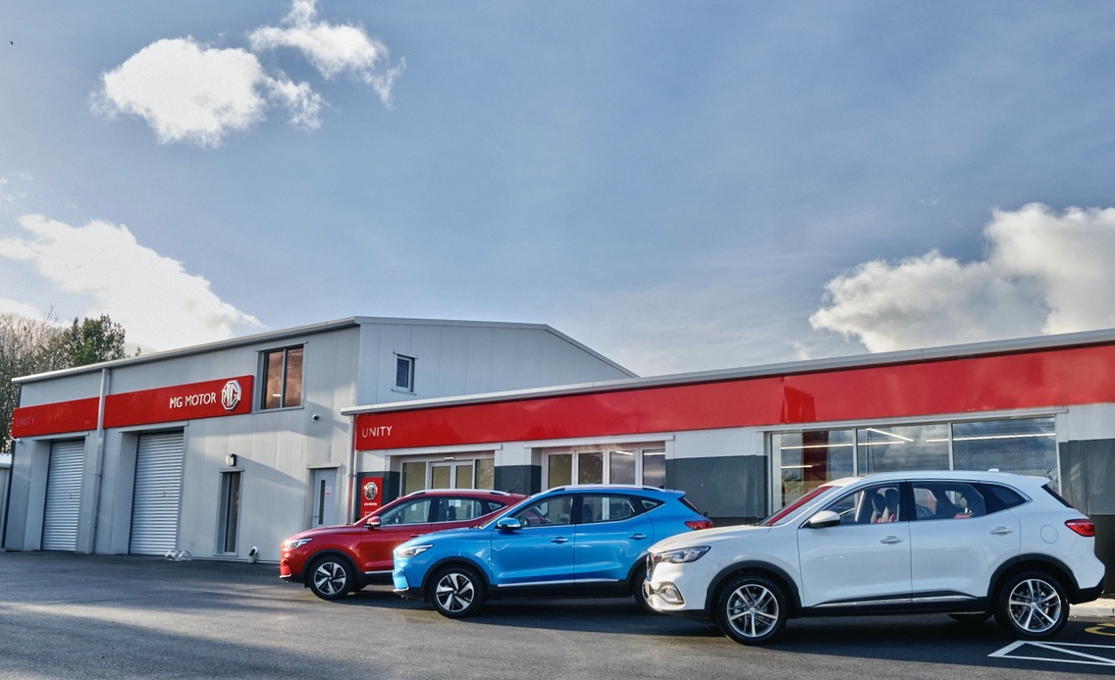

- MG Motor and Unity Automotive open new showroom in Coventry
- Move follows over 40 new dealers joining the brand in past 12 months
- EV leadership and great value proposition make MG a highly desirable franchise
- MG saw record sales of 30,600 in 2021
- All MGs covered by 7 year warranty

A brand-new MG Motor UK dealership has opened its doors in the heartland of the British car industry.
Unity MG of Coventry is now operating from a new site in Balsall Common, just off the busy A46/A45 Ring Road intersection near Ryton-on-Dunsmore.
The newly-built site will carry a range of new and used cars as well as offering on-site EV charging, servicing and aftersales, along with the full range of MG vehicles, dedicated service and MOT bays and will also provide specialist advice to Motability customers.
Elliot Cartwright, Sales and Marketing Director for Unity Automotive, said: “We are delighted to be partnering with MG at this exciting time, as both Unity Automotive and MG Motor are growing rapidly. MG, especially with its electric models, is a brand that fits well into our business in the busy West Midlands, where the historic MG brand is well-loved and regarded.”
MG Motor Commercial Director, Guy Pigounakis, added: “We are very pleased to welcome Unity into the MG family with its Coventry site, which is a fantastic opportunity to work together on increasing MG’s market presence. The location is a great strategic fit for our network, helping us to reach an even wider customer base right in the heart of the country.”
MG currently offers six models in the UK including three plug-in cars – the new MG ZS EV, the New MG5 EV and MG HS Plug-in Hybrid - all backed up by MG’s comprehensive 7 year warranty and fast-developing dealer network.
To find your local dealer, or to discover the high-tech, value-for-money range of cars on offer, please visit MG.CO.UK.
- ENDS –
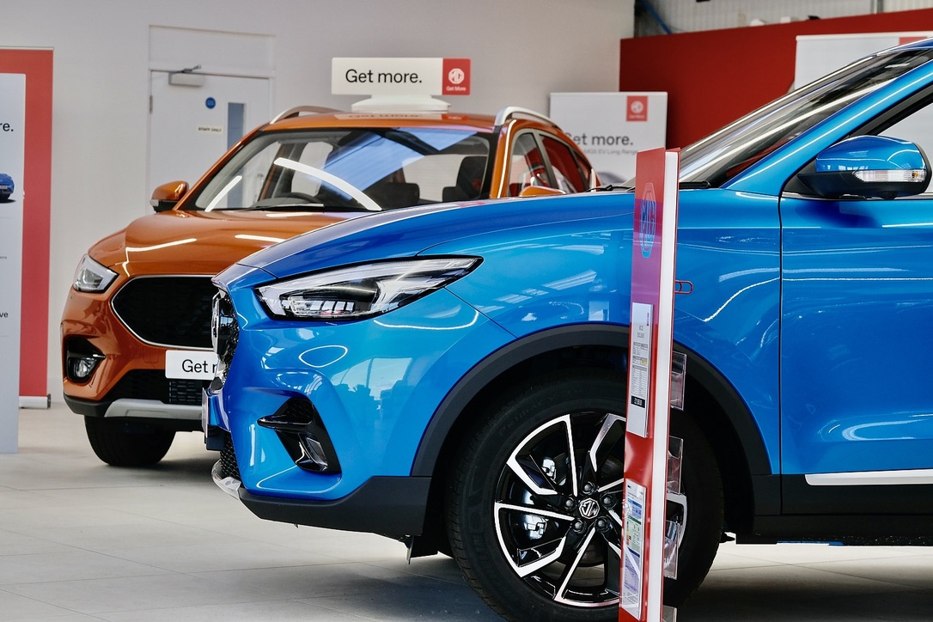
Notes to editors:

About MG

Tracing its history back to 1924, MG is the iconic British motoring brand, famous for building sporty, exciting and value-for-money cars which are always fun to drive. From the original MG 14/28 Super Sports car, designed by the legendary Cecil Kimber, to the all-electric MG5 EV of today, MG has always been innovative, always been radical and always been fun!

Today, MG is the fastest growing car brand in the UK, fielding a six-car range of practical and affordable hatchbacks, SWs and SUVs. Designed in Marylebone, London, and manufactured in state-of-the-art factories in several countries, today’s MGs are practical, spacious, packed with technology and perfect for modern life. With a national network of over 130 dealerships, MG is accessible to customers everywhere with professional sales and aftersales provision across the UK.

Backed by SAIC Motor, one of the world’s largest automotive companies, all new MGs are built with world-class components and are backed by a comprehensive manufacturer’s 7-year warranty. Well-established in the UK, MGs are now sold worldwide with western Europe being the latest region for expansion.

For further information please contact:

JASMINE JIANG
Event Marketing Manager, MG Motor
T: +44 (0)7443 071138
E: lin.jiang@mg.co.uk

CRAIG CHEETHAM
MG Press Office
T: +44 (0)7900 085571
E: craig@crccreative.co.uk

www.mg.co.uk

