PRESS INFORMATION – FOR IMMEDIATE RELEASE
9 DECEMBER 2021

MG MOTOR UK WINS MAJOR WEBSITE AWARD

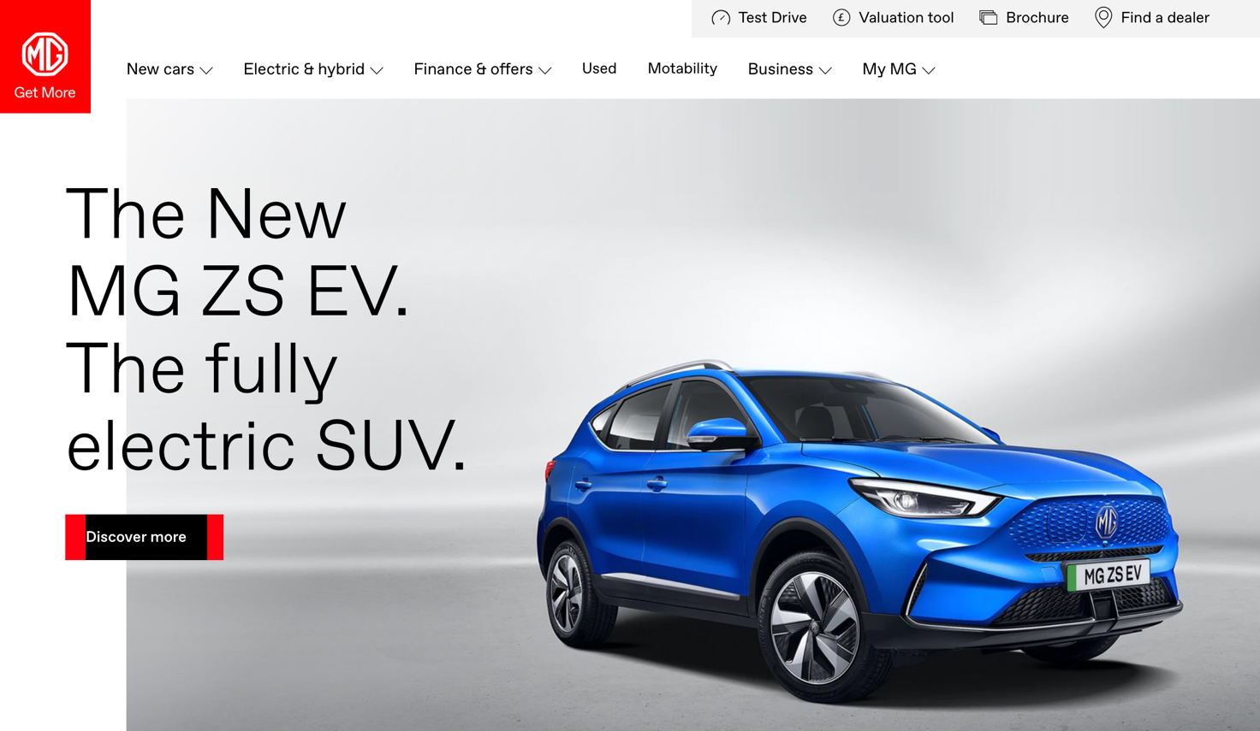

- MG Motor UK wins ‘Best Website Redesign’ in ContentSquare awards
- New customer website won top prize among 200 entries
- MG praised for its mobile-first approach and understanding of customers
The brand-new MG Motor UK website has won a top industry award just weeks after being launched to the public.
The UK’s fastest-growing mainstream car brand took the ‘Best Website Redesign’ accolade in the ContentSquare CX Awards, which judges the customer experience element of consumer-facing websites, taking in everything from design to simplicity of use, interactive features, navigability and functionality – in short, the whole customer experience.
MG was shortlisted in the top three alongside Mazda and TSB, with entries to the awards coming from all industries.
Category Judge Fiona Shaughnessy said: “MG has done a great job in the redesign, starting from the voice of the customers they clearly understood the assignment and delivered a mobile-first approach.”
Accepting the award, MG Motor UK’s Head of Digital, Patrick Beyer, said: ““We are so proud to receive this award out of so many entries across all industries as it shows just how customer-focused and appealing MG has become as a brand.
“As we continue our incredible growth, delivering the best customer experience possible is absolutely core to what we do. That applies just as much to the digital experience of MG cars as it does to the ownership experience, and this accolade goes to show that we’re currently at the top of our game in every element of our business.”
MG currently offers six models in the UK including three plug-in cars – the New MG ZS EV, the New MG5 EV and MG HS Plug-in Hybrid - all backed up by MG’s comprehensive manufacturer’s 7-year warranty and rapidly developing dealer network.
To find your local dealer, or to discover the high-tech, value-for-money range of cars on offer, please visit MG.CO.UK.
- ENDS –
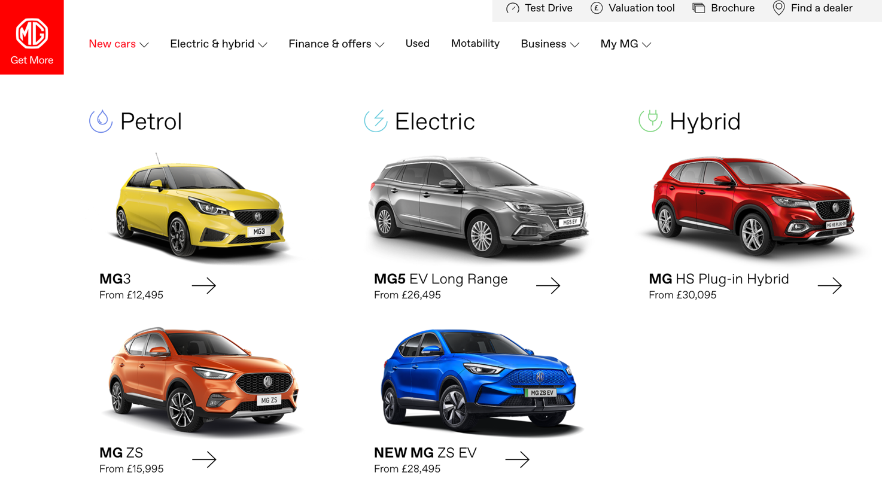
Notes to editors:

About MG

Tracing its history back to 1924, MG is the iconic British motoring brand, famous for building sporty, exciting and value-for-money cars which are always fun to drive. From the original MG 14/28 Super Sports car, designed by the legendary Cecil Kimber, to the all-electric MG5 EV of today, MG has always been innovative, always been radical and always been fun!

Today, MG is the fastest growing car brand in the UK, fielding a six-car range of practical and affordable hatchbacks, SWs and SUVs. Designed in Marylebone, London, and manufactured in state-of-the-art factories in several countries, today’s MGs are practical, spacious, packed with technology and perfect for modern life. With a national network of over 130 dealerships, MG is accessible to customers everywhere with professional sales and aftersales provision across the UK.

Backed by SAIC Motor, one of the world’s largest automotive companies, all new MGs are built with world-class components and are backed by a comprehensive manufacturer’s 7-year warranty. Well-established in the UK, MGs are now sold worldwide with western Europe being the latest region for expansion.

For further information please contact:

JASMINE JIANG
Event Marketing Manager, MG Motor
T: +44 (0)7443 071138
E: lin.jiang@mg.co.uk

CRAIG CHEETHAM
MG Press Office
T: +44 (0)7900 085571
E: craig@crccreative.co.uk

www.mg.co.uk

