PRESS INFORMATION – 21 JAN 2022

MG5 EV TAKES DOUBLE HONOURS IN WHAT CAR? AWARDS

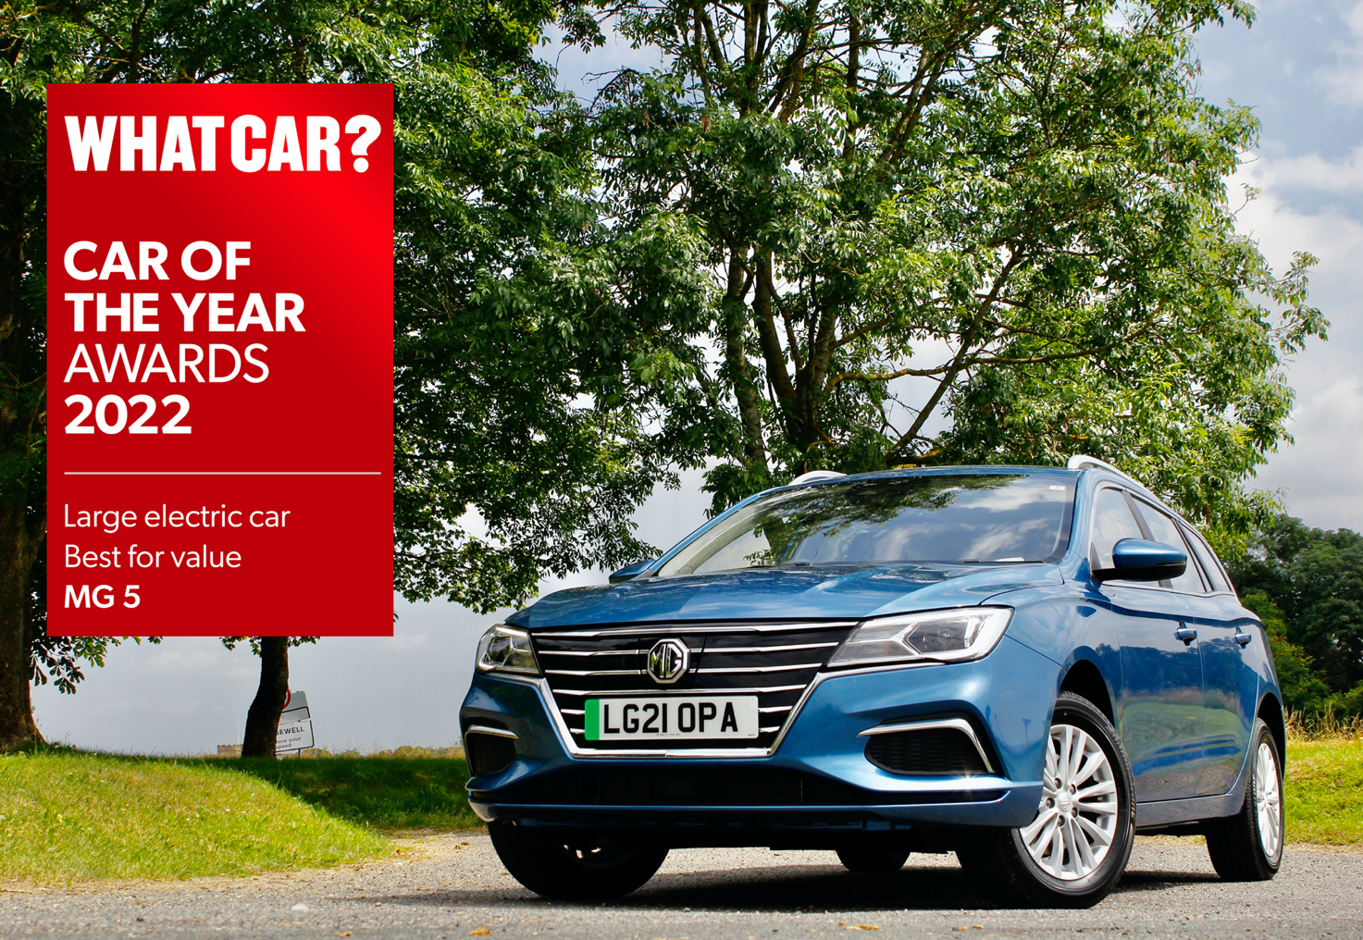

- MG5 EV scoops two awards from What Car?
- Named Best Large Electric Car for Value and Best Electric Estate
- Award follows record sales of 30,600 in 2021
- MG has best EV sales mix for companies selling both electric and ICE cars

MG Motor UK has added two new awards to its trophy cabinet after the MG5 EV was named Best Large Electric Car for Value and Best Electric Estate in the prestigious What Car? Awards.
Britain’s best-known consumer car title praised the innovative EV for its great value pricing and excellent equipment, as well as its build quality and practicality.
What Car? Editor Steve Huntingford said: “While all electric cars are cheap to run, the MG 5 is one of the few that manages to combine a low list price with a good range. And it’s not like that value forces you to accept major compromises elsewhere; the interior is well screwed together, even the entry-level Excite model comes with plenty of kit, and being an estate, the MG 5 is a very practical choice.”
The MG5 EV Long Range debuted in Summer 2021 and offers a range of up to 250 miles. It is unique in the market as it offers the flexibility and practicality of a capacious station wagon with great driving dynamics and absolutely no driving exhaust emissions.
The new longer range variant sits in MG’s rapidly expanding electric car portfolio, alongside MG ZS EV and the MG HS Plug-in Hybrid, which between them accounted for over 40% of MG’s total sales in 2021. The brand has the highest share of EV sales for any brand selling both EV and ICE cars in the market.
MG Motor Commercial Director, Guy Pigounakis, said: “Our MG5 EV has already won some impressive awards since it was introduced but to receive honours from a title as prestigious and well-respected as What Car? is an incredible achievement.
“We are delighted to receive the award, which is great news for our customers and our franchise partners as we continue to grow and develop the MG brand in the UK.”
MG currently offers six models in the UK including three plug-in cars – the new MG ZS EV, the New MG5 EV and MG HS Plug-in Hybrid - all backed up by MG’s comprehensive 7 year warranty and fast-developing dealer network.
To find your local dealer, or to discover the high-tech, value-for-money range of cars on offer, please visit MG.CO.UK.
- ENDS –

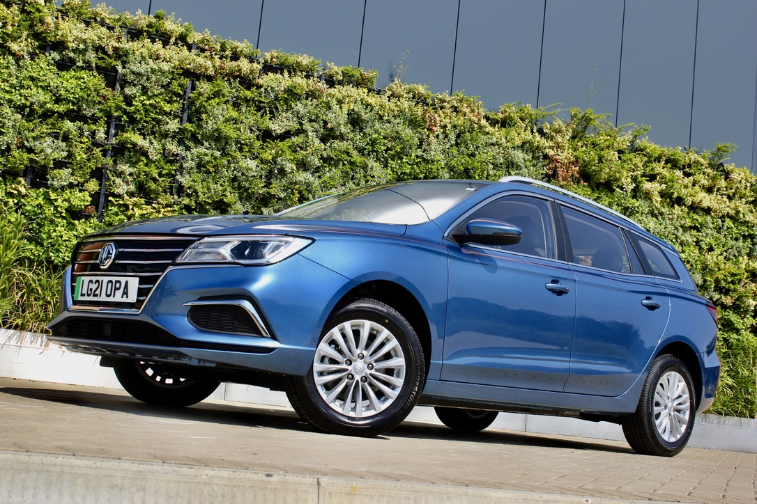
Notes to editors:

About MG

Tracing its history back to 1924, MG is the iconic British motoring brand, famous for building sporty, exciting and value-for-money cars which are always fun to drive. From the original MG 14/28 Super Sports car, designed by the legendary Cecil Kimber, to the all-electric MG5 EV of today, MG has always been innovative, always been radical and always been fun!

Today, MG is the fastest growing car brand in the UK, fielding a six-car range of practical and affordable hatchbacks, SWs and SUVs. Designed in Marylebone, London, and manufactured in state-of-the-art factories in several countries, today’s MGs are practical, spacious, packed with technology and perfect for modern life. With a national network of over 130 dealerships, MG is accessible to customers everywhere with professional sales and aftersales provision across the UK.

Backed by SAIC Motor, one of the world’s largest automotive companies, all new MGs are built with world-class components and are backed by a comprehensive manufacturer’s 7-year warranty. Well-established in the UK, MGs are now sold worldwide with western Europe being the latest region for expansion.

For further information please contact:

JASMINE JIANG
Event Marketing Manager, MG Motor
T: +44 (0)7443 071138
E: lin.jiang@mg.co.uk

CRAIG CHEETHAM
MG Press Office
T: +44 (0)7900 085571
E: craig@crccreative.co.uk

www.mg.co.uk

