PRESS INFORMATION – 20 JAN 2022

MG MOTOR UK AND RRG OPEN NEW DEALERSHIP IN STOCKPORT

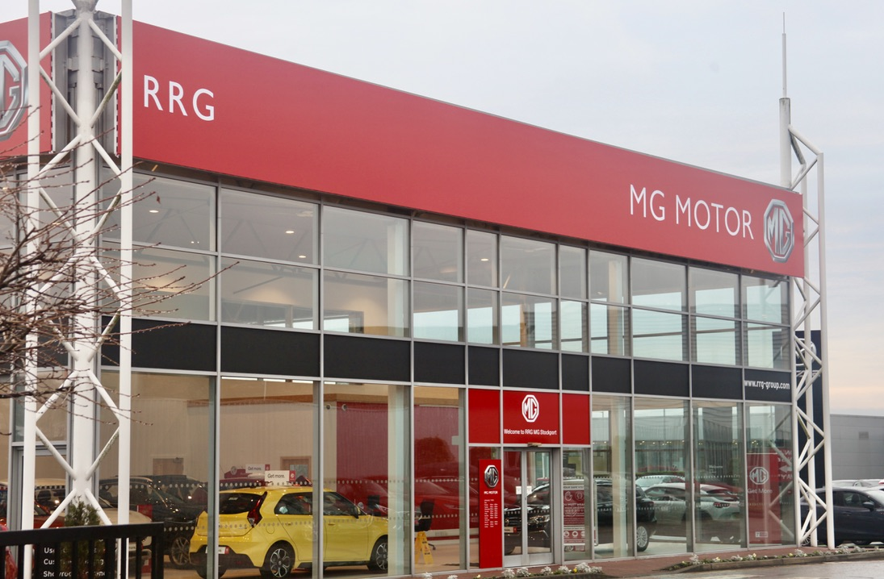

- MG Motor and RRG open new Stockport showroom
- Move follows over 40 new dealers joining the brand in past 12 months
- EV leadership and great value proposition make MG a highly desirable franchise
- MG achieved record 30,600 sales in 2021
- All MGs covered by 7 year warranty

One of the best-known dealer groups in North West England has joined the MG family, with RRG Group opening the doors to its new MG Motor UK showroom in Stockport.

RRG MG Stockport is on the Cheshire town’s Rooth Street, close to the town centre and just 10 miles south of Manchester City centre. The state-of-the-art site carries a range of new and used cars as well as offering on-site EV charging, servicing and aftersales.
RRG offers the full range of MG vehicles and will also provide specialist advice to Motability customers.
Dean Watson, RRG Dealer Principal, said: “We are very excited to be launching the MG dealership in Stockport, alongside our other franchises and we are confident that we will attract lots of customers to the MG brand and its affordable EV and Plug-in Hybrid offering.”
MG Motor Commercial Director, Guy Pigounakis, added: “We are delighted to announce the opening of the new RRG Stockport site, which is well positioned for Cheshire and South Manchester. It represents a great volume opportunity for our network helping us to further our presence in the North West and reach an even wider customer base through a well-established and highly respected local dealer group.”
MG currently offers six models in the UK including three plug-in cars – the new MG ZS EV, the New MG5 EV and MG HS Plug-in Hybrid - all backed up by MG’s comprehensive 7 year warranty and fast-developing dealer network.
To find your local dealer, or to discover the high-tech, value-for-money range of cars on offer, please visit MG.CO.UK.
- ENDS –
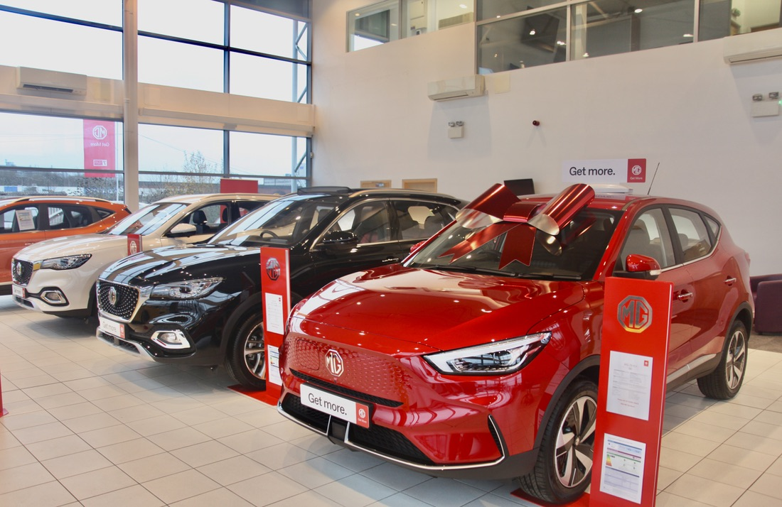
Notes to editors:

About MG

Tracing its history back to 1924, MG is the iconic British motoring brand, famous for building sporty, exciting and value-for-money cars which are always fun to drive. From the original MG 14/28 Super Sports car, designed by the legendary Cecil Kimber, to the all-electric MG5 EV of today, MG has always been innovative, always been radical and always been fun!

Today, MG is the fastest growing car brand in the UK, fielding a six-car range of practical and affordable hatchbacks, SWs and SUVs. Designed in Marylebone, London, and manufactured in state-of-the-art factories in several countries, today’s MGs are practical, spacious, packed with technology and perfect for modern life. With a national network of over 130 dealerships, MG is accessible to customers everywhere with professional sales and aftersales provision across the UK.

Backed by SAIC Motor, one of the world’s largest automotive companies, all new MGs are built with world-class components and are backed by a comprehensive manufacturer’s 7-year warranty. Well-established in the UK, MGs are now sold worldwide with western Europe being the latest region for expansion.

For further information please contact:

JASMINE JIANG
Event Marketing Manager, MG Motor
T: +44 (0)7443 071138
E: lin.jiang@mg.co.uk

CRAIG CHEETHAM
MG Press Office
T: +44 (0)7900 085571
E: craig@crccreative.co.uk

www.mg.co.uk

