PRESS INFORMATION – FOR IMMEDIATE RELEASE
6 DECEMBER 2021

MG ACHIEVES A RECORD 383% SALES INCREASE IN NOVEMBER AS NEW ZS EV ARRIVES IN SHOWROOMS

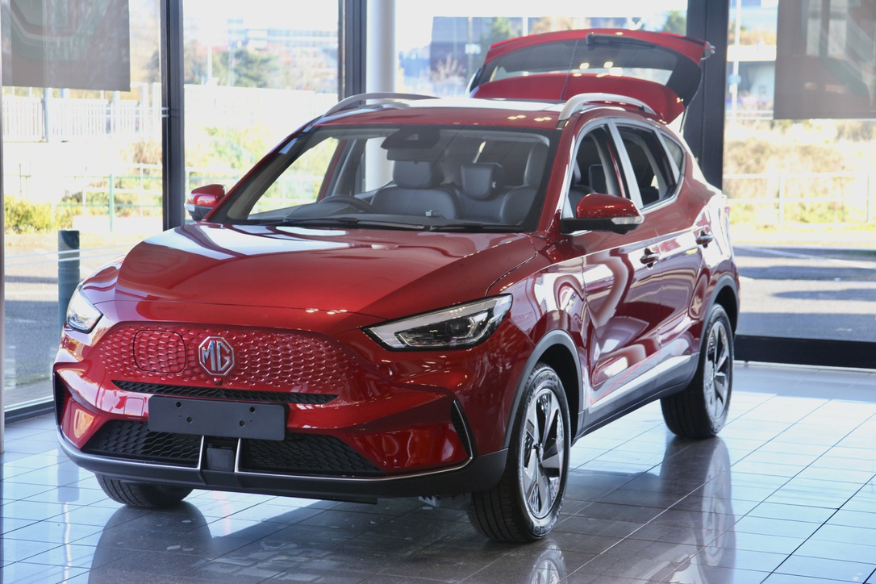

- Brand’s November sales up 383.1% with sales of 4,184 – MG’s second best ever sales month
- MG ZS is UK’s 6th best-selling car
- Year-to-date growth of 73.4% underlines MG’s position as the UK’s fastest-growing mainstream car brand
- Highest EV mix of any brand selling both Internal Combustion Engine and Alternative Fuel Vehicles
- Growth driven by new models and dealer network expansion
MG Motor UK has set yet more records recording an astonishing 383.1% sales increase in the same month that the New MG ZS EV arrived in the brand’s rapidly developing dealer network..
MG cemented its position as the fastest growing mainstream car brand in the UK with 4,184 sales, the second time it has surpassed 4,000 sales in one month, setting yet more records for the UK’s fastest-growing mainstream car brand. The MG ZS was also the UK’s sixth best-selling model across the entire car market.
The company’s year-to-date sales are now up 73.4% year-on-year, with the company expected to beat it’s 2021 sales target of 30,000 new cars with weeks to spare. It has the highest sales growth of any brand in the country’s top 27 car manufacturers.
Much of the success was driven by the brand’s plug-in models, with MG having the highest battery-electric (BEV) mix of any manufacturer selling a mix of traditional and alternative fuel cars.
Another key part of the sales success was the performance of MG’s dealer network, which is growing rapidly with over 40 new network points being appointed since the beginning of 2021.
MG Motor UK Commercial Director, Guy Pigounakis, said: “November 2021 saw an astonishing set of new records for MG Motor UK.
“Our EV performance is especially strong thanks to launch demand for the new ZS EV and MG5 EV models, which have really captured the imagination of electric car buyers. We also have an engaged and excited dealer network and have been able to provide the right cars at the right time, with a focus on generating great business for our retailers and incredible products and back-up for our customers.
“This is a key part of our commitment to long-term, sustainable growth and there are more exciting developments to come over the next few months.”
MG currently offers six models in the UK including three plug-in cars – the New MG ZS EV, the New MG5 EV and MG HS Plug-in Hybrid - all backed up by MG’s comprehensive manufacturer’s 7-year warranty and rapidly developing dealer network.
To find your local dealer, or to discover the high-tech, value-for-money range of cars on offer, please visit MG.CO.UK.
- ENDS –
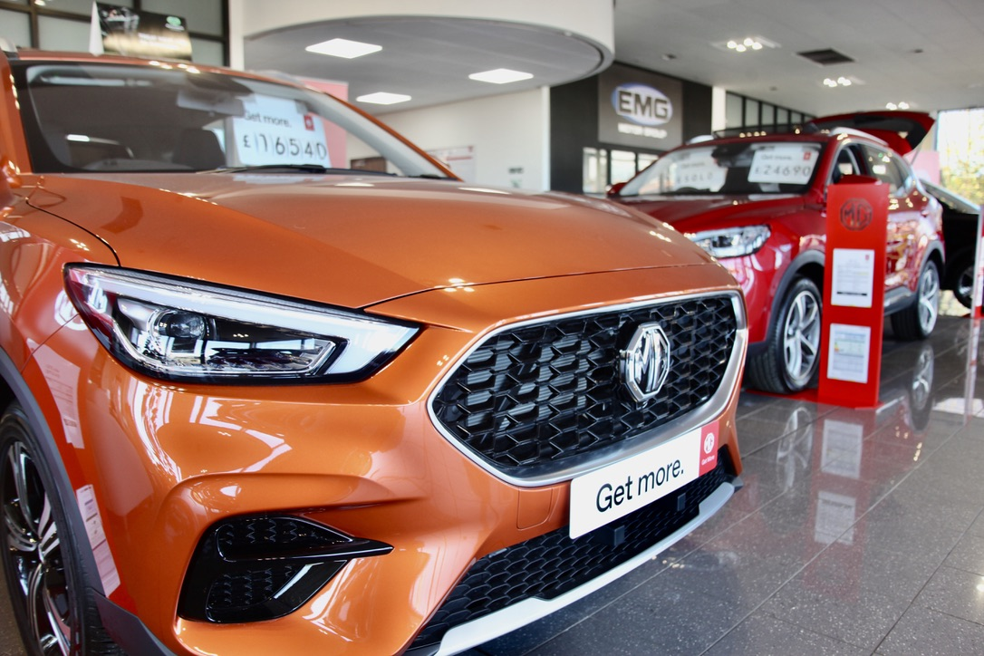
Notes to editors:

About MG

Tracing its history back to 1924, MG is the iconic British motoring brand, famous for building sporty, exciting and value-for-money cars which are always fun to drive. From the original MG 14/28 Super Sports car, designed by the legendary Cecil Kimber, to the all-electric MG5 EV of today, MG has always been innovative, always been radical and always been fun!

Today, MG is the fastest growing car brand in the UK, fielding a six-car range of practical and affordable hatchbacks, SWs and SUVs. Designed in Marylebone, London, and manufactured in state-of-the-art factories in several countries, today’s MGs are practical, spacious, packed with technology and perfect for modern life. With a national network of over 130 dealerships, MG is accessible to customers everywhere with professional sales and aftersales provision across the UK.

Backed by SAIC Motor, one of the world’s largest automotive companies, all new MGs are built with world-class components and are backed by a comprehensive manufacturer’s 7-year warranty. Well-established in the UK, MGs are now sold worldwide with western Europe being the latest region for expansion.

For further information please contact:

JASMINE JIANG
Event Marketing Manager, MG Motor
T: +44 (0)7443 071138
E: lin.jiang@mg.co.uk

CRAIG CHEETHAM
MG Press Office
T: +44 (0)7900 085571
E: craig@crccreative.co.uk

www.mg.co.uk

