PRESS INFORMATION – 13 DECEMBER 2021

MG MOTOR UK AND EMG DRIVE GROWTH WITH NEW IPSWICH DEALERSHIP

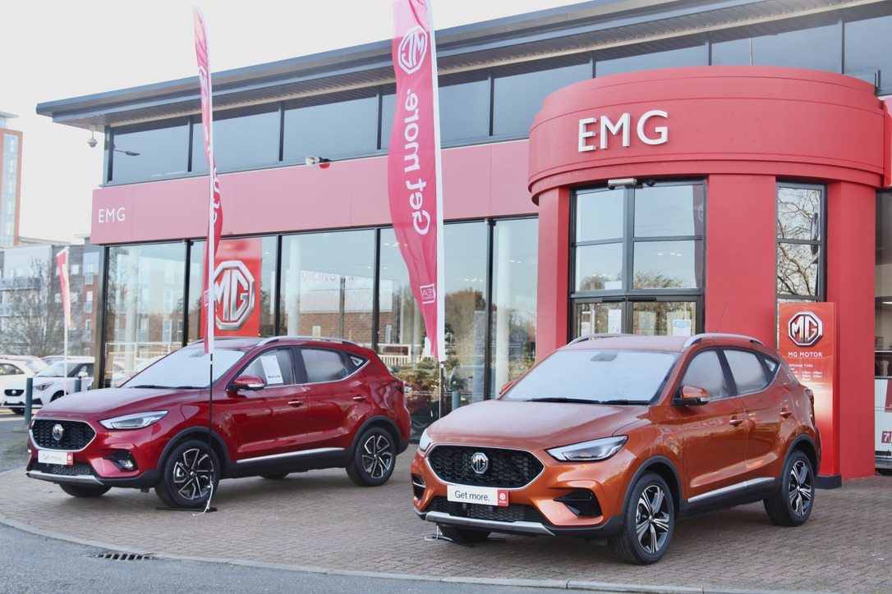

- MG Motor and EMG open new showroom in Ipswich
- Move follows over 40 new dealers joining the brand in past 12 months
- EV leadership and great value proposition make MG a highly desirable franchise
- MG has seen 73.4% year-to-date growth
- All MGs covered by 7 year warranty

One of the best-known dealer groups in East Anglia has joined the MG family, with EMG Motor Group opening the doors to its new MG Motor UK showroom in Ipswich.

EMG MG is on Ipswich’s West End Road, close to the town centre, and will carry a range of new and used cars as well as offering on-site EV charging, servicing and aftersales.
The site will offer the full range of MG vehicles and will also provide specialist advice to Motability customers.
Darren Allwright, EMG MG General Manager, said: “We are delighted to be joining MG at this exciting time. With MG offering a fantastic range of market leading cars which all come with a 7-year warranty it’s a brand that fits well into our business, which has been providing cars, aftersales care and great customer service to our customers in the East of England for over 25 years.”
MG Motor Commercial Director, Guy Pigounakis, added: “We are very pleased to welcome EMG into the MG family. The Ipswich location is a great strategic addition to our network helping us to further our presence in East Anglia and reach an even wider customer base through a well-established and highly respected partner.”
MG currently offers six models in the UK including three plug-in cars – the new MG ZS EV, the New MG5 EV and MG HS Plug-in Hybrid - all backed up by MG’s comprehensive 7 year warranty and fast-developing dealer network.
To find your local dealer, or to discover the high-tech, value-for-money range of cars on offer, please visit MG.CO.UK.
- ENDS –
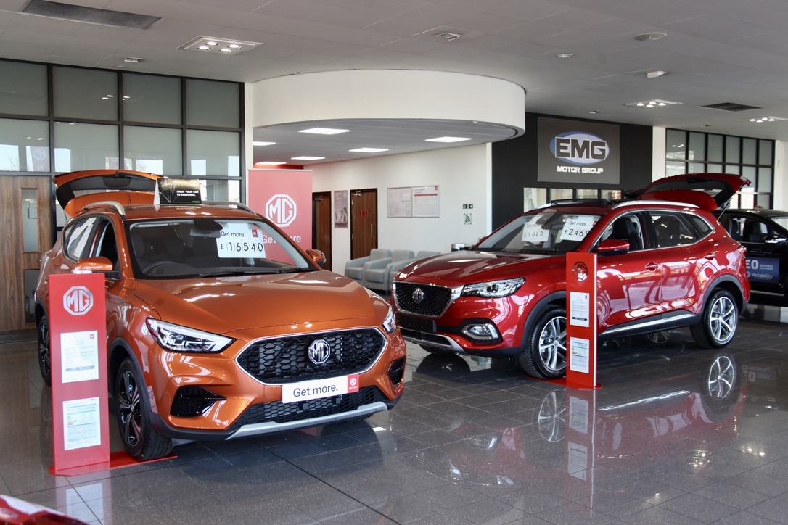
Notes to editors:

About MG

Tracing its history back to 1924, MG is the iconic British motoring brand, famous for building sporty, exciting and value-for-money cars which are always fun to drive. From the original MG 14/28 Super Sports car, designed by the legendary Cecil Kimber, to the all-electric MG5 EV of today, MG has always been innovative, always been radical and always been fun!

Today, MG is the fastest growing car brand in the UK, fielding a six-car range of practical and affordable hatchbacks, SWs and SUVs. Designed in Marylebone, London, and manufactured in state-of-the-art factories in several countries, today’s MGs are practical, spacious, packed with technology and perfect for modern life. With a national network of over 130 dealerships, MG is accessible to customers everywhere with professional sales and aftersales provision across the UK.

Backed by SAIC Motor, one of the world’s largest automotive companies, all new MGs are built with world-class components and are backed by a comprehensive manufacturer’s 7-year warranty. Well-established in the UK, MGs are now sold worldwide with western Europe being the latest region for expansion.

For further information please contact:

JASMINE JIANG
Event Marketing Manager, MG Motor
T: +44 (0)7443 071138
E: lin.jiang@mg.co.uk

CRAIG CHEETHAM
MG Press Office
T: +44 (0)7900 085571
E: craig@crccreative.co.uk

www.mg.co.uk

