PRESS INFORMATION – FOR IMMEDIATE RELEASE
13 DECEMBER 2021

MG MOTOR UK BREAKS ALL RECORDS AS SALES PASS 30,000 IN 2021

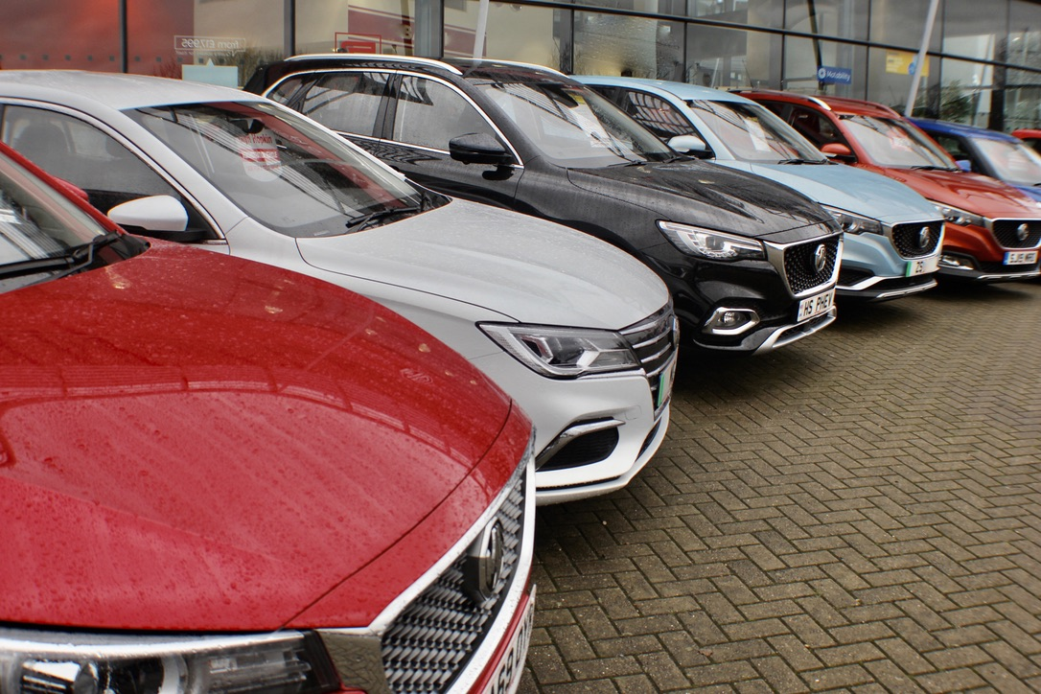

- MG Motor UK breaks 30,000 registrations for the first time
- Year-to-date growth of 73.4% underlines MG’s position as the UK’s fastest-growing mainstream car brand
- Highest EV mix of any brand selling both Internal Combustion Engine and Alternative Fuel Vehicles
- Growth driven by new models and dealer network expansion
The UK’s fastest-growing mainstream car brand has broken a new record, surpassing 30,000 new registrations in 2021.

The 30,000th new MG of 2021 was registered over the weekend as the company is on target to smash all of its previous records. In 2020, it sold a total of 18,415 cars, putting 2021 registrations already 11,585 ahead.
In November, the brand saw an astonishing 383.1% year-on-year sales increase in the same month that the New MG ZS EV arrived within its rapidly developing dealer network. The MG ZS was also the UK’s sixth best-selling model across the entire car market – the first time that MG has featured in the top 10 sellers charts.
The company’s year-to-date sales were up 73.4% year-on-year at the end of last month, the highest sales growth of any brand in the country’s top 27 car manufacturers.
Much of the success was driven by the brand’s plug-in models, with MG having the highest battery-electric (BEV) mix of any manufacturer selling a mix of traditional and alternative fuel cars.
Another key part of the sales success was the performance of MG’s dealer network, which is growing rapidly with over 40 new sales sites being appointed since the beginning of 2021.
MG Motor UK Commercial Director, Guy Pigounakis, said: “At the start of the year, we set out an ambition of achieving 30,000 registrations and are delighted to have surpassed this well before the end of the year.
“It shows just how much demand there is for MG’s great value, well-equipped and high quality cars, especially our booming EV models which currently account for almost half our total sales. Our customers and dealers are fully engaged and MG is poised for long-term, sustainable growth, with more extremely exciting developments to come as we head into 2022.”
MG currently offers six models in the UK including three plug-in cars – the New MG ZS EV, the New MG5 EV and MG HS Plug-in Hybrid - all backed up by MG’s comprehensive manufacturer’s 7-year warranty and rapidly developing dealer network.
To find your local dealer, or to discover the high-tech, value-for-money range of cars on offer, please visit MG.CO.UK.
- ENDS –
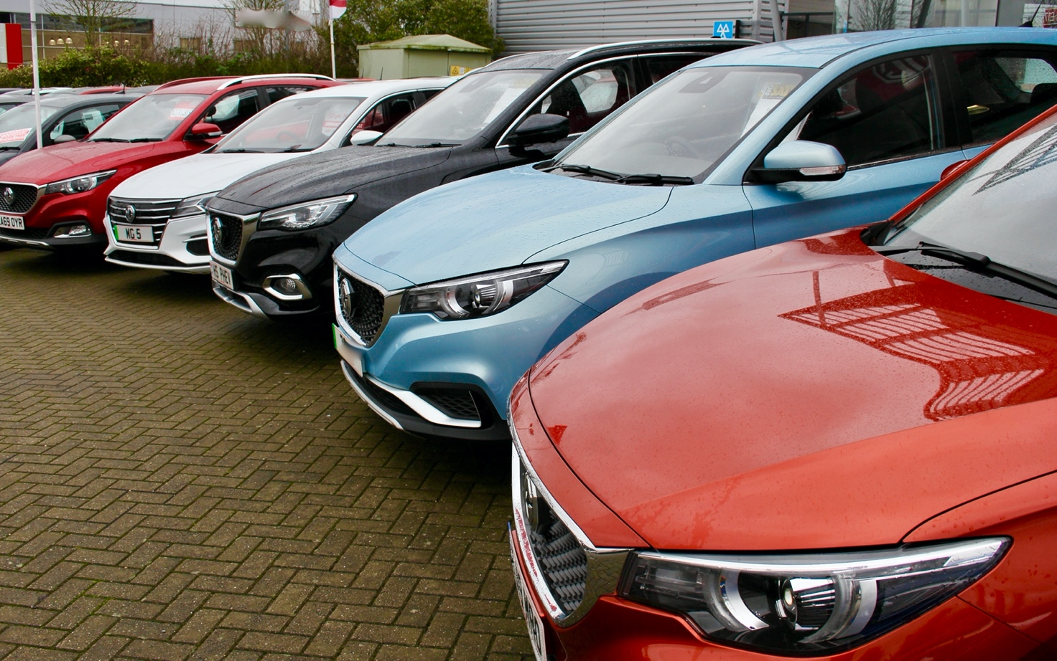
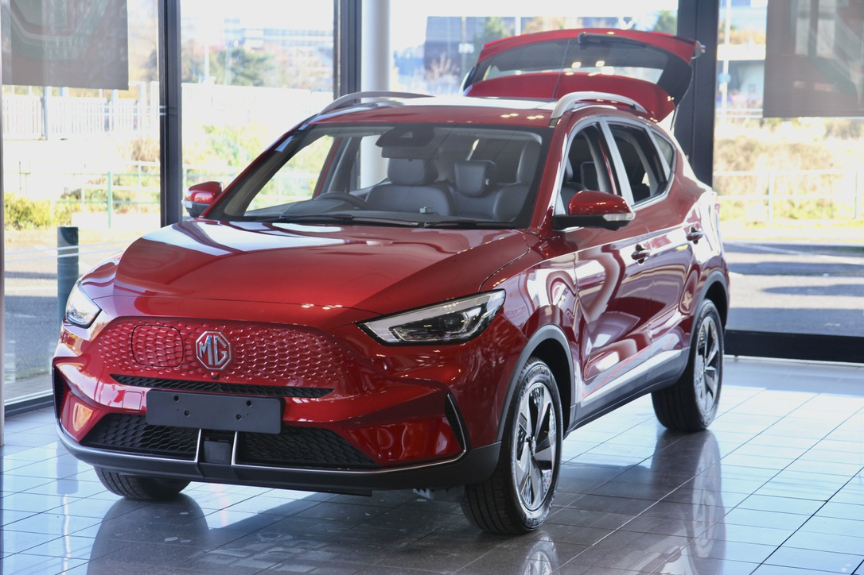
Notes to editors:

About MG

Tracing its history back to 1924, MG is the iconic British motoring brand, famous for building sporty, exciting and value-for-money cars which are always fun to drive. From the original MG 14/28 Super Sports car, designed by the legendary Cecil Kimber, to the all-electric MG5 EV of today, MG has always been innovative, always been radical and always been fun!

Today, MG is the fastest growing car brand in the UK, fielding a six-car range of practical and affordable hatchbacks, SWs and SUVs. Designed in Marylebone, London, and manufactured in state-of-the-art factories in several countries, today’s MGs are practical, spacious, packed with technology and perfect for modern life. With a national network of over 130 dealerships, MG is accessible to customers everywhere with professional sales and aftersales provision across the UK.

Backed by SAIC Motor, one of the world’s largest automotive companies, all new MGs are built with world-class components and are backed by a comprehensive manufacturer’s 7-year warranty. Well-established in the UK, MGs are now sold worldwide with western Europe being the latest region for expansion.

For further information please contact:

JASMINE JIANG
Event Marketing Manager, MG Motor
T: +44 (0)7443 071138
E: lin.jiang@mg.co.uk

CRAIG CHEETHAM
MG Press Office
T: +44 (0)7900 085571
E: craig@crccreative.co.uk

www.mg.co.uk

