PRESS INFORMATION – 1st November 2021

PRICES AND SPECIFICATION ANNOUNCED FOR REFRESHED MG ZS EV

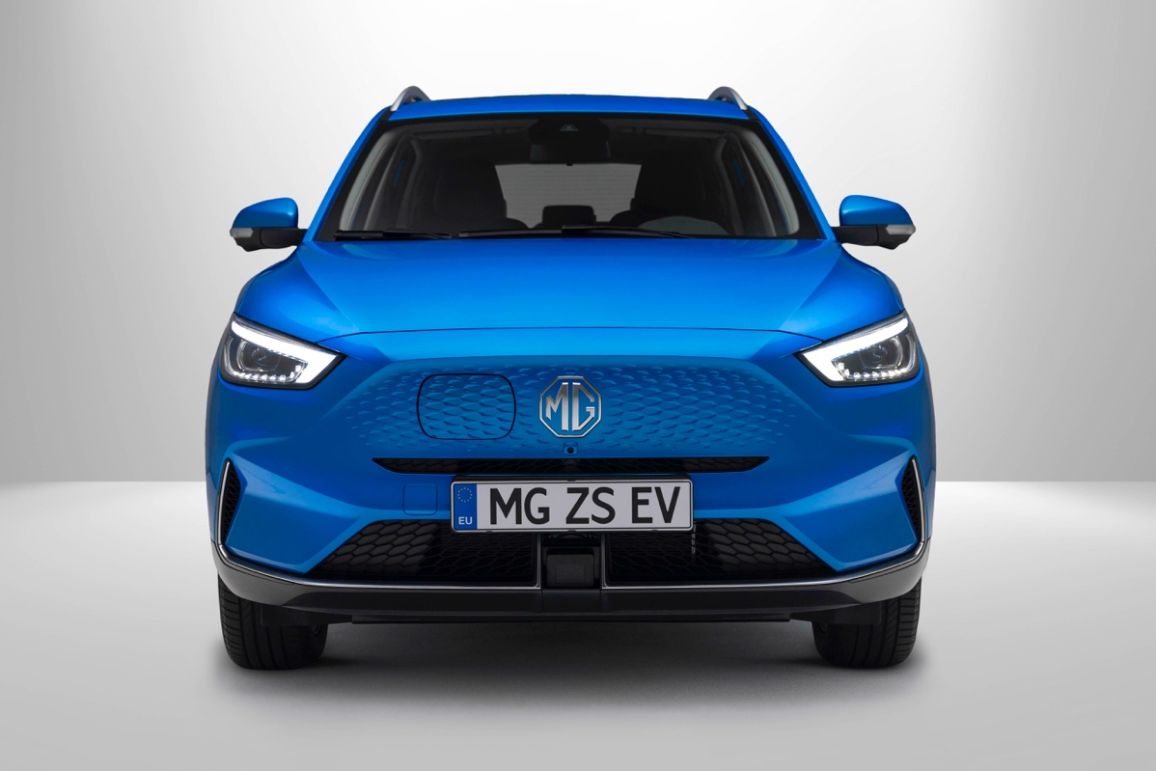

- Revised version of MG’s top selling EV on sale this month from £28,495 (including Plug-in Car Grant)
- Long Range battery delivers up to 273-mile range
- New iSMART connectivity infotainment system
- New trim names with third technology-filled level.

The New MG ZS EV arrives in the brand’s dealerships this month, priced from £28,495 on-the-road (after Plug-in Car Grant).
Available with a larger 72kWh Long Range battery, the New MG ZS EV will be offered in three trim levels: SE, Trophy and Trophy Connect.
The renewed model builds on the success of the existing ZS EV, which is the brand’s best-selling pure electric model and a consistent fixture among the UK’s top 10 best-selling EVs. The revised model makes the MG ZS EV even better and is characterised by a modernised design, improved performance, a significantly longer range, and even more technology.
In styling terms, the New MG ZS EV gets a new electric-only front end, with a stamped-effect grille to improve aerodynamics and a new side-opening charging port. The bold new face is set off by LED headlights and distinctive daytime running lights. It also gets a redesigned rear bumper and new wheels.
INCREASED BATTERY CAPACITY
The Long Range 72kWh battery delivers a range of up to 273 miles (WLTP combined cycle), a substantial increase over the outgoing model, which has a combined range of 163 miles.
CHARGING
Charging status is now readily viewed on the four stage indicator LEDs inside the charging port. The combination Type 2 and CCS charger provides up to 7kW fast charging using the on-board AC charger, or up to 76kW DC rapid charging (depending on climatic conditions). This means the Long Range 72kWh battery can be charged from 0-100% in 10½ hours on a standard 7kW charger, or as little as 42 minutes on a 100kW rapid charger. With Vehicle-to-Load capability now available as standard, you can even charge or power other external equipment, for example, an electric bike, using an accessory charging cable.
ISMART INFOTAINMENT SYSTEM
Every New MG ZS EV also comes with the new state-of-the-art MG iSMART connectivity system, which offers connection via a smartphone app. Many vehicle functions can be controlled via the app, including vehicle status, battery charge level, if the car is locked or unlocked, or the alarm has been triggered. Owners will benefit from new convenience features in the app to remotely lock and unlock the car, set the air conditioning and heating, and activate the windscreen demister when required. Owners will have access to view their charging statistics, stop and start a charge, and schedule charging to optimise lower rate energy.
At the heart of the infotainment system is a 10.1-inch tablet-style touchscreen, with new graphics and improved functionality. The new model also gets a new digital instrument cluster and wireless phone charging*.
The New ZS EV also sees the first over the air (OTA) software updates from MG. Owners will receive any new software updates, including new features and improvements, through iSMART at the touch of a button, rather than visiting their local dealership. In addition, and another first for MG, customers will no longer get a printed owners manual. It will now be accessible through the iSMART system, thus saving paper and printing costs and ensuring that the most up to date information is readily available.

MODEL RANGE, EQUIPMENT AND PRICING
The entry level ZS EV will be the well-equipped SE, priced at £28,495 (after PiCG) on-the-road. The SE is competitively equipped, with automatic air conditioning, bi-function LED headlights, adaptive cruise control, keyless entry and push-button start, vehicle-to-load charging, 360º parking camera, a 10.1-inch touchscreen, sat nav, iSMART and multiple USB charging points.
The Trophy model, priced at £30,995 (after PiCG), adds a stunning panoramic ‘Sky Roof’ and leather-style seats, along with more convenience options such as roof rails, heated front seats, electric driver’s seat adjustment, rain-sensing wipers and wireless phone charging.
Bringing the highest level of technology is the Trophy Connect, which adds iSMART with live services (weather, traffic and Amazon Prime). The Trophy Connect is priced at £31,495 after PiCG.
All ZS EVs benefit from just 1% benefit-in-kind P11D values for company car users until April 2022, and only 2% BiK thereafter for the 2022/23 tax year.
The New MG ZS EV will be offered in five colours including bold Battersea Blue, which is new to the range. Other colours in the lie-up are Arctic White, Black Pearl, , Monument Silver and Dynamic Red.
MG PILOT
All New ZS EVs feature MG’s suite of driver assistance technology – MG Pilot which includes Active Emergency Braking with Pedestrian and Bicycle Detection, Lane Keep Assist with Lane Departure Warning System, Traffic Jam Assist, Intelligent Speed Limit Assist and Intelligent High Beam Assist.
Trophy and Trophy Connect models also get Rear Cross Traffic Alert and Blind Spot Detection with Lane Change Assist.

TOWING
The New ZS EV is the first fully electric vehicle in the MG range to offer towing capability. A 500kg towing capacity means owners can now attach small trailers or fit a cycle carrier for example.

MG currently offers six models in the UK including three plug-in cars – the MG ZS EV, the MG5 EV and MG HS Plug-in Hybrid, all backed up by MG’s comprehensive 7-year warranty and nationwide dealer network.
To find your local dealer, or to discover the high-tech, value-for-money range of cars on offer, please visit MG.CO.UK.
*Wireless phone charging on Trophy model only
- ENDS –

Model | On-the-road price | On-the-road price (after PiCG) | P11D Value
ZS EV SE Long Range | £30,995 | £28,495 | £30,940
ZS EV Trophy Long Range | £33,495 | £30,995 | £33,440
ZS EV Trophy Connect Long Range | £33,995 | £31,495 | £33,940

New MG ZS EV Technical Data
Version |  | SE  Long Range | Trophy, Trophy Connect  Long Range
Transmission |  | Automatic 1 Speed | Automatic 1 Speed
Driven Wheels |  | Front Wheel Drive | Front Wheel Drive
Electric Motor Type |  | Synchronous Motor | Synchronous Motor
Battery Type |  | Lithium-Ion (NMC) | Lithium-Ion (NMC)
Battery Capacity (nominal) | kWh | 72.6 | 72.6
Battery Capacity (usable) | kWh | 68.3 | 68.3
Maximum Power | PS (kw) | 156 (115) | 156 (115)
Maximum Torque | lb ft (NM) | 206 (280) | 206 (280)
0-60mph | seconds | 8.2 | 8.2
0-62mph (100kmh) | seconds | 8.4 | 8.4
Maximum Speed | mph (km/h) | 108 (175) | 108 (175)
CO₂ - WLTP | g/km | 0 | 0
Charger Connection Type |  | Combined Type 2 and CCS | Combined Type 2 and CCS
On-board charger | AC | 7kW | 7kW
Maximum Rapid charge capability | DC | up to 76kW | up to 76kW
Estimated Charging Time (2.2kW 3-Pin Domestic) | 0 to 100% (emergency use) | 34 hours | 34 hours
Estimated Charging Time (7kW fast charger) | 0 to 100% | 10.5 hours | 10.5 hours
Estimated Charging Time (50kW public rapid charger) | 10% to 80% | 1hr 3 minutes | 1hr 3 minutes
Estimated Charging Time (100kW public rapid charger) | 10% to 80% | 42 minutes | 42 minutes
Electric Driving Efficiency - miles/kWh (kWh/100km) | Combined | 3.5 (17.8) | 3.5 (17.8)
 | City | 4.8 (12.9) | 4.8 (12.9)
Maximum Driving Range - miles (km) | Combined | 273 (440) | 273 (440)
 | City | 370 (596) | 370 (596)
Kerb Weight | kg | 1620 |  | 1620
Gross Vehicle Weight | kg | 2070 |  | 2070
Maximum Towing Weight (unbraked) | kg | 500 |  | 500
Maximum Towing Weight (braked) | kg | 500 |  | 500
Gross Train Weight | kg | 2570 |  | 2570
Maximum Tow Ball Weight | kg | 50 |  | 50
Maximum Roof Rail Load | kg | 75 |  | 75
Turning Circle | m | 11.2 |  | 11.2
Service Intervals | 12 months / 15,000 miles
Manufacturer's Warranty | 7 years / 80,000 miles

* Maximum charging rates and estimated charging times will vary dependent on vehicle and climatic conditions
Notes to editors:

About MG

Tracing its history back to 1924, MG is the iconic British motoring brand, famous for building sporty, exciting and value-for-money cars which are always fun to drive. From the original MG 14/28 Super Sports car, designed by the legendary Cecil Kimber, to the all-electric MG5 EV of today, MG has always been innovative, always been radical and always been fun!

Today, MG is the fastest growing car brand in the UK, fielding a six-car range of practical and affordable hatchbacks, SWs and SUVs. Designed in Marylebone, London, and manufactured in state-of-the-art factories in several countries, today’s MGs are practical, spacious, packed with technology and perfect for modern life. With a national network of over 140 dealerships, MG is accessible to customers everywhere with professional sales and aftersales provision across the UK.

Backed by SAIC Motor, one of the world’s largest automotive companies, all new MGs are built with world-class components and are backed by a comprehensive manufacturer’s 7-year warranty. Well-established in the UK, MGs are now sold worldwide with western Europe being the latest region for expansion.

For further information please contact:

LINDA ROBINSON
PR and Experiential Manager, MG Motor
T: +44 0203 917 5834
M: +44 7443 071138
E: linda.robinson@mg.co.uk

CRAIG CHEETHAM
MG Press Office
T: +44 07900 085571
E: craig@crccreative.co.uk

www.mg.co.uk

