PRESS INFORMATION – 7 OCTOBER 2021

REFRESHED ZS EV TO JOIN MG MOTOR UK LINE-UP

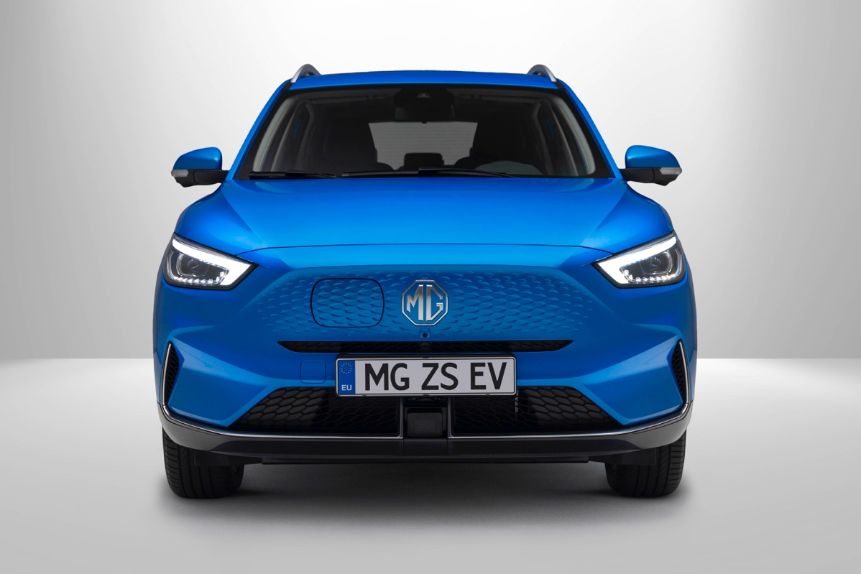

- MG’s top selling EV gets longer range and fresh new look for 2022 model year
- Longer range model to deliver up to 273-mile EV range
- New iSMART connectivity infotainment system
- New MG ZS EV in showrooms from November 2021

MG Motor has pulled the wraps off the New MG ZS EV, which arrives in the brand’s dealerships in November 2021.
The renewed model builds on the success of the existing ZS EV, which is the brand’s best-selling pure electric model and a consistent fixture among the UK’s top 10 best-selling EVs. The revised model makes the MG ZS EV even better and is characterised by a modernised design, improved performance, a significantly longer range, and even more technology.
It introduces a fresh 72kWh battery pack delivering a substantial range increase, as well as a new iSMART connectivity system, which brings state-of-the-art infotainment to the latest model.
In styling terms, the New MG ZS EV gets a new electric-only front end, with a stamped-effect grille to improve aerodynamics and a new side-opening charging port. The bold new face is set off by LED headlights and distinctive daytime running lights. It also gets a redesigned rear bumper and new wheels.
The New MG ZS EV will be offered in a choice of two trim levels and two battery variants. MG is introducing two new version names, starting with the new ZS EV – SE and Trophy. The 72 kWh Long Range battery will offer a range of 273 miles compared with 163 miles for the existing model (based on WLTP measurements). A 51 kWh battery with a 198-mile range will join the line up next year.
Charging status is now readily viewed on the four stage indicator LEDs inside the charging port. The combination Type 2 and CCS charger provides up to 7kW fast charging using the on-board AC charger, or up to 76kW DC rapid charging (depending on climatic conditions). This means the Long Range 72 kWh battery can be charged from 0-100% in 10½ hours on a standard 7kW charger, or as little as 42 minutes on a 100kW rapid charger.
Every New MG ZS EV also comes with the new state-of-the-art MG iSMART connectivity system, which offers a connection via a smartphone app, through which various car, climate, security and charging functions can be controlled remotely.
At the heart of the system is a 10.1-inch tablet-style touchscreen, with new graphics and improved functionality. The new model also gets a new instrument cluster and wireless phone charging*.
Prices for the New MG ZS EV will be announced in November 2021.
MG currently offers six models in the UK including three plug-in cars – the MG ZS EV, the game-changing MG5 EV and MG HS Plug-in Hybrid, all backed up by MG’s comprehensive 7-year warranty and nationwide dealer network.
To find your local dealer, or to discover the high-tech, value-for-money range of cars on offer, please visit MG.CO.UK.
*Wireless phone charging on Trophy model only
- ENDS –

Notes to editors:

About MG

Tracing its history back to 1924, MG is the iconic British motoring brand, famous for building sporty, exciting and value-for-money cars which are always fun to drive. From the original MG 14/28 Super Sports car, designed by the legendary Cecil Kimber, to the all-electric MG5 EV of today, MG has always been innovative, always been radical and always been fun!

Today, MG is the fastest growing car brand in the UK, fielding a six-car range of practical and affordable hatchbacks, SWs and SUVs. Designed in Marylebone, London, and manufactured in state-of-the-art factories in several countries, today’s MGs are practical, spacious, packed with technology and perfect for modern life. With a national network of over 130 dealerships, MG is accessible to customers everywhere with professional sales and aftersales provision across the UK.

Backed by SAIC Motor, one of the world’s largest automotive companies, all new MGs are built with world-class components and are backed by a comprehensive manufacturer’s 7-year warranty. Well-established in the UK, MGs are now sold worldwide with western Europe being the latest region for expansion.

For further information please contact:

LINDA ROBINSON
PR and Experiential Manager, MG Motor
T: +44 0203 917 5834
M: +44 7443 071138
E: linda.robinson@mg.co.uk

CRAIG CHEETHAM
MG Press Office
T: +44 07900 085571
E: craig@crccreative.co.uk

www.mg.co.uk

