PRESS INFORMATION – 4 MAY 2021

ALL HAIL THE MG5 EV THANKS TO INNOVATIVE WEFLEX DEAL

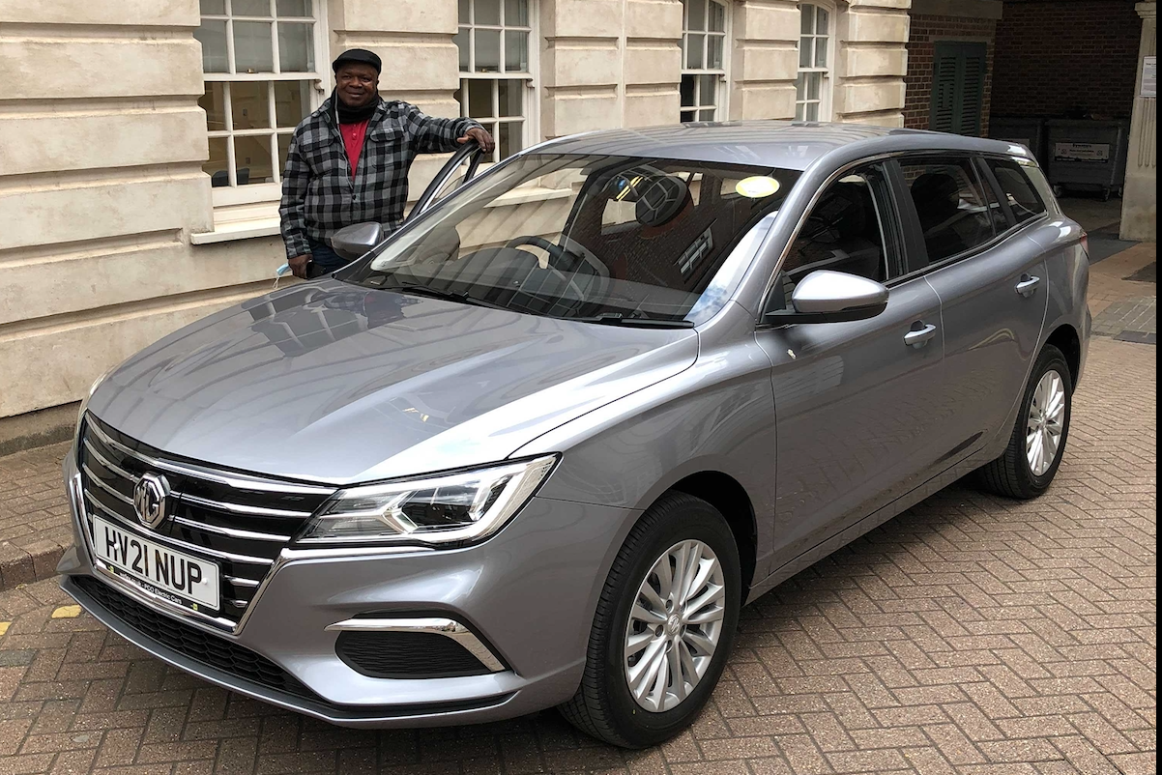

- Over 200 MG5 EVs being made available to ride-hailing drivers across London in 2021
- Over 1,000 deliveries planned in next two years
- MG partners with WeFlex to offer Uber-focused contract hire deals for drivers
- MG5 EVs electric powertrain delivers up to 214 miles of range
- All Uber vehicles in London to be electric by 2025

For the first time, London’s ride hailers will have the opportunity to be picked up in a fully electric Uber bearing the iconic MG badge, which has been a staple of British motoring for almost 100 years.
Ride-hailing rent-to-buy provider WeFlex, which has recently launched a 100% electric vehicle offering, is making almost 200 brand new MG5 EV vehicles available to existing and would-be professional ride hailing drivers by the end of 2021 – with plans for over a thousand over the next couple of years.
In London there are currently around 1,600 Uber operators in Electric Cars out of over 50,000 drivers, and Uber has committed to be 100% Electric by 2025. WeFlex plans to play a key part in this move to EV’s with a short-term aim to reach 5,000 electric vehicles, with MG playing a key part in the company’s development strategy.
Geraint Isaac, National Fleet Sales Manager for MG Motor said: “Ride hailing services such as Uber are ideal for the MG5 EV as the combination of the car’s pricing and range is unbeatable. As services such as Uber move towards a zero-emissions future we’re delighted that MG is going to play a key part and believe we have the perfect vehicle for the job.”
WeFlex Founder Nicko Williamson commented: “All-electric is the only way to clean up London’s air and travel in a truly environmentally sustainable way, whether you’re going to a business meeting or to the pub. We’re committed to providing practical solutions to help achieve this – excellent electric vehicles that drivers want to drive and that passengers want to ride in.
“The MG5 EV is a major new addition to our fleet, offering riders a comfortable, spacious, environmentally friendly option wherever their journey is taking them, and providing drivers with the perfect balance of range, features and value. The vehicle’s range of 214 miles also means no range anxiety for our customers.
“It's a great value vehicle, meaning we can price it competitively and the extra boot space inherent with the estate design means it’s perfect for the airport run – when things are eventually back to normal. We are really excited to be making so many of these vehicles available via WeFlex.”
WeFlex was launched in 2016 as a new way for ride-hailing drivers (Uber, FreeNow, Ola, Bolt etc) to own their own vehicles, but in a much more flexible way than was offered at the time via regular car dealers and finance businesses.
MG currently offers three plug-in models in the UK – the established MG ZS EV, the game-changing All New MG5 EV and MG HS Plug-in Hybrid, all backed up by MG’s incredible 7 year warranty and fast-developing dealer network.
To find your local dealer, or to discover the high-tech, value-for-money range of cars on offer, please visit MG.CO.UK.
- ENDS –
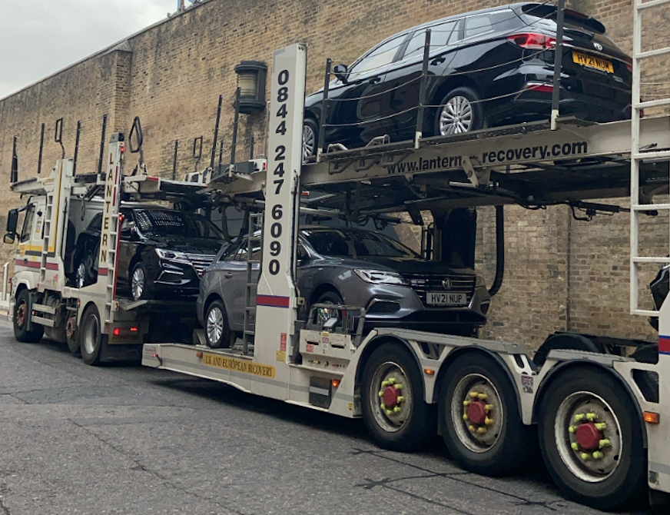
Notes to editors:

About MG

Tracing its history back to 1924, MG is the iconic British motoring brand, famous for building sporty, exciting and value-for-money cars which are always fun to drive. From the original MG 14/28 Super Sports car, designed by the legendary Cecil Kimber, to the all-electric MG5 EV of today, MG has always been innovative, always been radical and always been fun!

Today, MG is the fastest growing car brand in the UK, fielding a six-car range of practical and affordable hatchbacks, SWs and SUVs. Designed in Marylebone, London, and manufactured in state-of-the-art factories in several countries, today’s MGs are practical, spacious, packed with technology and perfect for modern life. With a national network of 120 dealerships, MG is accessible to customers everywhere with professional sales and aftersales provision across the UK.

Backed by SAIC Motor, one of the world’s largest automotive companies, all new MGs are built with world-class components and are backed by a comprehensive manufacturer’s 7 year warranty. Well-established in the UK, MGs are now sold worldwide with western Europe being the latest region for expansion during 2021.

About WeFlex

WeFlex, founded in 2016 by Nicko Williamson, is an impact company created to help Ride-Hailing drivers (Uber, Bolt, Ola etc.) own their own cars. WeFlex has pledged to do better for the planet and in 2021 has evolved into an electric vehicle focused business, becoming net zero and planting a tree for every EV sold. WeFlex works closely with Uber and is one of a select few companies where Uber drivers can spend their Uber Clean Air Plan funds. WeFlex’s Head Office is in London and also operates in Birmingham, their goal is to switch Ride-Hailing to Electric.

For further information please contact:
CRAIG CHEETHAM
MG Press Office
T: +44 7900 085571
E: craig@crccreative.co.uk
www.mg.co.uk

