PRESS INFORMATION – FOR IMMEDIATE RELEASE
5 OCTOBER 2021

SENSATIONAL SEPTEMBER SEES MG MOTOR UK BUCK INDUSTRY TRENDS AND SET SEVERAL NEW RECORDS

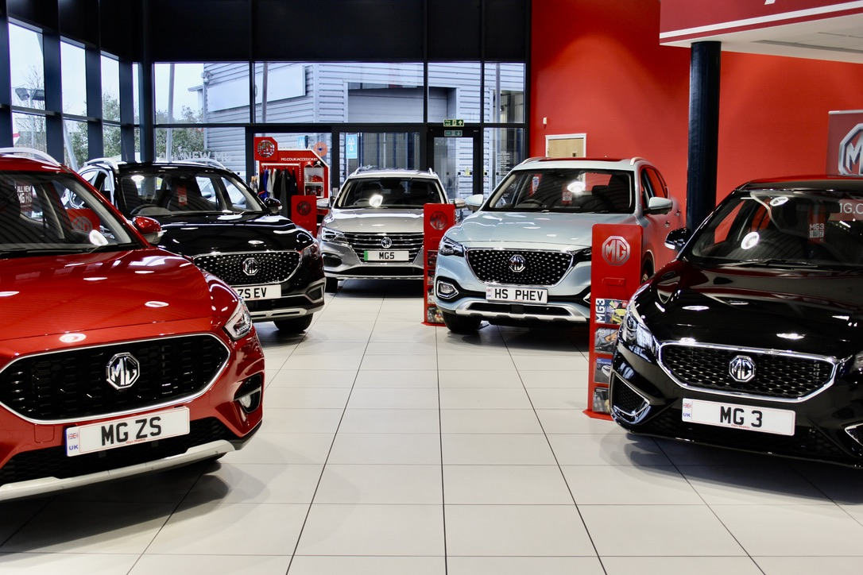

- MG Motor UK achieves highest ever monthly sales in the UK, passing 5,000 registrations for the first time ever
- Record 2.53% market share sees sales up 61.2% year-to-date
- MG also achieves 5.5% battery electric share, with the highest EV mix of any brand selling both Internal Combustion Engine and Alternative Fuel Vehicles
- Growth driven by new models and dealer network expansion
MG Motor UK has cemented its position as the fastest growing mainstream car brand in the UK with a record September that saw the brand’s registrations grow 48.6% year-on-year in a market that slumped by 34.4% against the same month last year.
The company’s year-to-date sales are now up 61.2%, with this September seeing MG achieve a record monthly market share of 2.53%. The monthly figure of 5,452 is the first time the brand has achieved over 5,000 vehicle sales in a single month, and saw it sail past 20,000 sales year-to-date.
Much of the success was driven by the brand’s plug-in models, with the new long-range MG5 EV off to an incredible start as the seventh best-selling pure EV in the UK. The company’s overall battery mix of 32.7% was the highest of any manufacturer selling both internal combustion and alternative fuel models.
Another key part of the sales success was the performance of MG’s dealer network, which is growing rapidly with over 40 new network points being appointed since the beginning of 2021.
MG Motor UK Commercial Director, Guy Pigounakis, said: “September 2021 was a milestone month for MG Motor UK, beating all previous records. It’s clear that our range of great value, well-equipped and stylish cars are in tune with market demands and our aim to offer affordable EVs to everyone is also firing car buyers’ imagination.
“We have an engaged and excited dealer network and have been able to provide the right cars at the right time, with a focus on generating great business for our retailers and a commitment to offering terrific cars that are just what the market demands. This is part of our commitment to long-term, sustainable growth and there are some very exciting developments to come over the next few months.”
MG currently offers six models in the UK including three plug-in cars – the established MG ZS EV, the New MG5 EV and MG HS Plug-in Hybrid, all backed up by MG’s comprehensive manufacturer’s 7-year warranty and fast-developing dealer network.
To find your local dealer, or to discover the high-tech, value-for-money range of cars on offer, please visit MG.CO.UK.
- ENDS –

Notes to editors:

About MG

Tracing its history back to 1924, MG is the iconic British motoring brand, famous for building sporty, exciting and value-for-money cars which are always fun to drive. From the original MG 14/28 Super Sports car, designed by the legendary Cecil Kimber, to the all-electric MG5 EV of today, MG has always been innovative, always been radical and always been fun!

Today, MG is the fastest growing car brand in the UK, fielding a six-car range of practical and affordable hatchbacks, SWs and SUVs. Designed in Marylebone, London, and manufactured in state-of-the-art factories in several countries, today’s MGs are practical, spacious, packed with technology and perfect for modern life. With a national network of over 130 dealerships, MG is accessible to customers everywhere with professional sales and aftersales provision across the UK.

Backed by SAIC Motor, one of the world’s largest automotive companies, all new MGs are built with world-class components and are backed by a comprehensive manufacturer’s 7-year warranty. Well-established in the UK, MGs are now sold worldwide with western Europe being the latest region for expansion.

For further information please contact:

LINDA ROBINSON
PR and Experiential Manager, MG Motor
T: +44 0203 917 5834
E: linda.robinson@mg.co.uk

CRAIG CHEETHAM
MG Press Office
T: +44 07900 085571
E: craig@crccreative.co.uk

www.mg.co.uk

