PRESS INFORMATION – 05 FEBRUARY 2021

MG IN PREMIER POSITION AS NEW EV OF CHOICE FOR UK’S GREENEST TAXI FLEET

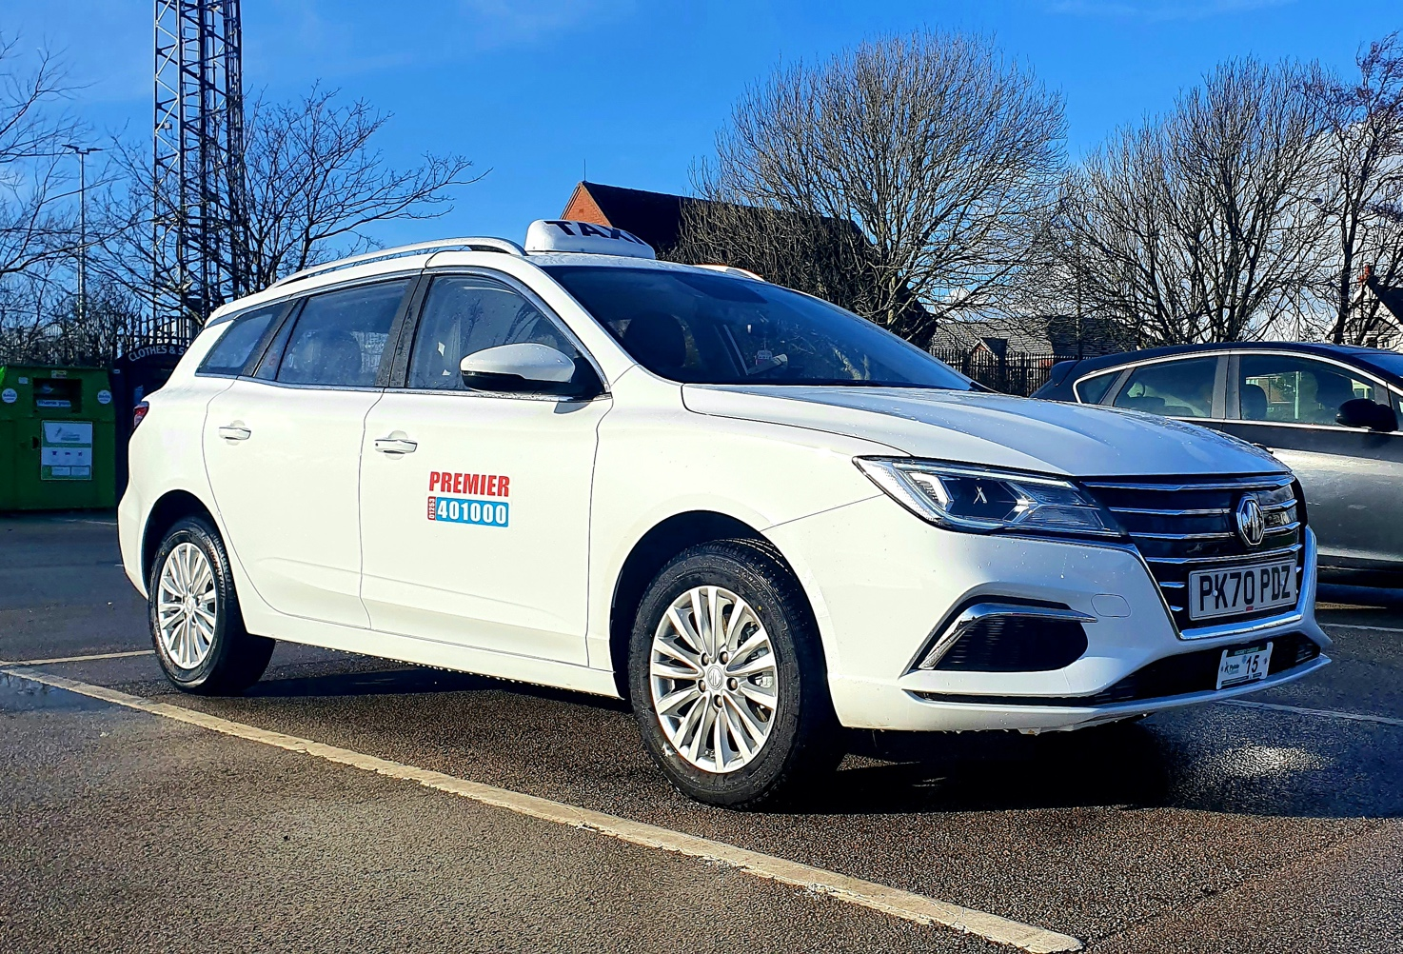

- UK’s greenest taxi fleet adds five new MG5 EVs to its roster
- Blackpool and Fylde’s Premier Taxis began EV switch in 2015
- Larger SW luggage capacity gives MG5 the edge over other EVs
- Award-winning firm moving to 100% full-EV

A PRIVATE hire and taxi firm that found fame by becoming one of the first to embrace electric car technology has added five MG5 EVs to its fleet.
Award-winning Premier Taxis was named GreenFleet Private Hire/Taxi Company of the year thanks to its EV initiative after it began operating electric taxis in 2015.
The new all-electric MGs replace Toyota Auris Hybrids on the Premier fleet and will be used across the Lancashire firm’s region, as well as airport transfers where the large luggage capacity comes in handy.
Premier Taxis Business Manager, Nikita Cutler, said: “The MG5 EV is great as it has a larger luggage capacity. This will come in handy as these vehicles are viable for airport transfers to Manchester, allowing us to offer customers the opportunity to use a Zero Emission airport transfer service for the first time.
“They will also be really handy for local journeys for those customers who have just been shopping, or for when we are collecting shopping for our most vulnerable customers during the Covid-19 pandemic.”
Premier Taxis is gradually converting its entire fleet to electric-only thanks to huge reductions in running costs as well as positive feedback from its passengers.
“The investment in new electric vehicles is money well spent as operating costs for the company and drivers have reduced while at the same time allowing us to contribute to improving the air quality around Lytham St. Annes, Blackpool and Wyre,” added Nikita. “Electric vehicles also require less day-to-day maintenance, further reducing cost.
“Our customers find them very comfortable, enjoy the smooth and quiet ride and some of them choose only to travel in a 100% Electric vehicle as they understand the difference Zero Emission travel can make to local air quality.”
Premier Taxis driver Steve Foster added: “I have already been managing more than 200 miles on a single charge. I plug the car in at home at 5pm and that will last me until the following day at 5pm.
“Our old cars cost £22 to get to Manchester Airport. With the MG it will cost hardly anything to complete the same trip so they make great sense for a taxi driver.”
MG’s ground-breaking MG5 EV went on sale in autumn 2020 and is the UK’s first and only all-electric SW model, with a luggage capacity of up to 1,456 litres (578 litres with rear seats up) and an EV-only range of 214 miles.
MG Motor’s Commercial Director, Guy Pigounakis, said: “The private hire and airport transfer market is one where MG5 EV has an amazing opportunity thanks to its unique market position as the only EV station wagon on the market. It also has the potential to offer huge savings to operators regardless of fleet size.”
MG currently offers three plug-in models in the UK – the established MG ZS EV, the game-changing All New MG5 EV and MG HS Plug-in, all backed up by MG’s incredible 7 year warranty* and fast-developing dealer network.
To find your local dealer, or to discover the high-tech, value-for-money range of cars on offer, please visit MG.CO.UK.

*Warranty for taxis - 3 year /60,000 miles

- ENDS -
Notes to editors:

About MG

Tracing its history back to 1924, MG is the iconic British motoring brand, famous for building sporty, exciting and value-for-money cars which are always fun to drive. From the original MG 14/28 Super Sports car, designed by the legendary Cecil Kimber, to the all-electric MG5 EV of today, MG has always been innovative, always been radical and always been fun!

Today, MG is the fastest growing car brand in the UK, fielding a six-car range of practical and affordable hatchbacks, SWs and SUVs. Designed in Marylebone, London, and manufactured in state-of-the-art factories in several countries, today’s MGs are practical, spacious, packed with technology and perfect for modern life. With a national network of 120 dealerships, MG is accessible to customers everywhere with professional sales and aftersales provision across the UK.

Backed by SAIC Motor, one of the world’s largest automotive companies, all new MGs are built with world-class components and are backed by a comprehensive manufacturer’s 7 year warranty. Well-established in the UK, MGs are now sold worldwide with western Europe being the latest region for expansion during 2020.

For further information please contact:
CRAIG CHEETHAM
MG Press Office
T: +44 7900 085571
E: craig@crccreative.co.uk
www.mg.co.uk

