PRESS INFORMATION – 1 OCT 2021

MG MOTOR UK PROMOTES GERAINT ISAAC TO HEAD OF FLEET SALES

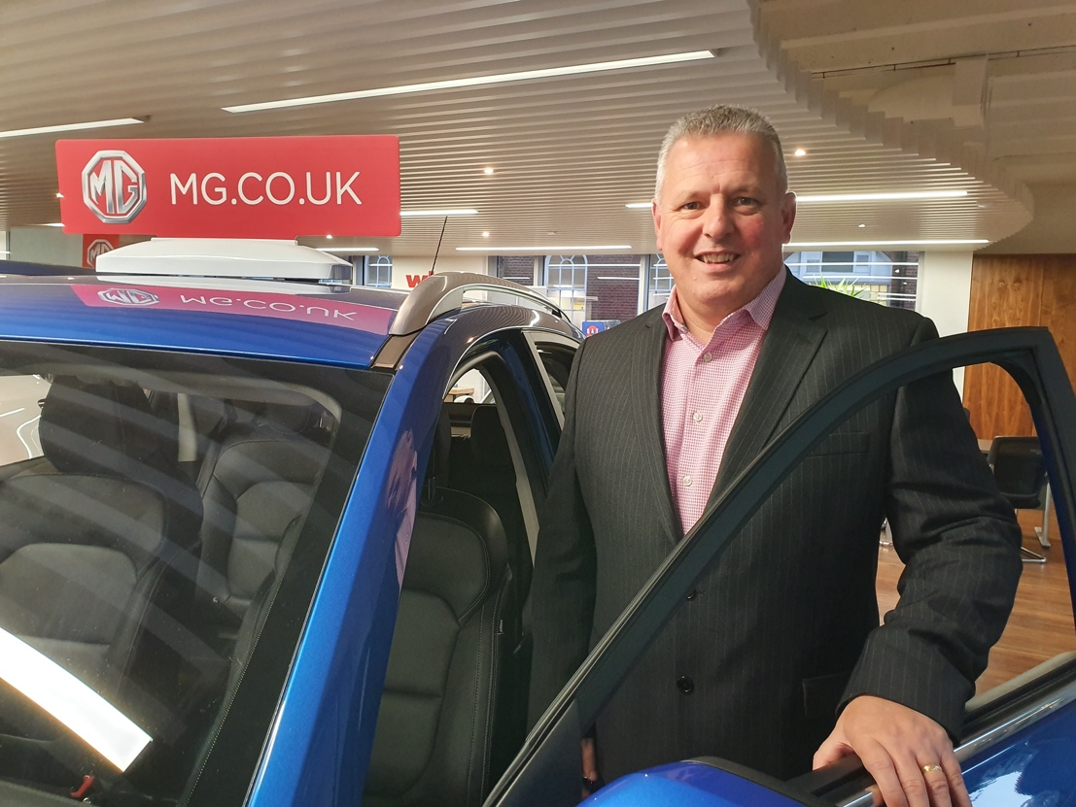

- MG Motor has promoted Geraint Isaac to new role as Head of Fleet Sales
- Formerly National Fleet Sales Manager, Geraint joined MG Motor in September 2019
- MG fleet sales have increased almost fourfold since 2019*
- MG positioned for fleet growth due to affordable EV leadership
MG Motor UK has promoted Geraint Isaac to Head of Fleet Sales, from his previous role as the brand’s National Fleet Sales Manager.
The role will see Geraint work with the expanding MG dealer network, as well as major fleet operators, helping grow the brand’s presence in both user chooser and core company fleets. He retains responsibility for vehicle remarketing, residual values and co-ordinating MG’s dealer fleet programmes and continues to be supported by a Regional Fleet Sales Manager and Public Sector & Leasing Manager
Geraint said: “As the UK’s fastest growing mainstream car brand and a leader in electric vehicles, MG has never been better placed to really grow its presence in the fleet market and in my new role I’m really keen to leverage those opportunities, making the most of new models including the MG5 EV and MG HS Plug-In Hybrid to boost MG’s appeal in both the core fleet and user-chooser markets, where low BIK rates and zero emissions are big selling points.”
Guy Pigounakis, MG Motor Commercial Director, added: “Geraint has already done a terrific job in raising awareness of MG in the fleet market and in securing some key deals for the brand. In his new role, we look forward to him developing those relationships and increasing MG’s visibility in the fleet market even further.”
MG currently offers six models in the UK including three plug-in cars – the established MG ZS EV, the game-changing All New MG5 EV and MG HS Plug-in Hybrid, all backed up by MG’s comprehensive 7-year warranty and nationwide dealer network.
To find your local dealer, or to discover the high-tech, value-for-money range of cars on offer, please visit MG.CO.UK.
* Full year 2019 fleet sales versus end September 2021 sales
- ENDS –
Notes to editors:

About MG

Tracing its history back to 1924, MG is the iconic British motoring brand, famous for building sporty, exciting, and value-for-money cars which are always fun to drive. From the original MG 14/28 Super Sports car, designed by the legendary Cecil Kimber, to the all-electric MG5 EV of today, MG has always been innovative, always been radical and always been fun!

Today, MG is the fastest growing car brand in the UK, fielding a six-car range of practical and affordable hatchbacks, SWs, and SUVs. Designed in Marylebone, London, and manufactured in state-of-the-art factories in several countries, today’s MGs are practical, spacious, packed with technology and perfect for modern life. With a national network of over 130 dealerships, MG is accessible to customers everywhere with professional sales and aftersales provision across the UK.

Backed by SAIC Motor, one of the world’s largest automotive companies, all new MGs are built with world-class components and are backed by a comprehensive manufacturer’s 7-year warranty. Well-established in the UK, MGs are now sold worldwide with western Europe being the latest region for expansion.

For further information please contact:

LINDA ROBINSON
PR and Experiential Manager, MG Motor
T: +44 0203 917 5834
E: linda.robinson@mg.co.uk

CRAIG CHEETHAM
MG Press Office
T: +44 07900 085571
E: craig@crccreative.co.uk

www.mg.co.uk

