PRESS INFORMATION – 9 APRIL 2021

THE MG CYBERSTER – FIRST OFFICIAL PICTURES RELEASED

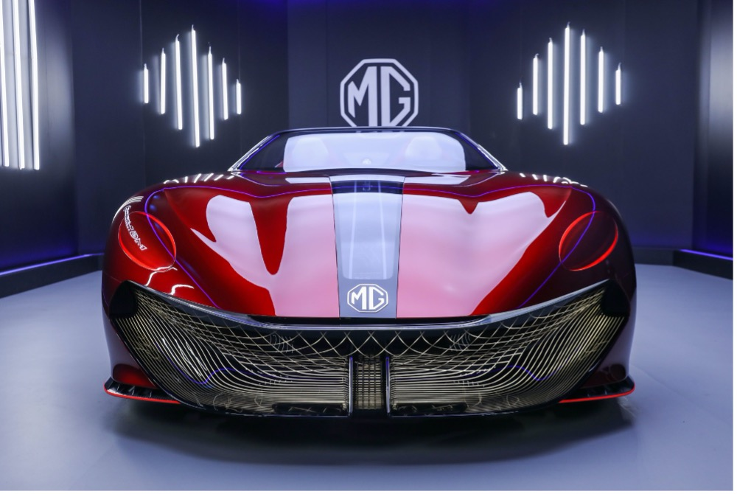

- First official photographs of MG Cyberster concept revealed
- Two-seater to be unveiled at Shanghai Auto Show later this month
- Stunning convertible shape recalls classic MG roadsters
- Electric powertrain promises 800km range
- Intelligent electrical architecture features gaming cockpit and 5G

Just days after revealing design renderings, MG has released the first official photographs of its Cyberster concept car, which will be making its debut at the Shanghai Auto Show later this month.
The Cyberster - developed by the team at the MG Advanced Design Centre in London – is a two-door, two-seater sports car recalling the brand’s tradition, drawing a number of styling cues from the classic MGB Roadster while also ushering in new high-tech features, including an interactive gaming cockpit and 5G connectivity.
The Cyberster’s intelligent all-electric architecture will enable an approximate EV range of 800km (500 miles) and deliver a 0-100km/h time (0-62mph) of less than three seconds, while the body is designed to enhance aerodynamic performance, the classically shaped MG grille also serving as an air duct to ensure airflow over the car’s chassis.
It features classic round MG headlights, coupled with a slim grille design, along with interactive ‘Magic Eye’ headlights that open when switched on.
Other striking details of the MG Cyberster are the 'laser belt' LED strip down the side of the car and the outline of the door, which follows the direction of the LED strip.
Its powerful sports car profile has a distinct two-stage shoulder line, with a flattened ‘kamm tail’ rear, accentuated by unusual ‘hacker blade’ alloy wheels. The tail lamps are of LED construction and are integrated flat into the rear of the car, projecting a digital image that echoes MG’s British heritage.
The "digital fibre" interior design theme adopts a driver-centric layout, with a separated cockpit for driver and passenger and a large-sized LED instrument cluster with a second central screen. The screen ahead of the driver presents all of the key vehicle information in a modern nut minimalist style, while the central display houses its more interactive features.
MG’s ‘Zero Gravity’ seats have floating head restraints, while the door panels and red leather handles reflect the ‘laser belt’ that runs down the car’s exterior.
Carl Gotham, Director of SAIC Design Advanced London, said: “The Cyberster is a bold statement that looks strongly into MG’s future, touching on our heritage but more importantly building on our technology and advanced design.
“Cyberster is a hugely exciting concept for us.”
More information on the Cyberster will be revealed when the model is shown at the Shanghai Motor Show (April 21-28, 2021).
MG currently offers three plug-in models in the UK – the established MG ZS EV, the game-changing All New MG5 EV and MG HS Plug-in, all backed up by MG’s incredible 7 year warranty and fast-developing dealer network. Its UK Advanced Design HQ employs over 40 designers.
To find your local dealer, or to discover the high-tech, value-for-money range of cars on offer, please visit MG.CO.UK.
- ENDS –
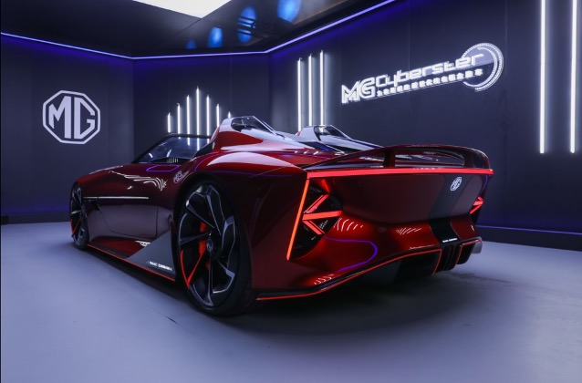
Notes to editors:

About MG

Tracing its history back to 1924, MG is the iconic British motoring brand, famous for building sporty, exciting and value-for-money cars which are always fun to drive. From the original MG 14/28 Super Sports car, designed by the legendary Cecil Kimber, to the all-electric MG5 EV of today, MG has always been innovative, always been radical and always been fun!

Today, MG is the fastest growing car brand in the UK, fielding a six-car range of practical and affordable hatchbacks, SWs and SUVs. Designed in Marylebone, London, and manufactured in state-of-the-art factories in several countries, today’s MGs are practical, spacious, packed with technology and perfect for modern life. With a national network of 120 dealerships, MG is accessible to customers everywhere with professional sales and aftersales provision across the UK.

Backed by SAIC Motor, one of the world’s largest automotive companies, all new MGs are built with world-class components and are backed by a comprehensive manufacturer’s 7 year warranty. Well-established in the UK, MGs are now sold worldwide with western Europe being the latest region for expansion during 2020.

For further information please contact:
CRAIG CHEETHAM
MG Press Office
T: +44 7900 085571
E: craig@crccreative.co.uk
www.mg.co.uk

