PRESS INFORMATION – FOR IMMEDIATE RELEASE
XX OCTOBER 2021

MG5 EV NAMED ‘BEST VALUE CAR’ IN BUSINESS CAR AWARDS

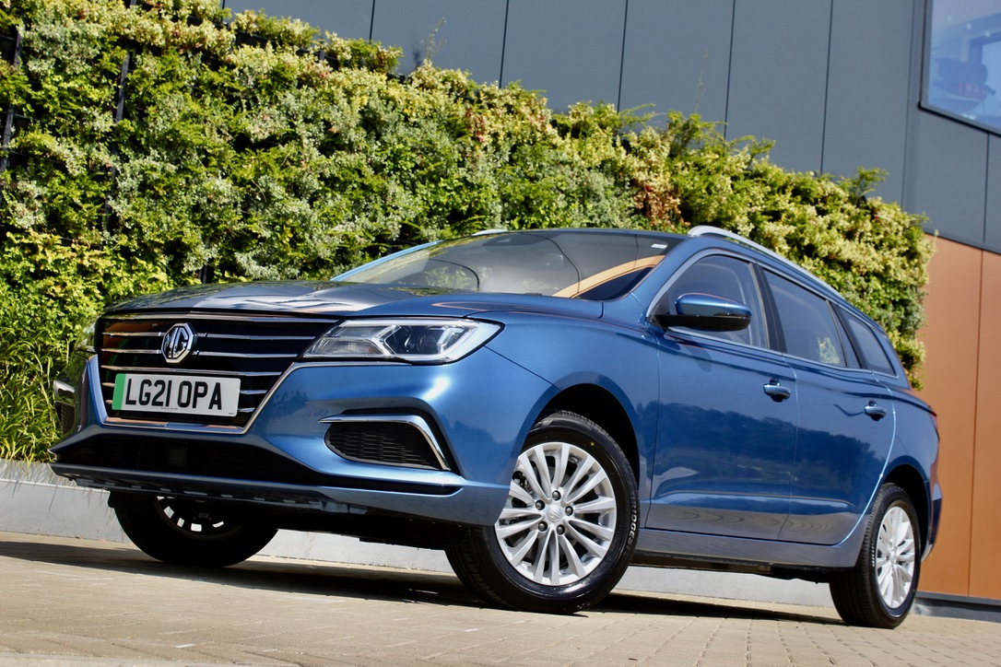

- MG Motor UK wins ‘Best Value Car’ honour in Business Car Awards
- MG5 EV praised for its low running costs and P11D pricing
- Second award in a month for the model, which also took honours from WhichEV.

THE MG5 EV has scooped a major accolade in the 2021 Business Car Awards, after being named the Best Value Car in the fleet title’s annual honours.

The MG 5 EV estate, which saw the addition of a new Long Range model this summer, offers unbeatable practicality, value and low running costs for fleet operators and company car drivers.
Presenting the award, Business Car Editor Martyn Collins said: “With fleet electrification progressing ever-faster, a good value offering in this sector has particular significance. The MG5 combines family car practicality with long-range battery capacity, at a price which could open up EV motoring to a wider selection of business drivers than had previously been the case.”
Geraint Isaac, MG Motor’s Head of Fleet Sales, added: “This is a tremendous accolade for the MG5 EV, which has given us a huge boost in the fleet market thanks to its unique body style, sensational value, excellent range and attractive P11D pricing. More and more fleet users are realising that the MG5 EV is a fantastic proposition from much greater than just a cost perspective, and our EV offering is about to get even better with the imminent introduction of the new longer range MG ZS EV, which will give us another highly desirable car for business users.”
The Business Car Award is the second honour in a month for the MG5 EV, which was also voted Best Value EV by WhichEV for the second time – the standard range MG5 EV picked up the 2020 award earlier this year. The publication described the MG5 EV Long Range as the “best value EV on the market by a considerable margin.”
MG Motor UK’s year-to-date registrations were up 61.2% to the end of September 2021 and the brand remains the fastest growing mainstream car brand in the UK. The company’s overall battery electric mix of 32.7% is the highest of any manufacturer selling both internal combustion and alternative fuel models, with the MG5 EV the 7th best-selling EV in the UK.
MG currently offers six models in the UK including three plug-in cars – the MG ZS EV, the MG5 EV and MG HS Plug-in Hybrid.
To discover the high-tech, value-for-money range of cars on offer, please visit MG.CO.UK.
- ENDS –

Notes to editors:

About MG

Tracing its history back to 1924, MG is the iconic British motoring brand, famous for building sporty, exciting and value-for-money cars which are always fun to drive. From the original MG 14/28 Super Sports car, designed by the legendary Cecil Kimber, to the all-electric MG5 EV of today, MG has always been innovative, always been radical and always been fun!

Today, MG is the fastest growing car brand in the UK, fielding a six-car range of practical and affordable hatchbacks, SWs and SUVs. Designed in Marylebone, London, and manufactured in state-of-the-art factories in several countries, today’s MGs are practical, spacious, packed with technology and perfect for modern life. With a national network of over 130 dealerships, MG is accessible to customers everywhere with professional sales and aftersales provision across the UK.

Backed by SAIC Motor, one of the world’s largest automotive companies, all new MGs are built with world-class components and are backed by a comprehensive manufacturer’s 7-year warranty. Well-established in the UK, MGs are now sold worldwide with western Europe being the latest region for expansion.

For further information please contact:

LINDA ROBINSON
PR and Experiential Manager, MG Motor
T: +44 0203 917 5834
E: linda.robinson@mg.co.uk

CRAIG CHEETHAM
MG Press Office
T: +44 07900 085571
E: craig@crccreative.co.uk

www.mg.co.uk

