PRESS INFORMATION – 03 NOVEMBER 2021

BRISTOL STREET MG BEACONSFIELD OPENS ITS DOORS

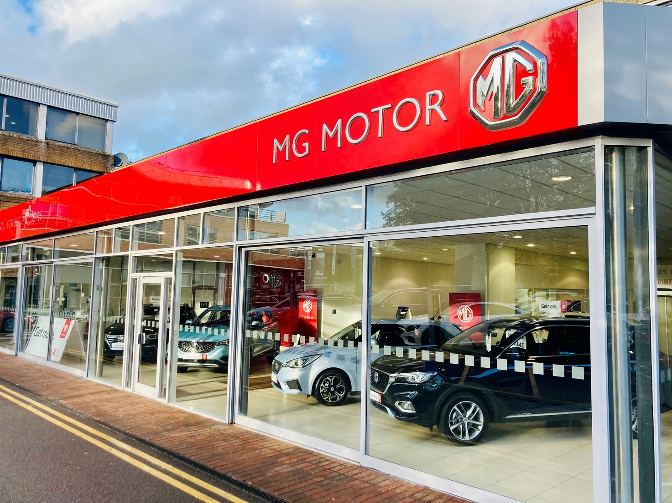

- MG Motor and Bristol Street Motors open new showroom in Beaconsfield
- Buckinghamshire dealership is second Bristol Street Motors site to retail MG
- Move follows over 40 new dealers joining the brand in past 12 months
- EV leadership and great value proposition make MG a highly desirable franchise

MG Motor UK and Vertu Motors Plc have extended their partnership, with a second Bristol Street Motors dealership opening in the prestigious market town of Beaconsfield, Buckinghamshire. The first Bristol Street Motors MG site opened in Carlisle, Cumbria, in August 2021.
The company has added MG to its portfolio as it believes the brand offers a great opportunity to increase sales and EV penetration.
Bristol Street Motors MG Beaconsfield is based on the town’s Station Road adjacent to the Vertu Motors Mercedes-Benz of Beaconsfield site and carries a range of new and used cars as well as offering on-site EV charging, servicing and aftersales.
Lee Clark, Sales Manager at Bristol Street Motors MG Beaconsfield, said “I am very pleased to open the doors to our brand-new MG facility after several months of works to create an excellent atmosphere for customers and colleagues.
“We’ve invested significant amounts to bring MG to Beaconsfield and recruited people to fill a range of roles. I’m looking forward to working with my new colleagues and welcoming the customers through the doors of Beaconsfield’s newest and most modern car dealership.”
Robert Forrester, Chief Executive of Bristol Street Motors, said: “We’re very pleased to create our second MG dealership at Beaconsfield. It’s great to be able to create jobs in the area with this investment.
“The MG brand has a long history and a very bright future and I’m delighted that Bristol Street Motors is part of that. MG delivers incredible electric and hybrid vehicles at affordable prices, opening up the option of owning a zero-emissions car to more people than ever before.”
MG Motor Commercial Director, Guy Pigounakis, added: “We are delighted to further our relationship with Vertu Motors Plc with the opening of this new dealership in one of the most important and desirable locations on the periphery of London. This new site in Beaconsfield is right in the heart of the Home Counties and the London commuter belt.
“Working with a group as high profile as Bristol Street Motors shows just how far and how quickly MG has grown in recent years and, with our rapidly growing EV portfolio in particular, how attractive the MG franchise has become.”
MG currently offers six models in the UK including three plug-in cars – the MG ZS EV, the MG5 EV and MG HS Plug-in Hybrid, all backed up by MG’s 7 year warranty and fast-developing dealer network.
To find your local dealer, or to discover the high-tech, value-for-money range of cars on offer, please visit MG.CO.UK.
- ENDS –
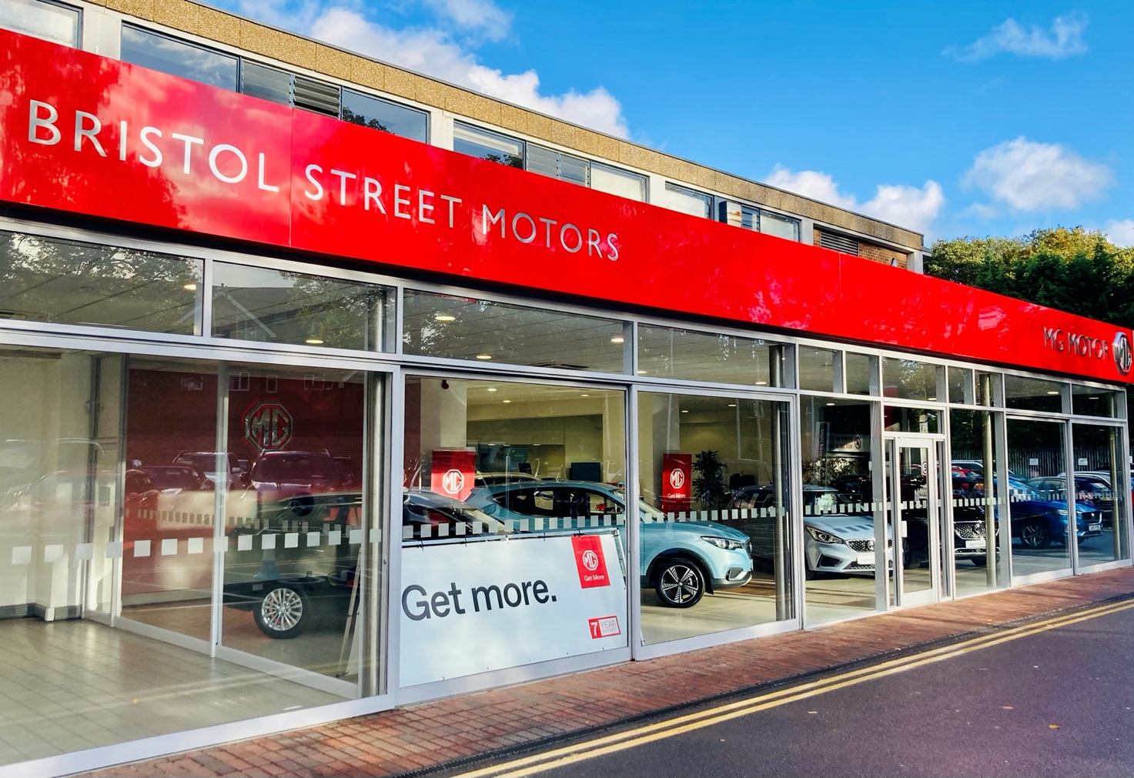
Notes to editors:

About MG

Tracing its history back to 1924, MG is the iconic British motoring brand, famous for building sporty, exciting and value-for-money cars which are always fun to drive. From the original MG 14/28 Super Sports car, designed by the legendary Cecil Kimber, to the all-electric MG5 EV of today, MG has always been innovative, always been radical and always been fun!

Today, MG is the fastest growing car brand in the UK, fielding a six-car range of practical and affordable hatchbacks, SWs and SUVs. Designed in Marylebone, London, and manufactured in state-of-the-art factories in several countries, today’s MGs are practical, spacious, packed with technology and perfect for modern life. With a national network of over 130 dealerships, MG is accessible to customers everywhere with professional sales and aftersales provision across the UK.

Backed by SAIC Motor, one of the world’s largest automotive companies, all new MGs are built with world-class components and are backed by a comprehensive manufacturer’s 7 year warranty. Well-established in the UK, MGs are now sold worldwide with western Europe being the latest region for expansion.

For further information please contact:

LINDA ROBINSON
PR and Experiential Manager, MG Motor
T: +44 203 917 5834
E: linda.robinson@mg.co.uk

CRAIG CHEETHAM
MG Press Office
T: +44 7900 085571
E: craig@crccreative.co.uk

www.mg.co.uk

