PRESS INFORMATION – 1 JUNE 2021

MG TAKES DOUBLE HONOURS IN AUTO TRADER NEW CAR AWARDS 2021

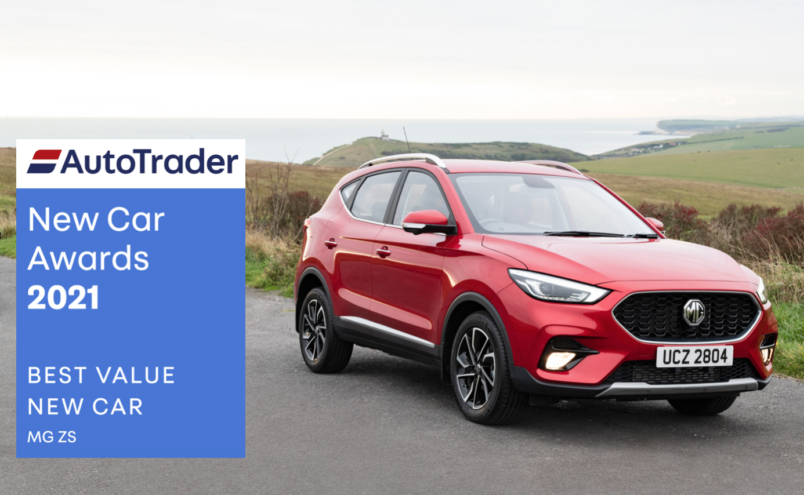

- MG ZS scoops two honours in Auto Trader New Car Awards
- Voted Best Value New Car as well as the Best Car for Dog Owners
- Available from just £15,600 on-the-road
- All-electric ZS EV from just £26,095 (after plug-in car grant)
- MG sales increased by 41% in 2020
- All MGs covered by brand’s famous 7 year warranty

The MG ZS has taken the awards for Best Value New Car and Best Car for Dog Owners at the fifth-annual Auto Trader New Car Awards.
The ZS, which was also a finalist for the New Car of the Year Award, beat very strong competition from the Dacia Duster and Kia Sportage to take the award for Best Value New Car. It also scooped the award for Best Car for Dog Owners ahead of the Toyota RAV4 and Dacia Duster.
Unlike other car awards which rely on editorial judging panels, the winners of the Auto Trader New Car Awards are determined by genuine car owners who voted in 19 of this year’s 21 categories, making them true consumer champions.
Over 148,000 car owners took part in the judging process between September 2020 and April 2021, helping to provide the industry with an accurate measure of owner satisfaction across a broad range of consumer-centric categories.
MG’s victory was based on the honest opinions of those who have bought, driven and lived with their new cars.
Erin Baker, Auto Trader’s Editorial Director, said: “With its combination of great quality, roominess, reliability and performance mixed in with a fair price and low running costs, the MG ZS has taken the Best Value New Car Award and Best Car for Dog Owners Award at this year’s Auto Trader Retailer Awards. We were inundated with fantastic feedback from owners, including: ‘I’m just staggered by the quality, ride, performance and specification. Best car we have ever had.’
“Happy owners of the electric variant [the MG ZS EV] really stood out in their responses, with one owner saying: It is the only affordable fully electric SUV around. What a lovely car to drive’. Winning two awards is a brilliant achievement, and really is very well deserved.”
Consumers were asked to rate their cars across 16 different criteria, from reliability and performance to appearance and running costs. They were also asked about their overall satisfaction with their car and how likely they would be to recommend it to others.
Erin continued: “The Auto Trader New Car Awards recognise the brands and cars that are doing it right in the eyes of those whose opinions matter most: consumers. The awards are now in their fifth year and we had input from over 148,000 consumers telling us what they thought about all aspects of owning and driving a car. They prove how manufacturers are taking consumers’ needs into consideration and innovating to bring a great and wide choice to market. MG, and all of this year’s winners, are incredibly well-deserving.”
Winners of the awards will be promoted across Auto Trader, which is the UK’s largest automotive marketplace with an average of 58 million cross-platform visits every month.
Accepting the award, MG’s Marketing Director, David Pugh, said: “There’s no better feedback than that which you get from the customers who have bought and lived with your cars, so to see the ZS get such positive recognition from people who drive the car every day is fantastic.
“MG is committed to offering great value, high quality cars with an exceptional 7 Year Warranty and is also committed to making EVs affordable for everyone. The ZS has been exceptionally well-received since it went on sale and is our best-selling model – ideal for all sorts of people including the nation’s dog lovers!”
MG currently offers six models in the UK including three plug-in cars – the established MG ZS EV, the game-changing All New MG5 EV and MG HS Plug-in Hybrid, all backed up by MG’s incredible 7 year warranty and fast-developing dealer network.
To find your local dealer, or to discover the high-tech, value-for-money range of cars on offer, please visit MG.CO.UK
-ENDS-

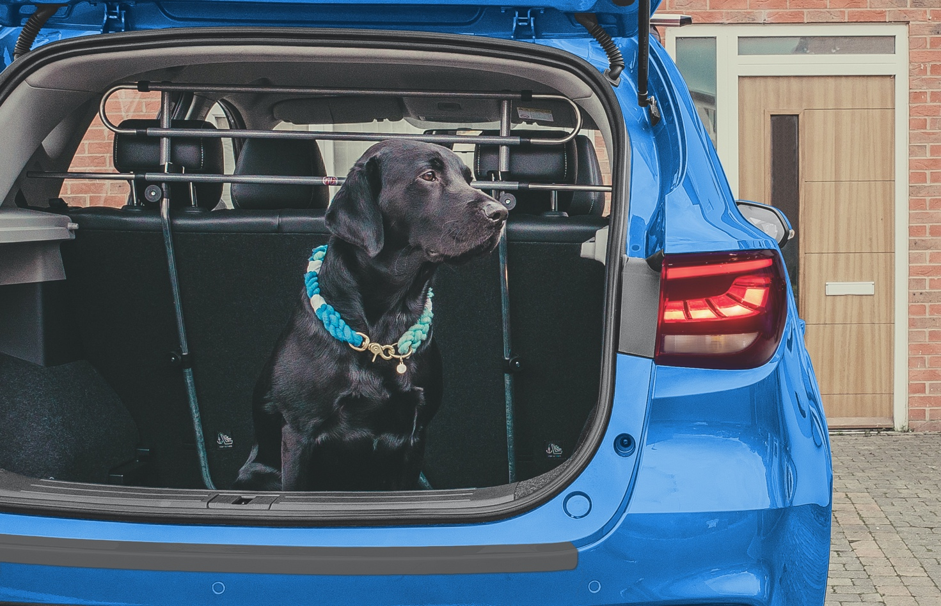

Notes to editors:

About MG

Tracing its history back to 1924, MG is the iconic British motoring brand, famous for building sporty, exciting and value-for-money cars which are always fun to drive. From the original MG 14/28 Super Sports car, designed by the legendary Cecil Kimber, to the all-electric MG5 EV of today, MG has always been innovative, always been radical and always been fun!

Today, MG is the fastest growing car brand in the UK, fielding a six-car range of practical and affordable hatchbacks, SWs and SUVs. Designed in Marylebone, London, and manufactured in state-of-the-art factories in several countries, today’s MGs are practical, spacious, packed with technology and perfect for modern life. With a national network of over 120 dealerships, MG is accessible to customers everywhere with professional sales and aftersales provision across the UK.

Backed by SAIC Motor, one of the world’s largest automotive companies, all new MGs are built with world-class components and are backed by a comprehensive manufacturer’s 7 year warranty. Well-established in the UK, MGs are now sold worldwide with western Europe being the latest region for expansion.

About Perrys

Perrys Motor Sales is a franchised car dealer, with its head office in Northampton, operating fifty showrooms at 25 sites across the UK now including three MG dealerships.

For further information please contact:
CRAIG CHEETHAM
MG Press Office
T: +44 7900 085571
E: craig@crccreative.co.uk
www.mg.co.uk

