PRESS INFORMATION MG5 EV
MG5 EV GOES EVEN FURTHER TO OFFER VALUE FOR MONEY

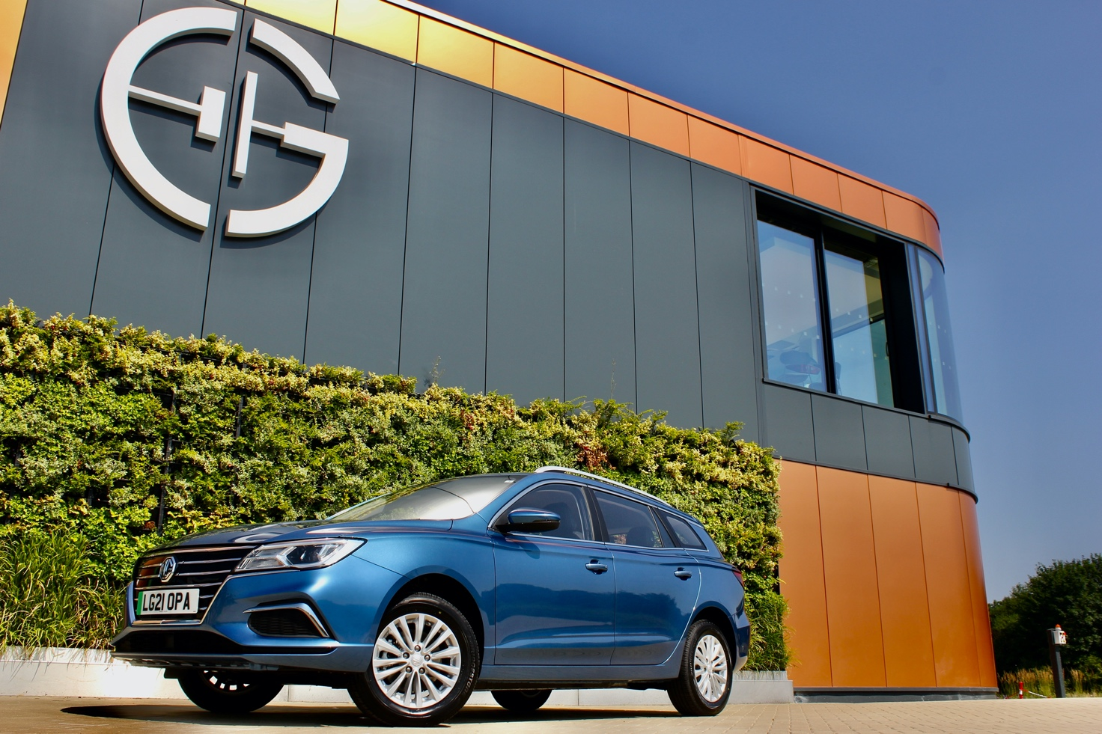

- MG introduces new longer range MG5 EV
- MG Pilot Advanced Driver Assistance now added
- MG5 EV is a fully electric C-segment SW
- New long-range model extends EV range to 250 miles
- Long Range model from £26,495 on-the-road (after OZEV grant)
- MG5 EV has the highest range per £ of MSRP of any EV currently on sale in the UK
- 80% rapid charge in just 61 minutes
- Huge load capacity, designed with fleet buyers and SMEs in mind
- Covered by MG’s famous seven-year warranty
- MG has a range of three plug-in cars suitable for everything and everyone

OVERVIEW
THE MG5 EV is stretching its value for money even further with the introduction of a new longer-range model, which is on sale now.
With a 250-mile range from its 61.1kWh battery, the longer range MG5 EV will take an 80% charge in just 61 minutes on a 50kW rapid charger or 40 minutes on a 100kW rapid charger. A 100% overnight fast charge takes approximately 9.5 hours on a domestic home charger supply.
The new model joins the already thriving MG5 EV model range, which made its debut in October 2020 as Europe’s first EV estate car. The new longer range model will continue to be sold for the time-being alongside the standard car, which has an electric range of 214 miles.
The MG5 EV offers the flexibility and practicality of a capacious station wagon with great driving dynamics and absolutely no driving exhaust emissions. The new longer range variant is the perfect addition to MG’s rapidly expanding electric car portfolio, alongside MG ZS EV and the MG HS Plug-in Hybrid, which already account for a third of MG’s total sales. The brand is now the fourth most popular EV brand in the UK and its EV model split is over four times the average in today’s car market.
Like all MG models, the New MG5 EV Long Range comes with a 7 year/80,000-mile fully transferable warranty as standard. It is powered by a 115kW electric motor (equivalent to 156PS), giving acceleration of 0-60mph in 7.3 seconds, and developing 260Nm of torque.
With its new 61.1kWh lithium-Ion battery pack that can be charged up to 80% in just 40 minutes using a 100kW rapid charger, the longer range MG5 EV has a WLTP approved combined range of 250 miles in normal day-to-day use. This rises to 334miles if the car is used solely for urban driving, as confirmed by the WLTP City driving cycle.
Also new on the long range model is the addition of MG’s MG Pilot Driver Assistance System. MG Pilot is a comprehensive suite of driver assist technologies that complements the driver and gives added confidence on the road.
MG ZS EV was the first MG model to feature MG Pilot, with both the Excite and Exclusive versions including the technology as standard. MG Pilot offers a selection of warning and alert features to assist the driver, including Active Emergency Braking, Lane Keep Assist, Adaptive Cruise Control, Traffic Jam Assist, Intelligent High Beam Assist and Intelligent Speed Limit Assist.
Prices for the longer range MG5 EV start from just £26,495 after the Plug-In Car Grant (currently £2,500) and business users benefit from 1% Benefit-in-Kind tax (2021/22 tax year).
David Pugh, MG Motor Marketing Director, said: “With MG5 EV we’ve already proven that there’s huge demand for a sensibly priced all-electric station wagon and it has proven hugely popular with fleet and retail customers alike since its debut in autumn 2020.
“With the new longer-range model we’re offering MG customers even greater value and flexibility form their EVs. With a full charge given a WLTP-approved range of 250 miles and the ability to be rapid charged to 80% in as little as 40 minutes, the MG5 EV is a car that really can bring electric motoring to the masses, and it has played a big part in MG’s rapid charge ahead as one of the leaders in the UK EV market.”
BACKGROUND
One of the reasons many EVs are built on SUV platforms is their ability to accommodate battery packs and additional motors within the footprint of a relatively small car, which results in a ‘body on top’ stance.
MG5 EV bucks that trend. The model brings an option to the market that optimises its superior aerodynamic properties and better handling, ideal for high mileage fleet drivers and those who value maximum driving efficiency, combined with excellent internal space and driving dynamics.
It’s a formula that has already gone down well, with over 100,000 sold in global markets since 2018, its innovative battery layout allowing it to have more of a conventional stance than many EVs.
DESIGN
Thanks to its unique body style, MG5 EV looks like no other electric car. It sits much lower than most, with the water-cooled battery pack integrated into the car’s chassis, giving it an extremely low centre of gravity and excellent dynamics as well as a sleek, low-slung and aerodynamic appearance.
It was designed from the outset to appeal to buyers in global markets, so it sports a classical silhouette - a smart, low-roofed tourer with a distinctive “kick” towards the rear of its swage line. It’s a handsome car from every angle, but the rear three-quarter view is particularly pleasing, with a lean and low appearance that proves how being battery-powered doesn’t have to affect practicality.
A total of five colours are available - Piccadilly Blue, Westminster Silver, Dynamic Red, Black Pearl or Arctic White.
That smart design continues into the cabin, the centrepiece of which is an eight-inch colour touchscreen with smartphone mirroring capability, compatible with both Android Auto TM and Apple CarPlay TM, and on the new long range model, MG Pilot.
POWERTRAIN
MG5 EV features a powerful 115kW motor equivalent to 156PS. The motor sends power to the front wheels, which gives the car very similar handling characteristics to those of a conventional large C-segment SW, but with a more assured feel thanks to its low centre of gravity. It accelerates from 0-60mph in 7.3 seconds, with a top speed of 115mph.
The battery pack, meanwhile, is mounted beneath the floor of the car and has a total capacity of 61.1kWh.
CHARGING
With a range of 250 miles on the WLTP cycle (rising to 334miles for city use) MG5 EV has the ability to exceed the driving requirements of most individuals, while the ability to be charged up to 80% charge in 40 minutes using a 100kW rapid charger (61 minutes via a 50kW unit) makes it even more practical. A full charge at home using Type 2 fast charging can be attained in around nine and a half hours.
PRACTICALITY
The large, versatile boot - the car’s true USP - is accessed from a wide tailgate opening. With the rear seats up and load cover in place there are 464 litres of boot space, or with the load cover retracted that extends to 578 litres with the rear seats still in place.
Drop the 60:40 folding seat back and the load capacity increases to an astonishing 1,456 litres.
But all that luggage capacity is not to the detriment of passenger space. Rear seat passengers are very well catered for with ample head room and plenty of legroom, even when seated behind a tall driver. Those in the front can easily get comfortable thanks to the six-way adjustable driver’s and four-way adjustable passenger seats, with cloth upholstery on the Excite and leather-style upholstery on the Exclusive. The Exclusive also gets heated front seats and driver’s lumbar support.
FLEET OPPORTUNITY
There’s a lot of focus on electric cars for company car drivers and fleet managers alike at present, with attractive tax incentives.
For the user-chooser, MG5 EV offers 1% BIK tax in 2021/22 and 2% in 2022/23. When you look at its list price versus other electric cars, the tax incentives are significant.
It’s an ideal choice for fleet managers, too, with a 7 year manufacturer’s warranty that’s transferable to the next owner, meaning not only peace of mind during the time they own or lease the car, but also helping residual values at the time of resale.
“There are multiple reasons why MG5 EV is the ideal fleet car,” says Geraint Isaac, National Fleet Sales Manager for MG Motor. “Whether it’s for multi-drop urban work, private hire, ride hailing or commuting to and from an office or to visit clients, MG5 EV’s combination of range, efficiency and ultra-low fleet running costs make it a very difficult prospect to ignore.”
SAFETY AND TECHNOLOGY
As well as the eight-inch colour touchscreen that is compatible with both Android Auto TM and Apple CarPlay TM, MG5 EV is brimming with high tech and essential safety kit.
Chief among these on the new long range model is MG Pilot, which brings with it a host of driver assistance systems detailed more fully below.
On the gadget side, it gets a six-speaker 3D audio system, a DAB radio, 4 USB ports, electric windows all-round, air conditioning, regenerative braking, adaptive cruise control with speed limiter, an auto-hold electric parking brake, rain-sensing wipers and push-button starter, all as standard equipment.
In addition, MG5 EV also gets MG’s clever rotary gear selector, which debuted on the brand’s MG ZS EV. It’s also packed with active and passive safety systems, with front, side and curtain airbags, electronic brake assist, ABS with EBD, twin ISOFIX points in the rear, a tyre pressure monitoring system, Hill Start Assist and seatbelt warnings for front and rear passengers.
MODEL RANGE, EQUIPMENT AND PRICING
The long range MG5 EV line-up comprises two versions, with prices starting at just £26,495 for the Excite (after the Plug-in Car Grant).
It comes with 16-inch ‘Meteor’ alloys, remote entry with push-button start, air conditioning, four electric windows, electrically adjustable mirrors, smartphone compatibility, an eight-inch colour touchscreen and seven-inch driver information display, Adaptive Cruise Control, a leather steering wheel, rotary gear selector, speed-sensing locking, three driving modes, rear parking sensors and follow-me-home headlights, as well as a 7-year warranty.
The Exclusive version adds leather-style upholstery with heated front seats with six-way electric adjustment for the driver, one-shot electric rear windows, silver roof rails, electrically adjustable folding heated mirrors, smart keyless entry with push-button start, an automatically dimming rear view mirror, rain-sensing wipers and satellite navigation.
The New long range MG5 EV Exclusive is available from just £28,995 (after the Plug-in Car Grant).
Both versions qualify for 1% BIK tax for company car users.
MG PILOT
WHAT DOES MG PILOT INCLUDE?
MG Pilot includes a range of driver assistance technologies, all with the aim of making driving easier, more pleasurable and most importantly, safer. They are:
ACTIVE EMERGENCY BRAKING
Active Emergency Braking is an emergency braking system designed to avoid low-speed collisions. At speeds below 12 mph, the car will automatically apply its brakes to avoid a collision with a vehicle, bicycle or pedestrian. At speeds above 12 mph, active emergency braking will still activate, but will instead reduce the likelihood or mitigate the severity of an accident.
LANE KEEP ASSIST
Lane Keep Assist is a really valuable tool included in MG Pilot, that actively monitors your vehicles position on the road through the use of a wide-angle camera (located in the front mirror). When the function detects the vehicle is about to unintentionally move out of its lane, it will either send a warning or steer back into the appropriate lane.
ADAPTIVE CRUISE CONTROL
Adaptive Cruise Control is an intelligent form of cruise control that allows vehicles to speed up and slow down automatically in order to keep pace with the traffic ahead. Adaptive Cruise Control (ACC) monitors the road ahead and as long as the road is clear, ACC maintains the speed set by the driver.
If the system spots a slower vehicle within its detection range, it gently reduces speed by releasing the accelerator or actively engaging the brakes. If the vehicle ahead speeds up or changes lanes, ACC automatically accelerates back to the driver’s desired speed.
TRAFFIC JAM ASSIST
Traffic Jam Assist uses existing functions such as Adaptive Cruise Control and Lane Keep Assist to allow easy, controlled driving in heavy traffic. When Adaptive Cruise Control is turned on, Traffic Jam Assist continuously analyses the speed of the surrounding vehicles and compares it with its own driving speed. Your car will follow the vehicle in front and will automatically adjust its speed to make driving in traffic more comfortable for you.
INTELLIGENT HIGH BEAM ASSIST
High Beam Assist recognises oncoming traffic at night and adjusts your headlights accordingly, switching between high beam and dipped lights automatically without you having to use your in-car controls. High beam assist will only work when the headlight high beam is set to the AUTO position. This can help reduce distraction whilst driving and support safer driving.
INTELLIGENT SPEED LIMIT ASSIST
Across the UK, failure to effectively adjust speed is the cause of many road traffic accidents. The MG speed limit assist system, as featured in MG Pilot, can remind drivers of the current speed limit of the road, and in doing so, helps them to drive more safely. The system alerts the driver of the current speed limit by way of a symbol on the driver's instrument cluster, which remains visible until the speed of the vehicle is amended or the speed limit changes.
FURTHER INFORMATION
MG currently has a network of over 130 dealers with further expansion planned before the end of 2021. To find your local dealer, or to discover the high-tech, value-for-money range of cars on offer, please visit MG.CO.UK
- ENDS –
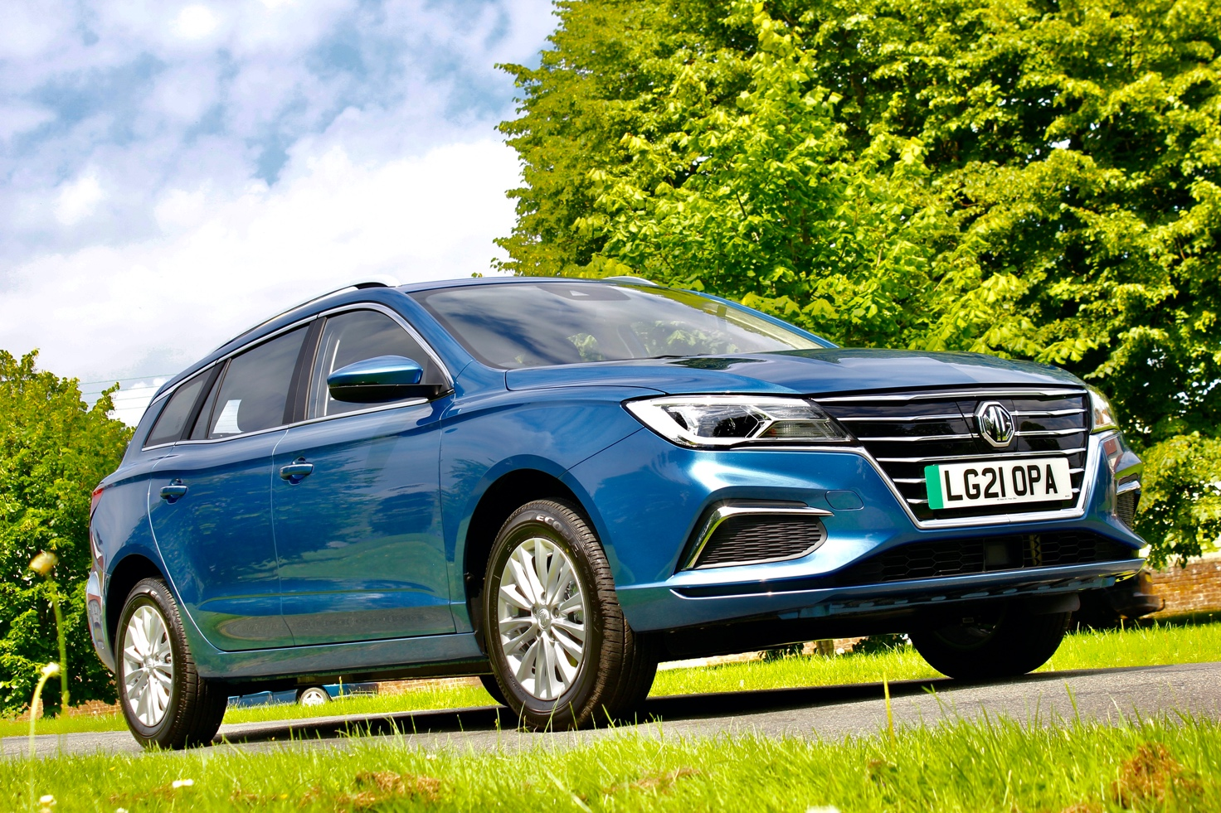
Notes to editors:

About MG

Tracing its history back to 1924, MG is the iconic British motoring brand, famous for building sporty, exciting and value-for-money cars which are always fun to drive. From the original MG 14/28 Super Sports car, designed by the legendary Cecil Kimber, to the all-electric MG ZS EV of today, MG has always been innovative, always been radical and always been fun!

Today, MG is the fastest growing car brand in the UK, fielding a six-car range of practical and affordable hatchbacks, SWs and SUVs. Designed in Marylebone, London, and manufactured in state-of-the-art factories in several countries, today’s MGs are practical, spacious, packed with technology and perfect for modern life. With a national network of over 130 dealerships, MG is accessible to customers everywhere with professional sales and aftersales provision across the UK.

Backed by SAIC Motor, one of the world’s largest automotive companies, all new MGs are built with world-class components and are backed by a comprehensive manufacturer’s 7 year warranty.

For further information please contact:

CRAIG CHEETHAM

MG Press Office
T: +44 7900 085571
E: craig@crccreative.co.uk
www.mg.co.uk

